Open the TI-Nspire document Standard_Error_of_Sample_ Means.tns.  The mean of the sampling distribution of sample means will be the mean of the population. What do we know about the spread of the distribution of sample means? This activity investigates that question. | 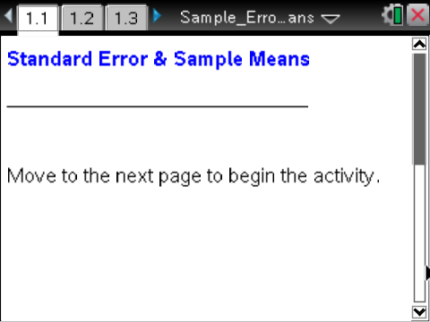

Move to pages 1.2 and 1.3. | Press / ¢ and / ¡ to navigate through the lesson.
This activity involves generating a number of random samples from a population. In order to avoid having your results be identical to those for another student in the room, it is necessary to “seed” the random number generator. Read the instructions on Page 1.2 for seeding your random number generator, then carry them out on Page 1.3.

1. From your earlier work, what do you know about the mean of the sampling distribution of sample means?

Move to page 1.4.

2. The top arrow on Page 1.4 will generate a sample of size 50, chosen with replacement, from a population of rectangles and will display the mean area of the rectangles in the sample.
a. Generate 10 samples. Describe the simulated sampling distribution of the mean areas for the samples, and make a rough sketch of what you see.

b. The vertical line will display the mean of the simulated sampling distribution of the mean areas. Click the line, and record the result on your sketch above.

3. Click the top arrow on Page 1.4 to generate five new samples and plot the sample mean for each of the new samples. Generate 45 more samples. How did the simulated sampling distribution change as the number of samples changed?

Move to page 1.5.

The bottom work area on Page 1.5 is the same as Page 1.4. The arrow in the top work area will generate samples of size 40 from the population and display the distribution of the sample means.
4. Generate 50 samples of size 40. How do the simulated sampling distributions for the two sample sizes compare?

Move to page 1.6.

The mean of the sampling distribution of all sample means will be the population mean. A question of interest is how the standard deviation of the sampling distribution of sample means behaves.
5. On Page 1.6, click the arrow to display simulated sampling distributions for 50 samples of different sample sizes.
a. What conjecture can you make about the standard deviation of distributions of sample means for samples of size n drawn from the same population? Justify your answer by referring to the graphs. (Note that using the left arrow will generate 50 new samples for each sample size.)

b. What value would you expect for the standard deviation of the sampling distribution of all sample means for sample size 1? Explain your reasoning.

Move to page 1.7.

6. The spreadsheet shows the standard deviations for simulated sampling distributions of 100 sample means for different sample sizes.
a. Hover over a point in the graph. Explain what the coordinates represent.

b. What function do you think might model the relationship between the variables? Explain your reasoning.

c. Click the arrow once to see a power regression as a model of the relationship between the sample size and standard deviation. Does the equation support your conjecture? Why or why not?

d. The mean of the areas, the population in the activity, is 7.4 sq. units, and the standard deviation is 5.19 units. Click the arrow again to see the theoretical model for the relationship between the sample size and the standard deviation in the sampling distribution of sample means. How does the theoretical model compare to the regression equation for your data? (Note the model uses the variable x to represent n, the sample size.)

7. The standard deviation of the sampling distribution of sample means is called the standard error of the distribution.
a. Suppose you had a sampling distribution of sample means for samples of size 64. If the population standard deviation is 9.6, what is the standard error of the sampling distribution?

b. In general, how can you find the standard error for a sampling distribution of sample means for samples of any size?

