Science Objectives  - Use a Gas Pressure Sensor and a gas syringe to measure the pressure of an air sample at several different volumes.  - Determine the relationship between gas pressure and volume.  - Use the results to predict the pressure at other volumes.  Math Objectives  - Mathematically describe the relationship between gas pressure and volume.  - Evaluate an inverse mathematical relationship.  - Generate and analyze a power regression model.  - Linearize an inverse relation.  Materials Needed  - TI-Nspire CX II  - Calculator Connection Cable (Mini-A to Micro-B USB)  - Vernier Gas Pressure Sensor  - 20 ml syringe  Vocabulary  TI-Nspire™ Navigator™ System (If available.)  - Class Capture to monitor student progress.  - Live Presenter allows students to show their graphs to the class. | 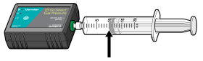  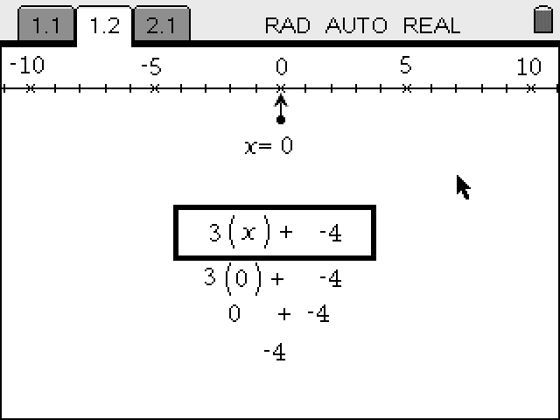  Figure 1.  TI-Nspire™ Technology Skills:  - Open a document  - Move between pages  - Entering and graphing data  - Tracing and interpolating  Tech Tip:  Access free tutorials at http://education.ti.com/calculators/pd/US/Online-Learning/Tutorials  Lesson Files:  Student Activity  - Boyles_Law_Student.pdf  - Boyles_Law_Student.doc
  - pressure
  - volume
  - inverse
  - linear
  - correlation coefficient (r)
TI-Nspire Navigator Opportunity
Use the TI-Nspire Navigator System to monitor student progress using Class Capture.

Activity Overview
- Please print the student worksheet and make available to students before beginning the lab. Lab background information as well as lab procedures are included only in the student worksheet. Always remember to review any safety precautions thoroughly with your students prior to starting the lab.
- Vernier GoDirect (GDX) probes and sensors can be either directly connected to the TI-Nspire CX II with Calculator Connection Cable (Mini-A to Micro-B USB) or through TI’s Bluetooth Adapter. For this activity, we used the USB direct connection method.
- Optional Procedure: For those of you wishing to use the Bluetooth Adapter instead of the USB cable, here is the procedure:
- Turn the TI-Nspire CX II on.
- Turn on the GDX Probe or Senor of choice.
- Plug the Mini-A end of the cable into the Npsire CX II and the Micro-B into the Bluetooth Adapter.
- Press Menu on the TI-Nspire unit and choose Add Vernier DataQuest.
- Click Add Bluetooth Sensor on the Handheld screen.
- On the next screen, choose Connect for the Probe or Sensor that you wish to add.
- Choose OK on that screen and OK on the following screen.
- The Probe or Sensor is ready for use.

- TI-Nspire CX II’s Vernier DataQuest app can also support many of the newer Vernier GDX sensors as well as maintains support for some of Vernier’s older sensors and probes.
- Time Required: One 45-60 minute class period.

DATA ANALYSIS
Is Boyle’s Law k = P/V or k = P•V? Explain.
Answer: Boyle’s Law is k = P•V. a value from the Power Regression most closely matches the P•V column of the Lists and Spreadsheet. Boyle’s Law is an inverse relationship where as one value increases the other must decrease meaning that P time V must equal a constant (a).
Questions
- What happens to the pressure when the volume is doubled? Show the pressure values in your answer.
Answer: The pressure is halved.
- What occurs to the pressure if the volume is halved from 20.0 mL to 10.0 mL? Show the pressure values in your answer.
Answer: The pressure is doubled.
- How is the pressure changed when the volume is tripled from 5.0 mL to 15.0 mL? Show the pressure values in your answer.

Answer: The pressure is reduced to one third.

- From your data, do you think the relationship between the pressure and volume of a confined gas is direct or inverse? Explain your answer.
Answer: The relationship is inverse because as one quantity increases, the other decreases.
- Based on your data, what would you expect the pressure to be if the volume of the syringe was increased from 10.0 mL to 40.0 mL? Explain or show work to support your answer.
Answer: The pressure would decrease to one fourth due to the inverse relationship.
- Based on your data, what would you expect the pressure to be if the volume of the syringe was decreased from 10.0 mL to 2.5 mL? Explain or show work to support your answer.
Answer: The pressure would be four times as much due to the inverse relationship.
- What experimental factors are assumed to be constant in this experiment?
Answer: The number of molecules and the temperature are considered to be constant.
- Of the two which is more constant k = P/V or k = P•V? Explain your answer.
Answer: k = P•V is more constant because as P increases V must decrease and vice versa.
This activity was adapted from Experiment #19: Boyle’s Law from the Science with TI-Nspire Technology™, ©2019 Vernier®.

