Open the TI-Nspire document Periodicity_of_Properties.tns.  In this activity, you will learn how certain properties of elements tend toward a periodic similarity when the elements are arranged in order of increasing atomic number. You will also note the intervals between similarities and the relationship between similar elements. | 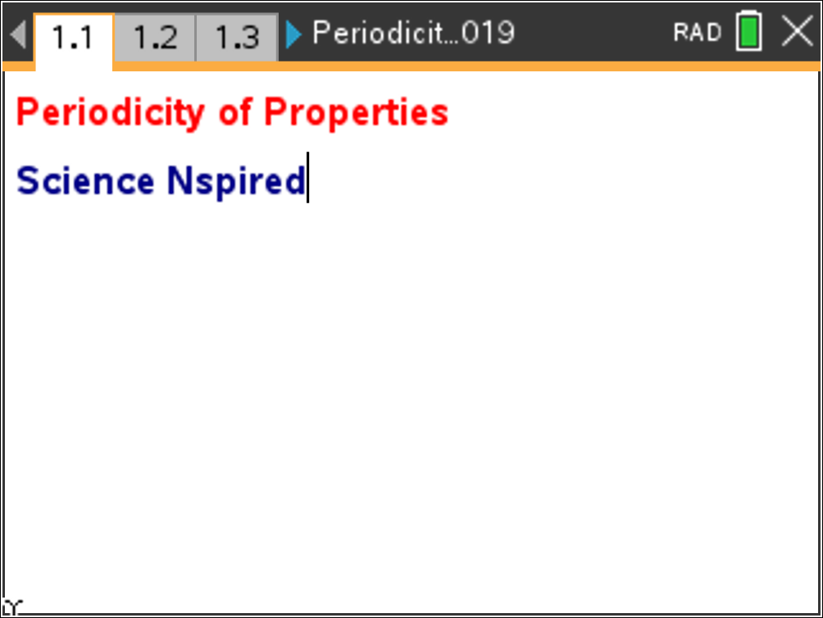

Move to page 1.2.

Page 1.2 contains a Periodic Table that you can use.

Move to pages 1.3 – 1.7.

Early in the Nineteenth Century, scientists noted similarities between elements and tried to find a pattern or relationship between them.
In 1869, Dmitri Mendeleev of Russia and Lothar Meyer of Germany independently arranged the elements in order of increasing atomic mass and noted that these similarities appeared in predictable intervals. At this time, nothing was known of the structure of atoms, and no reasons could be given for the periodic similarities. In 1913, Henry Moseley determined the nuclear charge (atomic number) of the elements, and pointed out that the fundamental order of arrangement of the elements should be based on increasing atomic numbers (Z) instead of increasing atomic mass. In the next few years, theories of atomic structure founded on the work of Rutherford, Bohr, and many other scientists explained the repeated similarities of behavior within the Periodic Table.
The modern Periodic Law can be stated as follows: When the elements are arranged in order of increasing atomic number, similarities of properties occur periodically.
Move to pages 1.8 – 1.11.

1. Who is given credit for creating the first Periodic Table?

2. The first Periodic Table was arranged by ________.

3. Who rearranged the Periodic Table into its current order?

4. When the element are arranged in order of increasing atomic number, similarities of properties ________.

Move to page 2.2. |  |  | 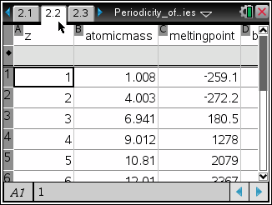
On page 2.2 observe the following data:
- atomic number(Z);  - atomic mass;  - melting point;  - boiling point; |  | - density;  - electronegativity;  - first ionization energy; and  - atomic radius.
Move to page 2.3.

5. The atomic trends in the Lists & Spreadsheets page _________.

Move to pages 2.4 – 2.7.

Move to the Data & Statistics page (page 2.5). The atomic number (Z) is graphed on the x-axis; atomic mass is graphed on the y-axis. Observe the trend, and answer the following questions (from pages 2.6 and 2.7).  6. The relationship between atomic mass and atomic number is _________.  7. The atomic mass increases as the atomic number increases because of the addition of ________. |  |  |  | 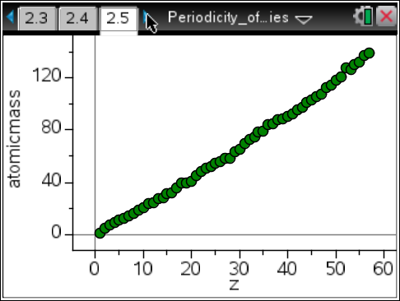
Move to pages 3.2 – 3.11.  Select the y-axis, and choose electroneg. Observe the trend, and answer the following questions (from pages 3.3 through 3.10). |  |  |  | 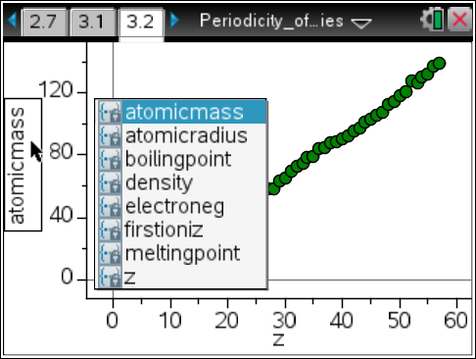
8. There are no electronegativity values for elements 2, 10, 18, 36, and 54 because they are _______.

9. Locate the ‘peaks’ on the graph. The elements that are found on the peaks are part of what group on the Periodic Table?

10. These elements have the highest electronegativity values because they have _______.

11. What elements are found in the ‘valleys’ of the graph?

12. Why would these elements have the lowest electronegativity values?

13. What happens to the electronegativity values as you go down a group?

14. What causes the trend from the previous question?

15. If this graph were turned one quarter turn clockwise, the pattern would mimic ________.

Move to pages 4.1 – 4.11.

Select the y-axis, and choose first ionization energy (firstioniz). Observe the trend on page 4.2, and answer the following questions (from pages 4.3 through 4.10) before moving on to the next procedure.
 | Tech Tip: You may need to scroll down through the list of variables to find firstioniz. After selecting the y-axis, select any location within the list of variables and drag your finger to scroll through the list.
16. The peaks on this graph are elements from what group of elements?

17. This group of elements have the highest first ionization energy because they have the largest ______.

18. The elements found in the valleys on this graph represent what group of elements?

19. This group of elements has the smallest ionization energy because they have the smallest _______.

20. As you move across a period from left to right, the first ionization energy _________.

21. This trend occurs because of increasing __________.

22. As you go down a group, the ionization energy _______.

23. This trend occurs because the electrons are farther from the nucleus causing Zeff to ________.

Move to pages 5.1 – 5.3.

24. The relationships observed in this activity were not evident until 1913 because of the work of ________.

25. In 1913, the Periodic Table was rearranged in order of increasing _________.

26. From studying the graphs of various periodic properties versus the atomic number, it can be stated that these properties ________.

