Heart Rate and Physical Fitness
The circulatory system is responsible for the internal transport of many vital substances in humans, including oxygen, carbon dioxide, and nutrients. The components of the circulatory system include the heart, blood vessels, and blood. Heartbeats result from electrical stimulation of the heart cells by the pacemaker, located in the heart’s inner wall of the right atrium. Although the electrical activity of the pacemaker originates from within the heart, the rhythmic sequence of impulses produced by the pacemaker is influenced by nerves outside the heart. Many things might affect heart rate, including the physical fitness of the individual, the presence of drugs such as caffeine or nicotine in the blood, and the age of the person.
As a rule, the maximum heart rate of all individuals of the same age and sex is about the same. However, the time it takes individuals to reach that maximum level while exercising varies greatly. Since physically fit people can deliver a greater volume of blood in a single cardiac cycle than unfit individuals, they can usually sustain a greater work level before reaching the maximum heart rate. Physically fit people not only have less of an increase in their heart rate during exercise, their heart rate recovers to the resting rate more rapidly than unfit people.
In this experiment, you will evaluate your physical fitness. An arbitrary rating system will be used to “score” fitness during a variety of situations. Tests will be made while in a resting position, in a prone position, as well as during and after physical exercise.
Important: Do not attempt this experiment if physical exertion will aggravate a health problem. Inform your instructor of any possible health problems that might be affected if you participate in this exercise.
Objectives
In this experiment, you will
- Determine the effect of body position on heart rates.
- Determine the effect of exercise on heart rates.
- Determine your fitness level.
- Correlate the fitness level of individuals with factors such as smoking, the amount of daily exercise, and other factors identified by students.

MATERIALS
TI-Nspire handheld or | stepping stool, 45 cm (18 inches) high
computer and TI-Nspire software | dropper bottle with saline solution
data-collection interface | (only for use with the Exercise HRM)
Vernier Hand-Grip Heart Rate Monitor or | stopwatch or clock with second hand
Vernier Exercise Heart Rate Monitor

PROCEDURE
Each person in a lab group will take turns being the subject and the tester. When it is your turn to be the subject, your partner will be responsible for recording the data on your lab sheet.
1. Connect the receiver module of the Heart Rate Monitor to the data-collection interface. Connect the interface to the TI-Nspire handheld or computer.
2. Set up data collection.
- Choose New Experiment from the Experiment menu. Choose Collection Setup from the Experiment menu. Enter 15 as the experiment duration in seconds. Choose the Strip Chart option and select OK.
- Click on the Graph View tab () to view the graph. Choose Y-axis Columns ► Signal from the Graph menu.
- Press Ctrl+D to display the Sensor Console at the bottom of the page.

3. Set up the Heart Rate Monitor. Follow the directions for your type of Heart Rate Monitor.
Using a Hand-Grip Heart Rate Monitor
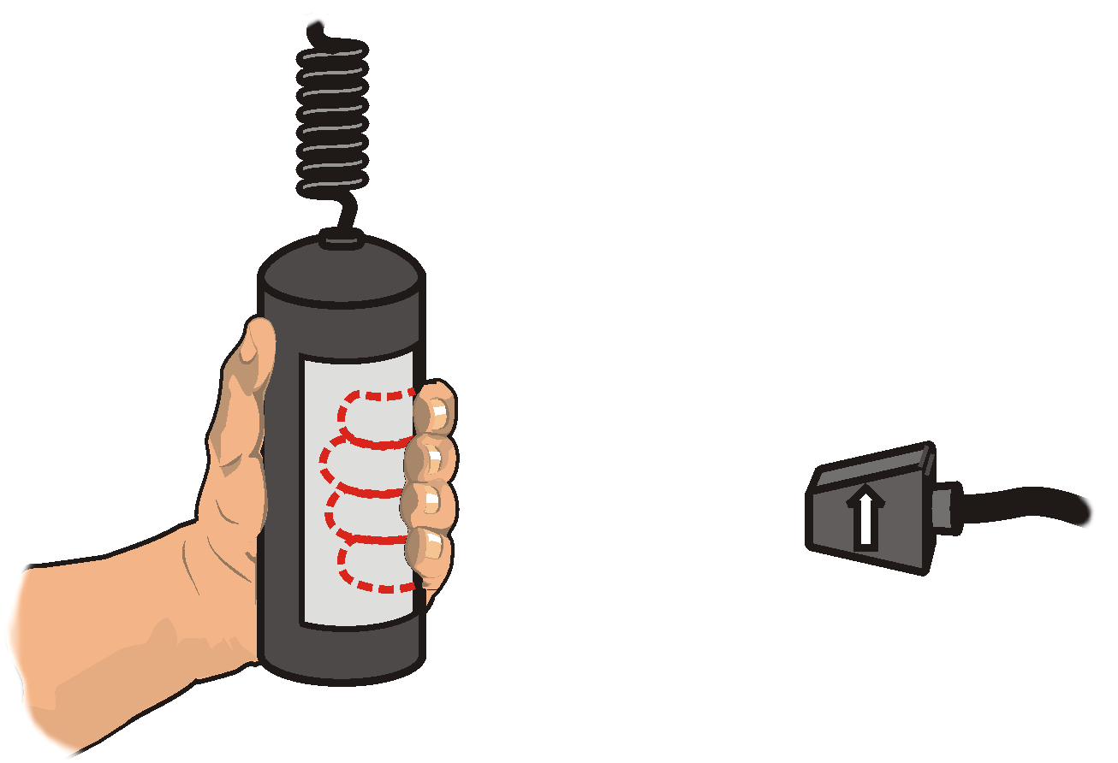
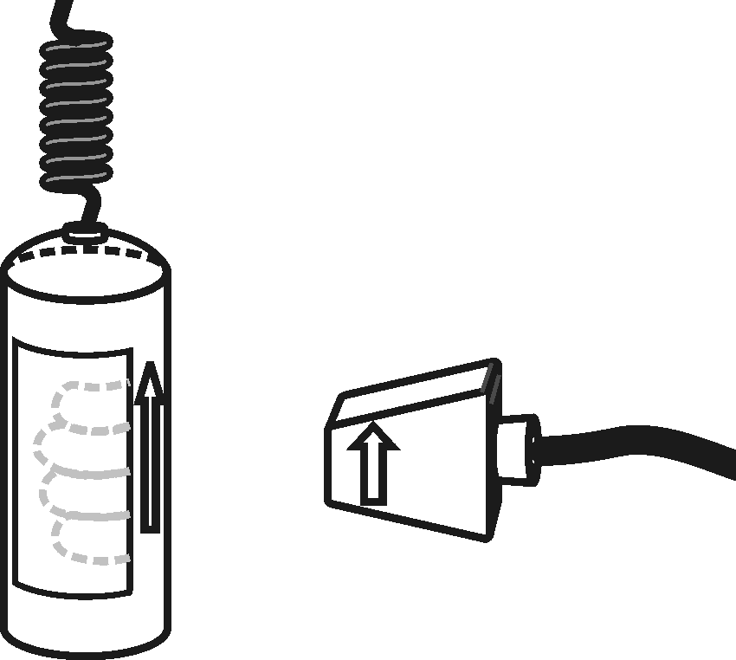
- Grasp the handles of the Hand-Grip Heart Rate Monitor. Place the fingertips of each hand on the reference areas of the handles (see Figure 1).
Figure 1
- The left hand grip and the receiver are both marked with an alignment arrow. When collecting data, be sure that the arrow labels on each of these devices are in alignment (see Figure 2) and that they are not too far apart. The reception range of the plug-in receiver is 80–100 cm, or 3 feet.
Figure 2

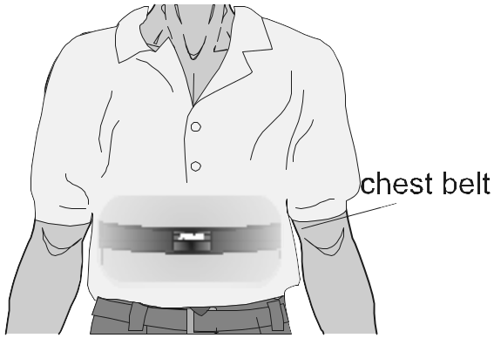
Using an Exercise Heart Rate Monitor
Figure 3
- If you have an older sensor that does not auto-ID, manually set up the sensor.
- Depending upon your size, select a small- or large-size elastic strap. Secure one of the plastic ends of the elastic strap to the transmitter belt. It is important that the strap provide a snug fit of the transmitter belt.
- Wet each of the electrodes (the two textured oval areas on the underside of the transmitter belt) with 3 drops of saline solution.
- Secure the transmitter belt against the skin directly over the base of the rib cage (see Figure 3). The POLAR logo on the front of the belt should be centered. Adjust the elastic strap to ensure a tight fit.
- Take the receiver module of the Heart Rate Monitor in your right hand. Remember that the receiver must be within 80 cm of the transmitter in the Heart Rate Monitor belt.

4. Start data collection. Determine that the sensor is functioning correctly. The readings should be consistent and within the normal range of the individual, usually between 55 and 80 beats per minute. When you have determined that the equipment is operating properly, stop data collection and proceed to Step 5.
5. Collect data.
- Start data collection ().
- Instruct the subject to stand upright for 2 minutes.
- When the 2 minutes have passed, record the subject’s Standing Heart Rate in Table 1.
- Instruct the subject to recline on a clean surface or table for 2 minutes.
- When the 2 minutes have passed, record the subject’s Reclining Heart Rate in Table 1.
- Instruct the subject to quickly stand up and remain standing still.
- Record the subject’s peak heart rate observed after standing as the Reclining to Standing Heart Rate in Table 1.
- Instruct the subject to rest for 2 minutes.
- After the rest period, record the subject’s heart rate as the Pre-exercise Heart Rate in Table 1.
- Instruct the subject to begin the Step Test as describe below.

Step Test
- Place the right foot on the top step of the stool.
- Place the left foot completely on the top step of the stool next to the right foot.
- Place the right foot back on the floor.
- Place the left foot completely on the floor next to the right foot.
- This stepping cycle should take 3 seconds to complete.
- Repeat until the test subject completes 5 steps.

- When five steps have been completed, record the heart rate as the After 5 Steps Heart Rate in Table 1. Quickly move to the next step.
- Instruct the subject to stop. They should remain standing and relatively still.
- With a stopwatch or clock, begin timing to determine the subject’s recovery time. Monitor the heart rate readings and stop timing when the readings return to the pre-exercise heart rate value recorded in Step 5i. Record the recovery time in Table 1.
- Stop data collection ().

6. Repeat Step 5 with a new test subject until everyone in your group has been tested.
DATA
Table 1
Condition | Rate or time | Points
Standing heart rate | beats/min
Reclining heart rate | beats/min
Reclining to standing | beats/min
Heart rate increase after standing | beats/min
Pre-exercise heart rate | beats/min
After 5 steps | beats/min
Recovery time | seconds
Endurance | beats/min
 | Total points:

pROCESSING THE DATA
1. Locate your Standing Heart Rate in Table 2 and record the corresponding fitness point value in Table 1.
Table 2: Standing
Beats/min | Points | Beats/min | Points
60–70 | 12 | 101–110 | 8
71–80 | 11 | 111–120 | 7
81–90 | 10 | 121–130 | 6
91–100 | 9 | 131–140 | 4

2. Locate your Reclining Heart Rate in Table 3 and record the corresponding fitness point value in Table 1.
Table 3: Reclining
Beats/min | Points | Beats/min | Points
50–60 | 12 | 81–90 | 8
61–70 | 11 | 91–100 | 6
71–80 | 10 | 101–110 | 4

3. Subtract your Reclining Heart Rate from your Reclining to Standing Heart Rate to find your Heart Rate Increase after Standing. Record this value in Table 1
4. Locate the row corresponding to your Reclining Heart Rate in Table 4 and use your heart rate increase value to determine the proper fitness points. Record the corresponding fitness point value in Table 1.
Table 4: Reclining to Standing
Reclining heart rate | Heart rate increase after standing
 | 0–10 | 11–17 | 18–24 | 25–33 | 34+
50–60 | 12 | 11 | 10 | 8 | 6
61–70 | 12 | 10 | 8 | 6 | 4
71–80 | 11 | 9 | 6 | 4 | 2
81–90 | 10 | 8 | 4 | 2 | 0
91–100 | 8 | 6 | 2 | 0 | 0
101–110 | 6 | 4 | 0 | 0 | 0

5. Locate your recovery time in Table 5 and record the corresponding fitness point value in Table 1. If your recovery time is greater than 120 seconds, record a value of 6 points.
Table 5: Recovery
Time (s) | Points
0–30 | 14
31–60 | 12
61–90 | 10
91–120 | 8

6. Subtract your Pre-exercise Heart Rate from your After 5 Steps Heart Rate. Record this heart rate increase in the endurance row of Table 1.
7. Locate the row corresponding to the Pre-exercise Heart Rate in Table 6 and use the heart rate increase value to determine the proper fitness points. In Table 1, record the fitness points.
Table 6: Endurance
Pre-exercise  heart rate | Heart rate increase after exercise
Pre-exercise  heart rate | 0–10 | 11–20 | 21–30 | 31–40 | 41+
60–70 | 12 | 12 | 10 | 8 | 6
71–80 | 12 | 10 | 8 | 6 | 4
81–90 | 12 | 10 | 7 | 4 | 2
91–100 | 10 | 8 | 6 | 2 | 0
101–110 | 8 | 6 | 4 | 1 | 0
111–120 | 8 | 4 | 2 | 1 | 0
121–130 | 6 | 2 | 1 | 0 | 0
131+ | 5 | 1 | 0 | 0 | 0

8. Total all the fitness points recorded in Table 1. Determine your personal fitness level using the scale below. Mark your fitness level in Table 1 and on the scale below.
QUESTIONS
1. How did your heart rate change after moving from a standing position to a reclining position? Is this what you expected? How do you account for this?
2. How did your heart rate change after moving from a reclining position back to a standing position? Is this what you expected? How do you account for this?
3. Predict what your heart rate might be if you had exercised for twice the length of time that you actually did. Explain.
4. How does your maximum heart rate compare to other students in your group? Is this what you expected? How do you account for this?
5. Why would athletes need to work longer and harder before their heart rates were at the maximum value?
6. How do you evaluate your physical fitness? Do you agree with the rating obtained from this experiment? Explain.
7. Current research indicates that most heart attacks occur as people get out of bed after sleep. Account for this observation.

Extensions
1. Using a sphygmomanometer or a Vernier Blood Pressure Sensor, learn how to measure blood pressure. Compare a person’s blood pressure when reclining, to that of the same person immediately after standing from a reclined position. Relate the change in blood pressure to the heart rate values measured when going from reclining to standing.
2. Design an anonymous survey to be taken by each member of your class. In the survey, ask questions that you think might influence the test results. Examples might include:
- Did you have more than 6 hours of sleep last night?
- Do you regularly drink caffeinated beverages?
- Gender?
- Age?

3. Try to determine whether any of the variables from your survey show a statistical link to fitness. You may want to use a statistical T-Test to determine whether a relationship between the variable and physical fitness is due to chance.

