Open the TI-Nspire™ document Modeling_with_a_Quadratic_Function.tns.  You will determine the equation of a quadratic function that models the path of a basketball. Based on your equation, you will solve problems related to the path of the basketball. | 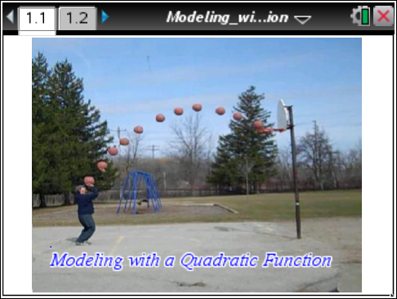

Move to page 1.2.
The scale of the graph is 1 meter = 2 tick marks.
1. Graph the parent quadratic function, f(x) = x². Transform the parent function so that it matches the path of the basketball. What is the equation of the quadratic function that matches the path of the basketball?

2. Attending to precision is important in mathematics. At the distance this picture was taken and with the scale provided, is it reasonable to get results that are correct to the nearest millimeter, centimeter, decimeter, or meter? In other words, how many decimal places should you keep?

- In this activity, the horizontal distance traveled by the basketball is the independent variable. What is the dependent variable?

4. Determine the maximum height of the basketball in meters. Explain your reasoning.
Note: Two tick marks on the axes represent 1 meter.

5. Visualize a point on the ground directly beneath the ball when it reaches its maximum height. How far is this point from the person shooting the basketball? Explain your reasoning.

- How high is the ball when it is a horizontal distance of 2 meters from the person shooting the basketball? Use your equation and explain your reasoning.

- If the ball follows the path modeled by your quadratic function, and the basket is not there, how far will the ball land from the person on the left? Explain your reasoning.

Extension questions
- How far, horizontally, from the person shooting the basketball is the ball when the ball reaches a height of 3.7 m?

- How far is the person standing from the basket? Explain your reasoning.

- The equation y = −0.1(x – 8)² + 9 describes the path of another basketball. The person throwing the ball is positioned on the y-axis. How is the path of this ball similar, and how is it different from the path of the ball in the activity? (Assume the scale is the same.)

- What assumptions have been made when creating this model?

