Open the TI-Nspire document A_Magnetic_Attraction.tns.  You have probably already observed that a magnet will not pick up a nail or stick to the door of a refrigerator until the magnet is brought close enough to attract the other object. How close you need to have the magnet depends on the strength of the magnet and its magnetic field. In this activity, you will measure how the strength of the field changes as the distance from the magnet changes. | 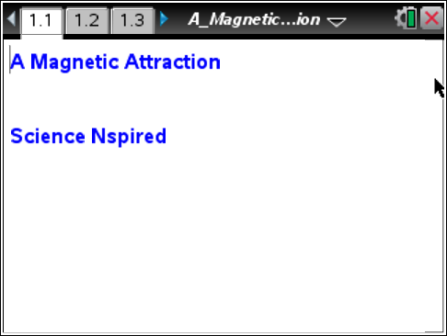

Move to page 1.2.
1. Read the first page. Then place a meterstick on a flat, level surface. Place the Vernier Magnetic Field Sensor at the zero end of the meterstick. Orient the sensor so the white dot is pointing along the axis of the meterstick. Tape the sensor in place so that it does not move during the experiment.
Move to page 1.3.  2. Page 1.3 is a blank DataQuest application. Connect the Vernier Magnetic Field Sensor to an EasyLink interface (if using a handheld) or a Go!Link interface (if using a computer). Then connect the EasyLink or Go! Link to your handheld or computer.  3. Set the units for the sensor to mT. You can change the units from the Sensors menu (Menu > Experiment > Set Up Sensors > Change Units > Magnetic Field). |  | 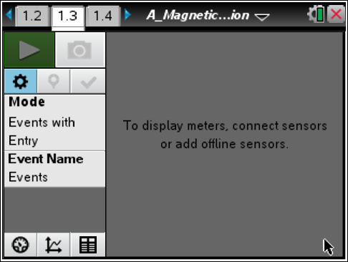
4. Make sure there are no magnets near the sensor and then zero the sensor (Menu > Experiment > Set Up Sensors > Zero).
5. Next, set up the data collection software to Events with Entry mode (Menu > Experiment > Collection Mode). Change the name of the event to “Distance” and units to “cm.”
6. Take care to keep the same orientation between the magnet and the sensor for all measurements. Your magnet should have its South pole facing the white dot of the sensor, with the axis of the magnet (the line connecting the North and South poles) parallel to the meterstick. Readings will be collected every 1 cm starting from the starting point. Your teacher will tell you where to place the magnet for the initial measurement. Select the Start Collection to start collecting data, and then click on the Keep Button to keep the data collected.
7. Move the magnet to the next mark and repeat the data collection, taking care to maintain the same orientation between the magnet and the sensor.
8. Repeat the data collection eight more times. Once you have collected ten data points, click on Stop Data Collection and disconnect the sensor.
Move to page 1.4.
9. On the spreadsheet, set Column A to display the distance data you collected (press h and select the variable from the list). Then set Column B to display the magnetic field strength data you collected (press h > Link To: select the variable from the list).
Move to page 1.5.
10. Page 1.5 contains a blank Graphs & Geometry application. Use this application to create a scatter plot of the data. Press Menu > Graph Type > Scatter Plot. Then press h > Link To: to select the distance variable for x, and repeat to select the magnetic field strength variable for y. Then press ·. To adjust the scale for the graph, press Menu > Window/Zoom > Zoom – Data.
Return to page 1.4.
11. Highlight Columns A and B. Then press Menu > Statistics > Stat Calculations > Power Regression. This function tells the handheld to calculate an equation of the form y = ax^{b} that best fits the highlighted data. Select OK to carry out the regression.
Move to page 1.5.
12. Change the plot type to Function (Menu > Graph Type > Function). Select f1(x) from the function list at the bottom of the screen and press · to plot the regression equation on the graph. Record this equation on a separate sheet of paper.
Part 2: Building a Model for the Relationship
Move to page 1.5.
1. Hide the graph of f1(x) using the Show/Hide tool (Menu > Actions > Hide/Show). Click on the graph to hide it. Then use the Trace tool (Menu > Trace > Graph Trace) to determine and mark the coordinates of the leftmost point. As established in Part 1, magnetic field strength and distance are related by an inverse-cube law. That is, the equation relating field strength B and distance d takes the form , where k is a constant. Use substitution to find the value of k that makes this equation true for the leftmost point on the graph. Record this value of k on a separate sheet of paper.
2. Place a text box (Menu > Actions > Text) somewhere on the page. Then type the value of k that you calculated into this text box and press ·. Then, click once on the value (it should be highlighted in gray) and press h. Select Store Var and then type k and press ·. This will assign the number in the text box to the variable k.
3. In the f2(x) line of the function bar on page 1.5, type k/x³ and press ·. (You may need to change the graph type to Function in order to see the function bar.) A graph of the estimated equation relating magnetic field strength to distance should appear on the screen.
4. You can vary the value of k by editing the text box. Vary the value of k to produce a better fit to the data. Record your best-fit value of k on a separate sheet of paper.
Part 3: Determining the Magnetic Moment
The equation relating magnetic field strength (B) to distance (d) is given below ( is the magnetic permeability constant, and is the magnetic moment of the field).
In Part 2, you approximated this equation with the function , and then calculated the value of k for the data. You will now use this value of k to calculate the magnetic moment of the field using the following equation:
Move to page 1.6.  5. This page contains a Calculator application. The magnetic permeability constant,, is equal to . Define the variable mu0 as as shown. You should make sure to use the := notation when you define the value of the constant. | 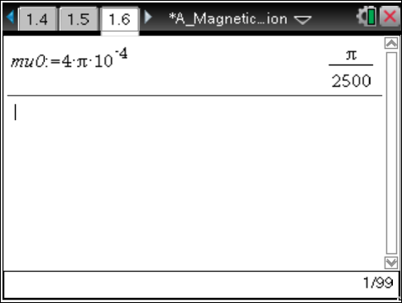
6. Next, use the nSolve function to solve the equation above for . Enter the expression as shown. Record the calculated value of on a separate sheet of paper. (In this equation, and are constants.) | 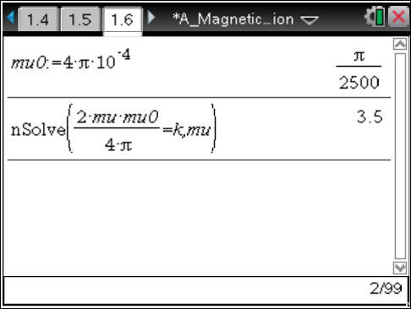
Answer the following questions here.
Q1. How well do the results of the power regression support the “ideal” relationship between field strength and distance: ? Explain your answer.

Q2. What is the value of k that you calculated from the data?

Q3. What is the value of that you calculated from the data?

Q4. Electric currents produce magnetic fields. For a single loop of wire, the magnetic moment of the field is , where is the magnetic moment, I is the current, and A is the area of the loop through which the current flows.
Suppose the magnetic field in this activity were produced by a round magnet with a radius of 29 mm. What current would be required to produce an equivalent magnetic field in a loop of wire with the same radius as the magnet? (Note: The units of that you calculated are m² • A.)

