Press . Change the fourth line to SEQ for sequence mode.  Press □. You have the capability to define 3 sequences, u, v, and w. | 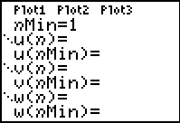
Consider the sequence where a₁ = 1 and a_{n} = 2 * a_{n–1}.  To enter this sequence and generate a table of values. nMin will be 1 because the subscript of our initial term is a₁. The u(n) notation replaces the a_{n} notation. Define u(n) as shown. Set u(nMin) as 1 because a₁ = 1. | 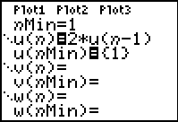
Press   to view the table.
1. What appears to be happening in this pattern?

2. Is the value of each term changing at a constant rate, a slowing rate or an increasing rate?

3. What function produces the same table?

A sum of terms in a sequence is a series.  Next you will find the partial sums of the terms in the sequence u(n). This will be defined like a sequence where the sum for the nth term, v(n), is the sum for the previous term, v(n–1), plus the next term in the sequence u(n), which is 2 * u(n – 1). Define as shown. | 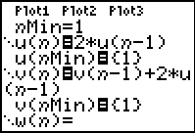
Press   to view the table.
4. What is the relationship between the values in u(n) and v(n)?

5. What is the sum of the first six terms?
6. Scroll down in the table. Do you notice anything more about the sum in column v(n)? Do the values appear to be stabilizing? Explain.

Consider the sequence where a₁ = 5 and  a_{n} = 0.1 * a_{n – 1}.  To enter this sequence and generate a table of values. nMin will be 1 because our initial term is a₁. The u(n) notation replaces the a_{n} notation. Define u(n) as shown. Set u(nMin) as 5 because a₁ = 5. | 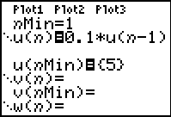
Press   to view the table.
7. What appears to be happening in this pattern?

8. Is the value of each term changing at a constant rate, a slowing rate or an increasing rate?

9. What function produces the same table?

Find the sum of the terms in the sequence u(n). This will be defined like a sequence where the sum for the nth term is the sum for the previous term, v(n–1), plus the next term in the sequence u(n). Define as shown. | 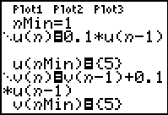
Press   to view the table.
10. What is the relationship between the values in u(n) and v(n)?

11. What is the sum of the first six terms?
12. Do you notice anything more about the sum in column v(n)?

13. Does it appear to be converging? That is, does it appear to be approaching a value that it will never exceed?

Return to □. Right arrow to highlight the equals sign after u(n). Press  to turn the sign off so that when you graph you will only be graphing the sums from v(n). | 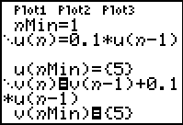
Press . Arrow down to set the Xmin, Xmax, Ymin, and Ymax as shown at the right. | 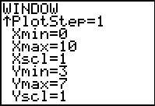
Press  and .
14. What is happening to the sum as n increases? Is there a value that the sum will never reach?

15. Investigate other series. When do series continue to take on larger and larger values, and when do series converge?

