Open the TI-Nspire document Foci_Definition_ of_Ellipses_and_Hyperbolas.tns.  In this activity, you will utilize sliders and will drag a point to explore and discover some of the properties of ellipses and hyperbolas. | 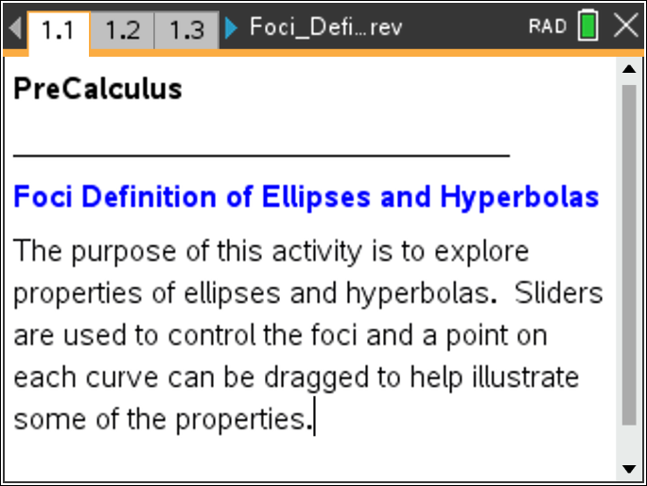

Move to page 1.3. | Press / ¢ and / ¡ to navigate through the lesson.
1. Points and are called the foci (plural of focus) of the ellipse pictured. Point is the center of the ellipse, and point lies on the ellipse.
a. Use the sliders to select arbitrary values for and Set the constant sum with the slider Set the foci with the slider Click on point P, and drag it around the ellipse. Describe what happens to:
- points and .
- distances and .
- the sum .

b. Use the slider to select an arbitrary value for . Click on the slider arrows that correspond to , and describe what happens to:
- the graph of the ellipse.
- points and .
- distances and .
- the sum .

c. As you click the slider, observe what is happening to points and on the graph. What is the relationship between the variable c and points and

d. Use the slider to select an arbitrary value for . Click on the slider arrows that correspond to and describe what happens to:
- the graph of the ellipse.
- points and .
- distances and .
- the sum .

e. Determine the relationship between the variable d and distances and
2. Based on your observations in Question 1, fill in the blanks in the following definition of an ellipse:

An ellipse is the set of points in a plane such that the _______ of the distances from two fixed points and called the foci, is _______________.

3. Click the sliders to set c = 4 and d = 10. Click and drag point P so that it lies on the x-axis at with and
a. What is the length of the semi-major axis?

b. What relationship exists between and

c. What is the relationship between the length of the major axis and the sum of the distances from the foci to a point on the ellipse?

4. Set c = 4 and d = 10. Click and drag point P so that it lies on the y-axis at and
a. What are the lengths of the semi-minor axis, and

b. What relationship exists among and
Among and

5. The shape of an ellipse is determined by its eccentricity, a number that indicates how elongated a conic section is. The eccentricity, , of a horizontal ellipse is defined as where c is the distance from the center of the ellipse to a focus, and a is the horizontal distance from the center to the vertex.
a. Continue with d = 10. As you click on the c-slider, describe what happens to the shape of the ellipse as c gets larger and as c gets smaller and why.

b. What is the shape of the ellipse if c = 0? Explain your answer.

c. Using the information above, give the range of values for e, the eccentricity of an ellipse.

Move to page 2.2.

6. Points and are called the foci of the hyperbola pictured. Point is the center of the hyperbola, and point lies on the hyperbola.
a. Use the sliders to select an arbitrary value for both and Set the constant difference with the slider Set the foci with the slider Click on point P, and drag it around the graph of the hyperbola. Describe what happens to:
- points and .
- distances and .
- the difference .

b. Use the slider to select an arbitrary value for . Click on the c-slider, and describe what happens to:
- the graph of the hyperbola
- points and .
- distances and .
- the difference .

c. As you click the slider, observe what is happening to points and on the graph. What is the relationship between the variable c and points and

d. Use the slider to select an arbitrary value for . Click on the d-slider and describe what happens to:
- the graph of the hyperbola.
- points and .
- distances and .
- the difference .

e. Determine the relationship between the variable d and distances and
7. Based on your observations in Question 6, fill in the blanks in the following definition of a hyperbola.

A hyperbola is the set of points in a plane such that the absolute value of __________________ of the distances from two fixed points and called the foci, is _______________.

8. Click the sliders to set c = 5 and d = 8. Click and drag point P so that it lies on the x-axis at with and
a. The line segment of length 2a that has its endpoints at the vertices of the hyperbola is called the transverse axis. What is the length of the transverse axis?

b. The line segment of length 2b that is perpendicular to the transverse axis at its center is called the conjugate axis. For a hyperbola, the lengths , , and are related by the formula What is the length of the conjugate axis?

9. The hyperbola has two branches that approach its linear asymptotes.
a. The two asymptotes will intersect at the center of the hyperbola. What point will lie on both asymptotes for the hyperbola on Page 2.2?

b. Starting from the origin, as the asymptote increases by b units vertically, it will also increase a units horizontally. Represent the slope of one of the asymptotes in terms of a and b. What is the slope of the asymptote for the hyperbola on Page 2.2?

c. As the other asymptote decreases by b units vertically, it will also increase by a units horizontally. Represent the slope of the second asymptotes in terms of a and b. What is the slope of the second asymptote for the hyperbola on Page 2.2?

d. Write the equations for the two asymptotes of the hyperbola on Page 2.2.

e. Press /G to open the function entry line, and enter your two equations for the asymptotes of the hyperbola. Check to see if your equations appear to be asymptotes for the hyperbola. If not, re-calculate and re-graph them.
10. The shape of a horizontal hyperbola is determined by its eccentricity, where c is the distance from the center of the hyperbola to a focus, and a is the horizontal distance from the center to a vertex. Use the slider to select an arbitrary value for . Click on the c-slider, and notice what happens to the graph of the hyperbola as c gets larger and as c gets smaller. Use this information to give the range of values for e, the eccentricity of a hyperbola.

