Open the TI-Nspire document  Vector_Components_and_Vector_Addition.tns.  Many quantities in physics such as displacement, velocity, force, and momentum are described by both a magnitude and a direction. These vector quantities require special skills to manipulate. In this activity you will explore concepts related to the components of a vector and the addition of vectors to find a resultant. | 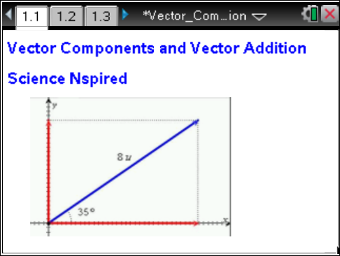

Move to pages 1.2–1.4.  1. Read the introductory material on pages 1.2, 1.3, and 1.4. | Press / ¢ and / ¡ to navigate through the lesson.  To change the value of a length or angle slider you may either click on the arrows, or you may click the number and change it directly.
Move to page 1.5. Answer the following questions here.  2. Use the slider controls to adjust the magnitude (l) and the direction (θ) of the vector. As the vector changes, observe the corresponding changes in the x and y components of the vector. You will be asked to describe patterns that express the relationship between a vector and its components. | 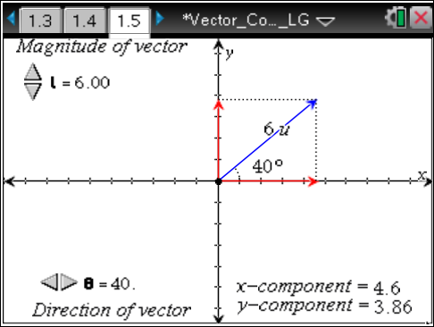
Q1. With the vector in the first quadrant, change the length of the vector while keeping the angle constant. Describe what happens to the x and y components of the vector as you increase and decrease its length.

Q2. Double the length of the vector. How do the x and y components change as a result of the increase in length?

Q3. Keep the length of the vector constant and manipulate the angle to move the vector within the 1st quadrant. What happens to the components as the vector moves toward the x-axis (decreasing the angle)?

Q4. What happens to the components as the vector moves toward the y-axis (increasing the angle)?

Q5. At what angle are the two components equal?

Q6. Set the length of the vector to 8 units and the direction to 30°. Write the values of the x and y components below.
x component = ______ |  | y component = ______
Q7. The y component can be drawn from the tip of the x component so that the two components form the sides of a right triangle. The vector will be the hypotenuse. Using trigonometry and this picture, write equations for calculating the x and y components of a vector with length L and angle θ. Verify that your equations work by using them to calculate the components of the vector in the previous question. |  |  | 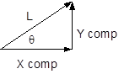
x component = ______ | y component = ______
Q8. Increase the angle of the vector so that it is greater than 90° and is in the 2nd quadrant. Move the vector into the 2nd quadrant, and describe what happens to the x and y components.

Q9. Set the vector length to 8 units and the direction to 115°. Write the values of the x and y components below. Verify that your equations for calculating the components give you the same results.
x component = ______ | y component = ______
Q10. What happens to the x and y components as you move the vector into the third and fourth quadrants?

Move to pages 2.2 and 2.3.
3. In many physics problems, vectors are added to produce a resultant vector. Read the background information describing vector addition on pages 2.2 and 2.3.
Move to page 2.4. Answer the following questions here.  Q11. Set vector 1 to a length of 5 units and a direction of 20°. Set vector 2 to a length of 3 units. Describe the resultant vector when you make the direction of vector 2 the same as vector 1 (20°). |  |  | 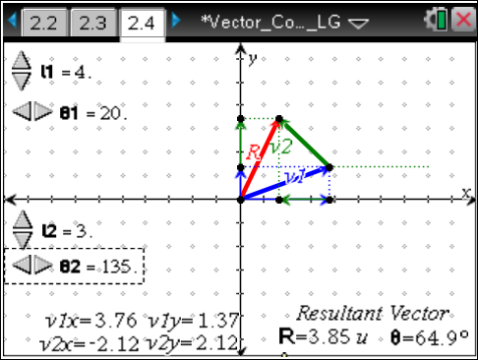
Q12. Change the direction of vector 2 so that it points opposite to vector 1 (θ₂ = 200°). Describe the resultant vector.

Move to page 3.2. Answer the following questions here.  Q13. When two vectors are perpendicular, what equation relates the length of their resultant vector, R, to the lengths of the two vectors, l₁ and l₂? Show that this equation works when l₁ = 4 units and l₂ = 3 units. |  |  | 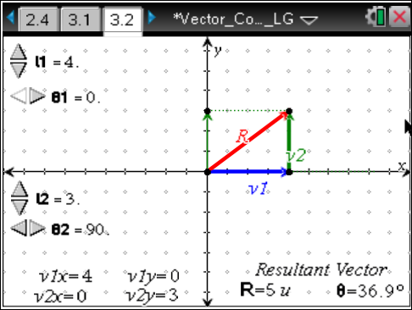
Q14. What equation can be used to calculate the angle of the resultant vector using l₁ and l₂ (think about trigonometry)? Show that this equation works when l₁ = 4 units and l₂ = 3 units.

Q15. Adjust the length of vector 2 until it is the same as the length of vector 1, but keep θ₁ = 0° and θ₂ = 90°. Observe the magnitude and direction of the resultant vector. Show how the magnitude and direction are calculated using the equations you identified above.

Move to page 4.2. Answer the following questions here. |  |  | 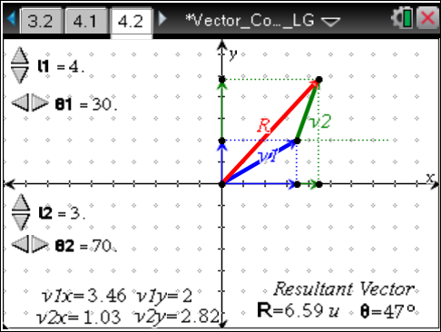
Q16. Set vector 1 to 4 units at 20°. Set vector 2 to 3 units at 70°. Record the x and y components of each vector below and then add each column to get the x and y components of the resultant. Calculate the magnitude and direction of the resultant vector using the x and y components. Show your work below. Verify that your calculation matches the magnitude and direction displayed in the simulation.
 |  |  |  | Show your work.
  Vector | x component | y component
  4 units at 20°
  3 units at 70°
  Resultant Vector
Q17. Set vector 1 to 3.5 units at 30°. Set vector 2 to 2 units at 145°. Record the x and y components of each vector below and then add each column to get the x and y components of the resultant. Calculate the magnitude and direction of the resultant using. Show your work below. Verify that your calculation matches the magnitude and direction displayed on the simulation.
 |  |  |  | Show your work.
  Vector | x component | y component
  3.5 units at 30°
  2 units at 145°
  Resultant Vector
Q18. Make up your own vector addition problem. Complete the table below. Calculate the magnitude and direction of the resultant vector. Show your work below. Verify that your calculation matches the magnitude and direction displayed on the simulation page. (Note: If the x component of the resultant vector is negative, you will need to add 180° to your calculated angle to match the direction.)
 |  |  |  | Show your work.
  Vector | x component | y component
  ____ units at ____°
  ____ units at ____°
  Resultant Vector

