Open the TI-Nspire document energy-skate-park.tns.
In this simulation, you will observe the changing potential and kinetic energies of a skateboarder-celestial body system as she moves over a track with negligible friction. You will also explore the relationship between the system’s potential and kinetic energy, and how they affect the total energy of the system. Finally, you will explore the impact of friction on these potential and kinetic energies.
Read the information on page 1.1.
Move to page 1.2.
To start the simulation, select and drag the skateboarder up to the top left side of the track. Then, release him. You will see the skateboarder moving up and down along the skateboarding track on Earth. The skater’s motion follows a predictable path:
- The skater starts from a stationary position.
- The skater’s direction of motion changes.
- The downward motion of the skater momentarily becomes horizontal at the bottom of the skating ramp, and then changes direction in an upward direction.
- The skater nears the top of the skating ramp on the other side, momentarily stops, then changes direction and starts moving again.
- The downward motion of the skater momentarily becomes horizontal at the bottom of the skating ramp, and then changes direction in an upward direction.
- The skater reaches the top of the skating ramp where he originally started, momentarily stops, then it resumes a new cycle of movement.

Part 1: Exploring Potential Energy
- Wait until the skateboarder reaches the top part of the ramp and select the Pause button . Your screen should now look like this. In this position the skateboarder isn’t moving, but that doesn’t mean the skateboarder doesn’t have any energy. In fact, the skateboarder-celestial body system has potential energy (PE).

Potential energy (PE) is based on the mass (m) of the skateboarder, the height (h) above the bottom of the ramp, and the acceleration due to gravity (g) for the celestial body he is on. The potential energy equation is PE = m•g•h. | 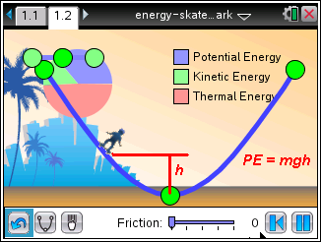
- Select the Play button so the skateboarder starts moving. As the skateboarder moves, her potential energy is converted to kinetic energy (KE), or the energy of motion as her position changes along the track and the velocity changes. The maximum amount of kinetic energy the skateboarder can have is entirely dependent on the amount of potential energy of the system.
You saw in the equation for the PE that there are three variables, mass (m), height (h), and acceleration due to gravity (g). In this simulation you can modify h and g.
Grab and drag the bottom green point of the skating ramp and shorten its height to decrease the magnitude of h.

Q1. How does shortening the height of the ramp change the potential energy of the system? How does the decreased height affect its kinetic energy? What happens when h = 0?

- Restore the original skating ramp by selecting the Undo button . Then start the simulation by dragging and dropping the skater at the top of the ramp. Now vary the acceleration due to gravity by changing celestial bodies for the system to see the effect on the potential energy. Select the Gravity button once to change the force of gravity from the Earth to the Moon. The Moon has one-sixth the force of gravity of Earth, so the value of g will be different than that of the Earth.

Q2. What happened to the skateboarder’s motion when you switched from the Earth to the Moon? What does this tell you about the potential energy that skater has in the skater-Moon system? Compare the acceleration due to gravity g_{E} on Earth and g_{M} on the Moon.

- Restore the original skater to Earth and restart the simulation. Quickly select the Gravity button twice to change the scene from Earth to Jupiter. Jupiter’s force of gravity is 2.5 times that of Earth.

Q3. What happened to the skateboarder’s motion when you switched from the Earth to Jupiter? What does this tell you about the potential energy that skater has in the skater-Jupiter system? Compare the acceleration due to gravity g_{E} on Earth and g_{J} on Jupiter.

Part 2: Exploring Kinetic Energy
- Reset the simulation so that the ramp is in the standard shape and the acceleration due to gravity is for Earth. Start the simulation to observe the motion of the skateboarder. | 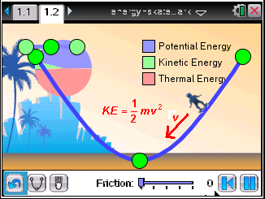
The Kinetic Energy (KE) of the skateboarder is based on two variables, the skateboarder’s mass and her velocity (v). The mass of the skateboarder doesn’t change, but the speed does. This means that the KE changes, too.

- This graph shows the changing KE for the skateboarder. At the top of the ramp, before he starts moving downward, the skateboarder has zero KE, due entirely to the fact that he is not moving. At the bottom of the ramp, the skateboarder has maximum KE because he is moving at the fastest speed. | 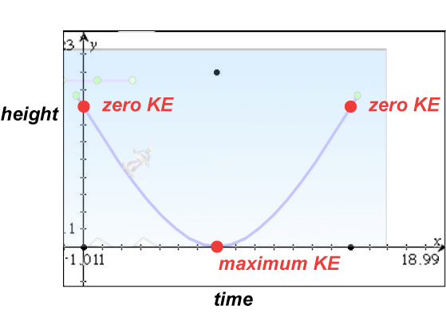
Q4. At the top of the ramp, where the skateboarder has zero KE, what is the potential energy of the system?

Q5. At the bottom of the ramp, where the skateboarder has maximum KE, what is the potential energy of the system?

Q6. At what part of the skateboarder’s motion is KE converted back to PE?

- Now change the setting from the Earth to the Moon and then to Jupiter. Note the changes to the speed in going from Earth to Moon and Earth to Jupiter.

Q7. In which system is the maximum KE the greatest, the Earth, the Moon, or Jupiter?

Q8. In which system is the maximum KE the least, the Earth, the Moon, or Jupiter?

Part 3: Exploring the Total Energy
- You’ve seen how the potential and kinetic energies of the systems change for the skateboarder. The two main areas you’ve explored are the places where the potential energy is at a maximum and the kinetic energy is at a minimum, or the potential energy is at a minimum and the kinetic energy is at a maximum. But between these extremes are the places along the ramp where the Total Energy (TE) of the system is equal to the sum of the potential and kinetic energies.
TE = PE + KE
- This graph shows the changing values for the potential energy (solid line) and the kinetic energy (dashed line) of the system. You can use this graph to find the Total Energy (TE) at any point on the ramp. | 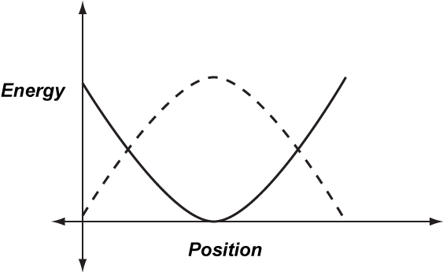
Q9. Identify several different Position points and find the values of the corresponding Energy coordinates for both PE and KE. Use a ruler to measure the height of each Energy value. Add the two values for PE and KE to find TE. What do you notice about the TE for any positions along the curve?

- The law of conservation of energy states that the total energy in a system is constant. At any point along the track, the skateboarder has varying values for PE and KE, but at all points along the ramp the sum of PE and KE is constant.

Q10. Suppose that energy conservation didn’t occur. Describe how this could affect the motion of the skateboarder.

Part 4: Exploring the Impact of Friction
- Restart the simulation with the standard ramp and acceleration of gravity for the Earth. You’ll notice that the motion of the skateboarder goes back and forth continuously and would continue this way indefinitely. In reality, you know that a skater would eventually come to a stop because of the force of friction between the skateboard and the ramp. Friction is a damping force that, in effect, slows things down.

- Select the slider that controls friction. It is in the bottom center of the screen. Drag the slider slowly to the right. | 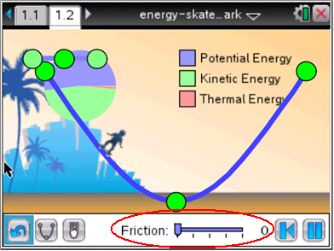
Q11. What happens to the motion of the skateboarder as the friction increases?

- As the skateboarder goes down the ramp, potential energy is converted to kinetic energy. Because of friction, some of the energy in the system is converted to heat energy. Once the kinetic energy is converted to heat, the energy cannot be converted back to the potential or kinetic energy in the system.

Q12. Once the skateboarder comes to a stop due to friction, describe the energy needed to have the skateboarder resume moving up and down on the ramp.

