Open the TI-Nspire document Stream_Erosion.tns.  How does the slope of the earth’s surface affect the flow rate of runoff? How does the flow rate of water affect its erosive force? In this activity, you will investigate the force of moving water on the earth’s surface and discover the relationship between the flow rate of water and its erosive power. |  |  |  |  |  | 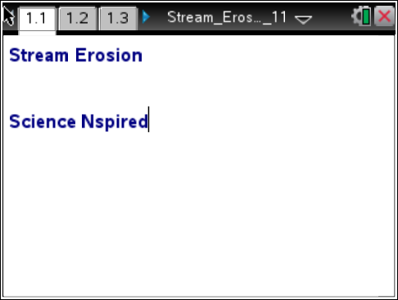
When rock particles are moved by air, water, or ice, this is called erosion. Deposition occurs when the force of the water is not large enough to continue the momentum of the rock particles. Flow rate is the measurement used to describe the speed of moving water. The greater the flow rate, the greater the force of the moving water.

Move to pages 1.2 and 1.3. Answer questions 1 and 2 below and/or in your .tns file.
Q1. When the slope of a ground increases, the flow rate of a stream _________.

A. increases |  |  | B. decreases |  | C. stays the same
Q2. When the flow rate of a stream increases, the size and amount of rock particles it erodes________.

A. increases |  |  | B. decreases |  | C. stays the same
Move to page 1.4.  1. After reading the instructions on page 1.4, close the directions box by selecting .  2. Select the up and down arrows of the River Angle slider to change the slope of the stream bed. Then, select the play button. Make observations on how the slope (angle of stream bed) affects the water’s ability to carry away the rock particles (designated as brown squares). |  |  |  |  |  | 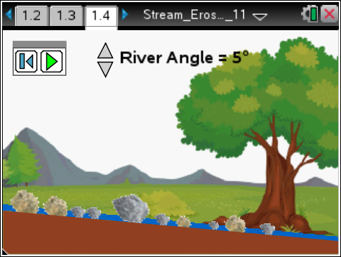
 | Tech Tip: To read the directions again, you can select Menu or  > Watersheds > Directions. You may need to back-out to the main Tools Menu to see the desired menu option.
Move to pages 1.5 – 1.11. Answer the questions 3-9 below and/or in your .tns file.
Q3. At what angle was the flow rate of the stream strong enough to erode all of the rock particles?

Q4. Which size of rock particle was deposited first when the flow rate of the water was decreased?

A. large |  |  | B. medium |  | C. small
Q5. What happened to the flow rate as the angle (slope) of the stream bed was decreased?

A. The flow rate increased. |  | B. The flow rate decreased. |  | C. The flow rate stayed the same.
Q6. What happened to the number of rock particles that were eroded as the flow rate increased?

A. More eroded. |  |  | B. Less eroded. |  | C. Erosion didn’t occur.
Q7. In order for the flow rate to increase, what has to happen?

Q8. In order for larger rocks to be eroded, what has to happen to the flow rate?

Q9. What force is causing the water to flow?

