Problem 1 – Size and Location of Sides and Angles
First, create, label, and measure a triangle
- Construct a triangle using the Triangle tool (found by pressing p).
- Label the vertices using the Alph-Num tool (found by pressing s).
- Measure all three angles using the Measure > Angle (found by pressing s).
- Measure all three sides using the Measure > D. & Length tool (found by pressing s).

Now, grab and drag a vertex of the triangle to change the angle measures and side lengths.

1. Where is the largest angle of the triangle located relative to the longest side?

2. Where is the smallest angle of the triangle located relative to the shortest side?

Save the file as TRIANGLE.

3. List the angles in order from smallest to largest.
a. | 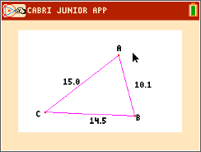 | b. | 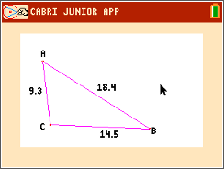

4. List the sides in order from shortest to longest.
a. | 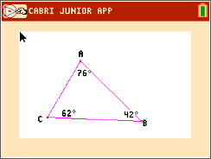 | b. | 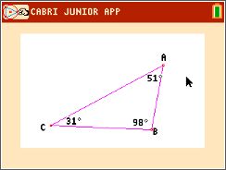

Problem 2 – The Isosceles Triangle Theorem
Open the file ISOSTRI1 which shows an isosceles triangle. Measure all three angles using the Measure > Angle tool.
5. At the right, make a sketch of your triangle
with the side lengths and angle measures
labeled.

Drag a vertex of the triangle to explore what happens to the angle measures.
6. Complete this statement:
If two sides of a triangle are congruent, then ______________________________.

Open the file ISOSTRI2 which shows another isosceles triangle. Measure all three sides using the Measure > Length tool, and then drag a vertex to explore.
7. Complete this statement:
If two angles of a triangle are congruent, then ______________________________.
Problem 3 – Types of Angles in a Triangle
Open the file TRIANGLE you saved in Problem 1.
8. Drag a vertex of the triangle and classify the types of angles that exist (acute, right, obtuse).
∠A | ∠B | ∠C

9. Can a triangle have three acute angles? Make a sketch to support your answer.

10. Can a triangle have three right angles? Make a sketch to support your answer.
11. Can a triangle have three obtuse angles? Make a sketch to support your answer.

