Open the TI-Nspire document Coulombs_Law.tns.  All matter is composed of charged particles. Charges come in two varieties: positive and negative. Many basic properties of matter result from the interactions and forces between these two different kinds of charges. In this activity you will explore Coulomb’s law, which describes how the force between two objects is related to their charges and the distance separating them. The standard unit of electric charge is defined as the Coulomb (C). | 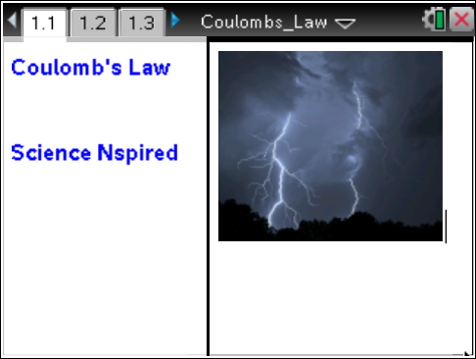
Move to page 1.2.  1. Read the information on page 1.2 before moving to the simulation on page 1.3. On the simulation page, there are sliders that you can use to set the amount and the sign of the charge (q) on each of the balloons. The amount of charge is shown as multiples of 10 µC (1 × 10^{–5} Coulombs). You can move either of the balloons toward or away from the other using the Position sliders. Arrows attached to the balloons represent the force they exert on each other. A play button on the screen allows the charges to move under the influence of the force. The reset button restores the page to its initial settings. Observe the changes in the magnitudes and directions of the forces as you make changes on the screen. | Press / ¢ and / ¡ to navigate through the lesson.  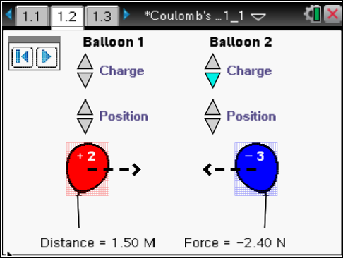
Move to page 1.3. Answer the following questions here.
Q1. Give both balloons a large positive charge. Describe the directions of the forces that result.

Q2. Press the play button and describe what happens to the balloons and to the forces they exert on each other. (Press the pause button and then the reset button before replaying.)

Q3. Give one balloon a negative charge by clicking on the down arrow until the number becomes negative. How does this change the directions of the forces.

Q4 Press the play button and describe what happens to the balloons and to the forces they exert on each other.

Q5. Describe the directions of the forces when both balloons are negatively charged.

Q6. Give both balloons a charge of +1. Separate the balloons by a distance of 1 m. Record the magnitude of the force. In the next several questions, you will compare other forces to this one.

F₁ = _____ N
Q7. Change the charge of Balloon 1 to +2. Record the new force as F₂. Calculate the ratio of F₂:F₁.

F₂ = _____ N $\frac{F_{2}}{F_{1}}=$ _____.

Q8. Change the charge of Balloon 2 to +2. Record the force as F₃. Calculate the ratio of F₃:F₁.

F₃ = _____ N $\frac{F_{3}}{F_{1}}=$ _____

Q9. Give Balloon 1 a charge of –3, and give Balloon 2 a charge of +4. Record the force as F₄ and calculate the ratio of F₄:F₁.

F₄ = _____ N $\frac{F_{4}}{F_{1}}=$ _____

Q10. Based on your observations in the previous questions, summarize the relationship between the magnitude of the force and the values of the charges.

Q11. Change the charge on both balloons back to +1. Move the balloons so that the separation between them is 2.0 m (twice the original distance). Record the force as F₅, and calculate the ratio F₅:F₁.
F₅ = _____ N $\frac{F_{5}}{F_{1}}=$ _____
Q12. Move the balloons so that the distance between them is now 3.0 m (three times the original distance). Record the force as F₆, and calculate the ratio F₆:F₁.
F₆ = _____ N $\frac{F_{6}}{F_{1}}=$ _____

Q13. Using your answers to questions 11 and 12 as a guide, predict the force between the balloons when they are separated by 0.5 m. Explain how you made your prediction. Check to see if you are correct.

You are now going to explore in more detail the relationship between the force the balloons exert on each other and the distance separating them.  2. Separate the balloons on page 1.3 by 0.5 m and assign each a charge of +1. Press the play button and observe the motion of the balloons. | 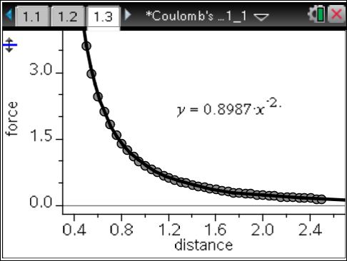
Move to page 1.4. Answer the following questions here.
3. As the balloons move apart, the distance and force data are automatically recorded and graphed on page 1.4. You may watch the graph as it is plotted by moving to page 1.4.

Q14. Based on your answers to questions 11 and 12 and the shape of the graph, how would you describe the relationship between the force and the distance between the charges? (You may need to rescale the graph by pressing Menu > Window/Zoom > Zoom – Data.)

Q15. If the equation is not displayed on the screen, click the curve to make it active. What is the exponent in the equation? Does this match the relationship you predicted in the previous question? Explain.

Q16. Write the equation of the curve. Remember that force is plotted on the y-axis of the graph and distance is plotted on the x-axis. When you write the equation, substitute F for y in the equation, and substitute r for x. Write the equation as a fraction instead of having a negative exponent. Describe the relationship between force and distance.

Q17. In the first part of this activity, you observed that the force two charges exert on each other is proportional to the product of the charges. The number in the equation you found in question 16 is equal to k × q₁ × q₂ where k is a special constant in physics. In this case both q₁ and q₂ are equal to 1 × 10^{–5} C. Calculate the value of the constant, k, using the number from the equation and the values of q₁ and q₂. Show your work.

Q18. Return to the simulation on page 1.3. Press the reset button to clear the data. Give each balloon a charge of +2, and separate them by 0.5 m. Press the play button to collect a new set of data. Look at the graph on page 1.4. What is the new equation? Calculate the constant, k, in the same manner as you did in the previous question. Remember q₁ and q₂ are now 2 × 10^{–5} C.

Q19. Write a general equation using the constant, k, to calculate the force, F, that exists between two charges, q₁ and q₂ separated by a distance, r. This equation is known as Coulomb’s law. Describe the relationships between the variables expressed in the equation in a sentence or two.

Q20. Use your equation to calculate the force when q₁ = 4 × 10^{–5} C, q₂ = 5 × 10^{–5} C, and r = 1.50 m. You may use the Scratchpad to make your calculation. Show your substitution of the numbers and your answer below.

Move to page 1.5. After you answer the questions on this activity sheet, answer the questions on pages 1.5–1.10 in the .tns file to review what you have learned.

