Open the TI-Nspire document Pangaea_Continent_Puzzle.tns  Were all of the continents once joined together in one big “supercontinent”? What evidence do we have to support that idea? How do scientists support their theories and hypotheses? In the early 1900s, Alfred Wegener, a German meteorologist, proposed the theory of continental drift in which the supercontinent, Pangaea, split apart. By moving and rotating continents from their present day positions, you will try to recreate Pangaea using evidence to support your hypothesis. |  | 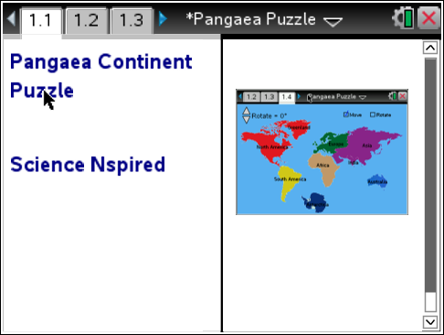
Move to page 1.2 and read the information given.
Fossil evidence, rock strata, the orientation of ancient glacial grooves, mountain range locations, and satellite measurements of continental movement are all used to support the theory of continental drift. However, one of the first pieces of evidence that supported the theory was the observation that South America and Africa fit together like puzzle pieces. On page 1.4, you will try to fit the continents together to recreate the continent of Pangaea.

Move to page 1.3 and answer question 1 below and/or on your device.
Q1. What evidence can be used to support the theory of continental drift? (Select all that apply.)

A. fossil types and locations
B. continental boundaries
C. rock types and locations
D. mountain range locations
E. scrape marks from ancient glaciers

Move to page 1.4.
Read the directions for the simulation.

1. To begin, select and drag a continent to the desired location. (Hint: Assume Africa has not moved much in the last 200 million years and use that as the starting point).  2. To rotate a continent, select the Rotate box in the upper right of the screen, and then select the continent. Use the Rotate up and down arrows (¤ and £) on the left to rotate clockwise or counterclockwise. When you are finished rotating a continent, select it again to lock it in place.  3. You may alternate between moving and rotating continents until you have constructed the Pangaea supercontinent. Be sure to select the Move or Rotate box to switch between moving and rotating continents.  4. To reset the map to current day, select Menu > Pangaea Continent Puzzle > Reset to Modern Day. | 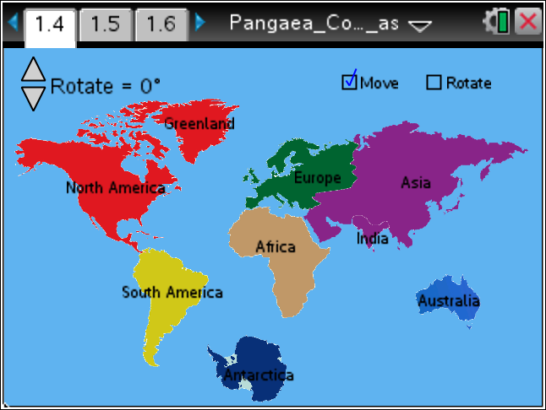
Tech Tip: To access the Directions again, select > Directions.
Tech Tip: To access the Directions again, select b or Document Tools () > Pangaea Continent Puzzle > Directions.
Move to pages 1.5 - 1.7.
After arranging the continents into your proposed map of Pangaea, answer questions 2 – 4 below and/or in your .tns file.

Q2. What characteristic did you find most useful in determining how to arrange the continents?

- color of the continents
- shape of the coastlines
- size of the continents
- location of the continents

Q3. Which two continents have the best matching coastlines?

Q4. Which two continents have coastlines that match the least?

Return to page 1.4.

5. Sketch the locations of your supercontinent below. Be sure to label the continents.

6. Listed below are some pieces of evidence that have been used to determine the locations of Earth’s continents in Pangaea. After reading them, you may return to page 1.4 to change the locations of the continents on your map.

- Geologist Alexander du Toit observed that rock layers on the western coast of Africa were almost identical to a sequence of rock layers on the eastern coast of South America.

- The Indian continent has fossils in common with the horn of Africa and the northern half of Antarctica.

- Antarctica and Australia have fossils in common with Africa and South America.

- When the orientations of grooves formed by large glaciers are aligned, an ancient ice sheet expanding outward in all directions is formed across Africa, South America, Australia, Antarctica, and India.

- An alpine mountain range is found along the east coast of North America, Northern Africa,Greenland, and Europe

- European plant fossils have been found in Canada and Greenland.

- In 1965, Geologist Edward Bullard used computers to match the underwater coastlines of South America and Africa. At an ocean depth of about 1,000 meters they matched very well.

7. Sketch the new locations of your supercontinent below. Be sure to label the continents.

Answer questions 5 - 11 below.
Q5. Why is the fact that similar fossils have been found on different continents considered evidence for the existence of Pangaea?

Q6. What might be the reason why the sea level outlines of the continents fit perfectly into a supercontinent underwater but not at land level?

Q7. In order for a theory to be accepted as the best explanation for a natural phenomenon, it must do the best job of explaining all evidence. Theories can sometimes be made stronger as new pieces of evidence are discovered. What do you think is the most convincing piece of evidence for the existence of Pangaea? Why?

Q8. The Himalayas are the tallest mountains in the world. Interestingly, fossils of seashells can be found in these mountains, which are far from the ocean. How do you think they got there?

Q9. Based on the evidence we have to reconstruct the history of the earth, it seems that Earth is always changing. What evidence do we have today that supports this idea? (Hint: Think about natural disasters.)

Q10. In 100 years, do you think the continents will still be where they are today, or will they be in a different location? Why do you think this?

