Open the TI-Nspire document Slope_of_Secant_Line.tns.  Objective: To use the slope of secant lines to predict the slope of the tangent line to a curve at a given point.  Directions: Move the indicated point toward the solid black point on the curve. At each step, the file is set up to capture the value of the slope of the secant line and display these slopes on the next page. Determine the value of the slope of the tangent line by examining the list of slopes on the subsequent page. | 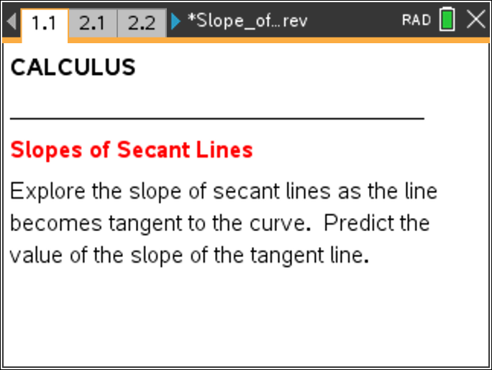

Move to page 2.2. | Press / ¢ and / ¡ to navigate through the lesson.
1. Given function f(x) = , Step size = 0.5, Point (1, 1)
Slope of Secant Line
Record some of your table of slopes and prediction for the slope of the tangent line.

Prediction for Slope of Tangent Line: ____________
Move to page 3.1.
2. Given function f(x) = , Step size = 0.2, Point (1, 1)
Slope of Secant Line
Record some of your table of slopes and prediction for the slope of the tangent line.

Prediction for Slope of Tangent Line: ____________

3. Do you feel this prediction is more accurate than your prediction from problem 1? Why or why not?

Move to page 4.1.
4. Given function f(x) = –x³ – 5x + 3, Step size = 0.05, Point (1, –3)
Record some of your table of slopes and prediction for the slope of the tangent line.
Slope of Secant Line

Prediction for Slope of Tangent Line: ____________

5. Do you feel this prediction is more accurate than your prediction from problem 3? Why or why not?

Move to page 5.1.
6. Given function f(x) = x², Step size = 0.005, Point (1, 1)
Record some of your table of slopes and prediction for the slope of the tangent line.
Slope of Secant Line

Prediction for Slope of Tangent Line: ____________
7. How do the values from this table compare to the values in the table with step size = 0.5?

8. Does your previous prediction match the prediction with step size = 0.05?

9. Why do you think step size is an important part of predicting the slope of the tangent line?

10. What step size is needed to be sure that your prediction for the slope of the tangent line is equivalent to the actual slope of the tangent line?

Move to page 6.1.
11. Given function f(x) = , Step size = .005, Point (0, 0)
Slope of Secant Line
Record some of your table of slopes and prediction for the slope of the tangent line.

Prediction for Slope of Tangent Line: ____________

12. What do you notice about the values of the slope in your table and the secant line pictured here? | 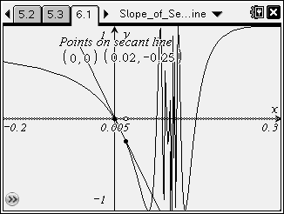
Adjust the screen for question 6.1 to match the screen above. Use this new window to predict the value of the slope of the tangent line.
Slope of Secant Line
13. Calculate the slope of each secant line and record them in the table.

New Prediction for Slope of Tangent Line: ____________

14. How does the new window affect your prediction?

