Open the TI-Nspire document Newtons_2nd_Law.tns.  It is easy to get a small wagon moving quickly, but not so easy for a wheelbarrow full of gravel. Sports, daily travel, heavy transport, and even rocket launches all must deal with getting objects moving: the application of Newton’s 2nd Law. In this activity we will explore the change in motion of a small cart being pulled by a steady force and analyze our observations to develop the equation describing Newton’s 2nd Law. |  |  | 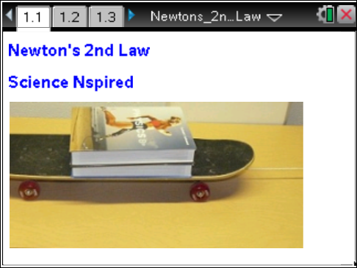
Problem 1: Acceleration and Force  In this simulation activity there will be no friction. For the first experiment you will vary the applied force and measure the acceleration of the cart. |  |  | Press / ¢ and / ¡ to navigate through the lesson.
Move to pages 1.2–1.4. Answer the following questions here or in the .tns file.
Q1. In the photo (page 1.1) is a frictionless cart on a smooth table. A constant horizontal force is being applied to the right. What will happen to the cart when it is released?
A. It will move to the right at constant speed. | B. It will move to the right at increasing speed. | C. Nothing because it has a load on it.
Q2. On page 1.4 is a simulation of a cart on a table. Press the start animation button and see that the cart does accelerate to the right. The accelerometer displays the value of the cart’s acceleration. What happens if you change the applied force?
A. More force gives more acceleration. | B. More force gives less acceleration. | C. Changing force makes no difference.
Move to page 1.5.  1. To explore the relationship between the force and the acceleration, go back to the simulation (page 1.4). Change the load to whatever you wish, but do not change it for the rest of the experiment. Note the mass of the cart and load. Press /^ to capture the current data of force and acceleration in a spreadsheet on page 1.7.  2. Change the force to another value, note how the acceleration value changes, and capture the new data by again pressing /^. Repeat this over a wide range of forces. The animation does not need to be active. |  |  | 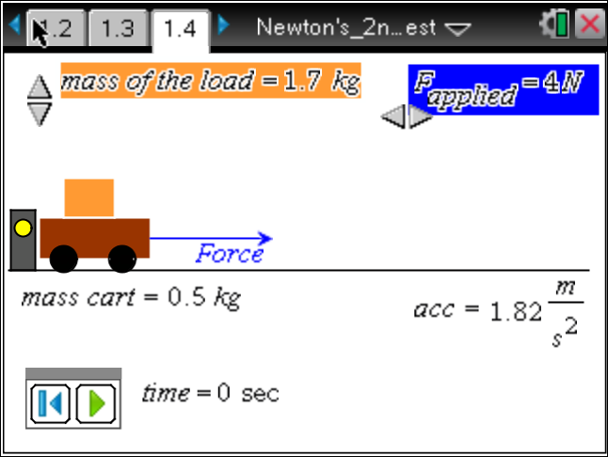
Move to pages 1.6–1.9.
3. After you have captured many data values, have a look at the spreadsheet on page 1.7. It is difficult to see a relationship in just a list of values, so then move to page 1.8 and plot force versus accel. Analyze this plot to find the relationship.

Move to pages 1.9–1.13. Answer the following questions here or in the .tns file.
Force is measured in newtons (N).
The slope units can therefore also be expressed as 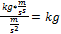
Q5. What is the slope of the force versus accel graph?

Q6. What are the units of the slope?

Q7. What quantity does the slope represent?

Q8. What quantity does the y-axis represent?

Q9. What quantity does the x-axis represent?

Q10. Rewrite the equation for your linear plot substituting the actual quantity symbols represented by y, x, and slope. This is equation is known as Newton’s 2nd Law.

Problem 2: Acceleration and Mass
For this experiment you will vary the mass and measure the acceleration of the cart with constant force.
Move to page 2.1. Answer the following question here or in the .tns file.
Q11. What happens to the cart if the force is kept constant but the load increases?
A. More load means more acceleration. | B. More load means less acceleration. | C. Changing the load will not make a difference in the acceleration.
Move to pages 2.2–2.6.  4. The next page shows the cart again. Set the force to any convenient value and note that value. Do not change the force again throughout this part of the experiment. Now note the mass, load, and acceleration. Press /^ to collect this data. Change the load, observe the new acceleration and again collect the data with /^. Repeat this over a wide range of loads. The animation does not need to be active. Observe the collected data on the next page. On page 2.6, plot:  - acceleration versus load, and  - acceleration versus masstotal. |  |  | 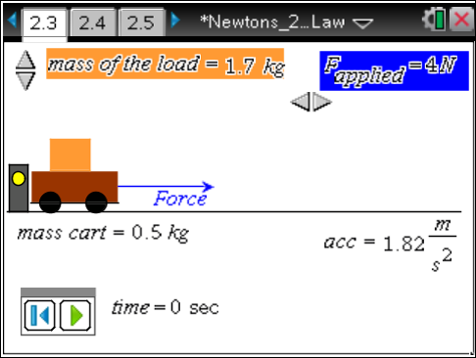
Move to pages 2.7 and 2.8.  5. None of your plots should appear linear. Their general shape suggests an inverse relation. Go back to the data page (2.5). Name column D invload and enter the formula =1/load in the formula cell under the title. Name column E invtotal and enter the formula =1/masstotal in the formula cell. Then move to page 2.8. |  |  | 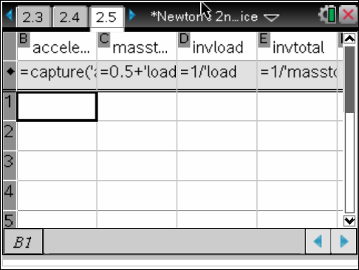
Move to page 2.9.
6. On page 2.9, plot:
- acceleration versus invload, and
- acceleration versus invtotal.
Find the linear relationship for the one that is most linear.
Move to pages 2.10–2.12. Answer the following questions here or in the .tns file.
Q15. What is the slope of the linear equation with units?

Q16. What does the slope represent?

Q17. Rewrite the equation for your linear plot substituting the actual quantity symbols represented by y, x, and slope. How does this equation compare to Newton’s 2nd Law?

Q18. When using Newton’s 2nd Law, what is important to remember about the mass?

Problem 3: Acceleration and Mass of System
For this experiment you will vary the force provided by a hanging mass and measure the acceleration of the cart. You will keep the system mass constant.
Move to pages 3.1 and 3.2.  7. Now we will change the system a little. The force will be provided by a weight hanging over a pulley on the edge of the table. You can change the applied force by adding mass to the hanger (with the slider). There is a slight problem with just adding mass to the hanger. We need the mass of the system to remain constant, so we transfer mass from the load on the cart to the hanger. (Note the load will change as you change the mass on the hanger.) |  |  | 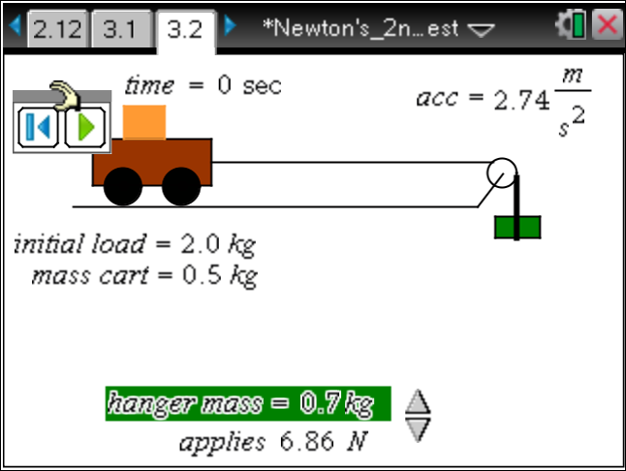
Move to page 3.3. Answer the following question here or in the .tns file.
Q20. Why must we transfer mass between the cart load and hanger and not just take mass from the table to the hanger (or from the hanger to the table)?

Move to pages 3.4–3.6.
8. On the simulation on page 3.2, note the mass of the cart, the initial mass of the load, the initial mass of the hanger, and the acceleration. Also note the force applied is the weight of the hanger = mass hanger x g. Capture the initial data with /^. Increase the applied force by increasing the mass on the hanger with the slider. Capture a new set of data. Repeat over a wide range of hanger masses.
9. On page 3.6 is the spreadsheet of captured data showing acceleration, applied force, hanger mass, load mass and total mass. Move to page 3.7 and explore various plots to get a meaningful linear relationship and find the equation.
Move to pages 3.7 and 3.8. Answer the following questions here or in the .tns file.
Q22. Record the equation here.

Q23. Rewrite the equation for your linear plot substituting the actual quantity symbols represented by y, x, and slope.

Move to page 3.9.
Q24. What is important to remember about the mass value in Newton’s 2nd Law?

Move to page 4.1.
Problem 4: Apply Newton’s 2nd Law
10. On the next several pages are some applications of Newton’s 2nd Law. Calculate the needed values and provide the answer with the correct units. Use Scratchpad » for the calculations, or do them on separate paper.

Move to pages 4.2–4.5. Answer the following question here or in the .tns file.
Q25. A 0.5 kg ball is dropped from a bridge and accelerates downwards at 9.8 m/s². What force is making it accelerate?

Q26. A 40 kg go-cart is being driven by a 60 kg driver. The cart can accelerate at 1.2 m/s². What force does the ground exert through the wheels to produce this acceleration?

Q27. What acceleration would a 200 N force cause on a 50 kg mass that was able to move freely?

Q28. A hanger has a mass of 0.80 kg and pulls on a string attached to a 0.60 kg frictionless cart carrying a load of 1.6 kg. What acceleration would we expect the cart to have?

Extension
For students familiar with calculus, applying Newton’s 2nd Law to a rocket launch can be very interesting. As the fuel burns and is ejected to provide thrust (force), the mass decreases, causing a change in acceleration. Knowing the rate of fuel use allows the calculation of the rate change of acceleration.
See Science Nspired activity: “NASA Shuttle Ascent”.

