Open the TI-Nspire document Parametric_Projectile_Motion.tns.  In this activity, you will explore the relationship between the initial velocity and initial angle of a projectile and the parametric equation for the path of the projectile. | 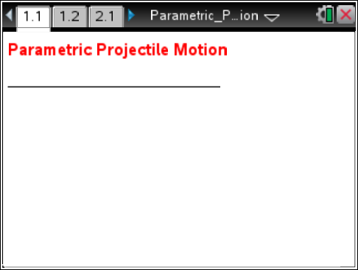

Move to page 1.2.
Select the “Start animation” button, and observe the trajectory of the ball. Point V changes the initial velocity vector that gives the initial speed and the initial angle.

 Tech Tip: The “Start animation” and ‘reset’ button are in the upper right of the window. 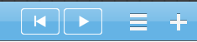

Reset the animation, and move point V to change the initial speed and/or the initial angle. Observe the effect of the changes, and continue to adjust the vector to score a basket.

Use ▲ to change to a new problem. The height of the player and the distance from the basket will both change.
1. What do you notice about the path of the ball when the velocity is large and the angle is small?

2. What do you notice about the path of the ball when the velocity is large and the initial angle is large?

3. How can you change your initial conditions to make the ball go very high?

4. How can you change your initial conditions to make the ball go very far?

Move to page 2.1.
5. Find the x-component (horizontal component) of the vector V₀ and the y-component (vertical component) of the vector V₀. Note: V₀ is the initial velocity, Vx is the x-component of the vector, and Vy is the y-component of the vector.

Move to page 2.2.
6. What is the vertical component of the vector with initial velocity of 10 meters/second and initial angle of 60º?

Move to page 2.3.
7. What is the horizontal component of the vector with initial velocity of 10 meters/second and initial angle of 60°?

8. The distance the ball travels in the horizontal direction (neglecting air resistance) is given by the
x-component (rate in the x-direction) multiplied by time (t). Find the distance the ball travels in the horizontal direction as a function of time.

9. The distance the ball travels in the vertical direction is given by the y-component multiplied by time (t) plus the initial height (h) minus the gravitational pull due to gravity given by 4.9t². Find the height of the ball as a function of time.

Move to page 3.1.
10. Find the parametric equation for the path of the ball that makes a basket if the player’s height is 2 meters and the player is 7 meters from the basket. Graph the parametric equation of the path of the ball that will go through the basket. Write your parametric equation below.

Move to page 4.1.
11. Practice making a basket by graphing parametric equations for at least two more problems that are randomly created when you select another problem. Change the initial conditions.

