Open or create the TI-Nspire document Cyclic_Quadrilaterals.tns.  You have seen before that for any triangle, you can find a circle that contains all three vertices (called the circumscribed circle or the circumcircle). When the four vertices of a quadrilateral lie on a circle, it is a special situation and deserves a special name: cyclic quadrilateral. In this activity, you will investigate some of the properties of cyclic quadrilaterals. | 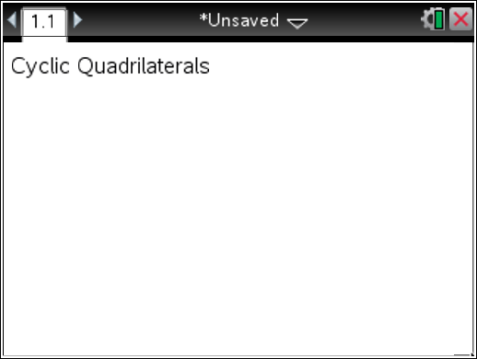

Move to page 1.2. | Press / ¢ and / ¡ to navigate through the lesson.
Part 1 – Investigating a Cyclic Quadrilateral  On page 1.2, there is a constructed cyclic quadrilateral with interior angles measured.  Drag any of the vertices of the quadrilateral, making sure the sides do not cross.  The expression a + b is provided so that pairs of angles can be added. Use the expression to find the sums of pairs of angles. Some of the angles are adjacent angles and some are opposite angles. | 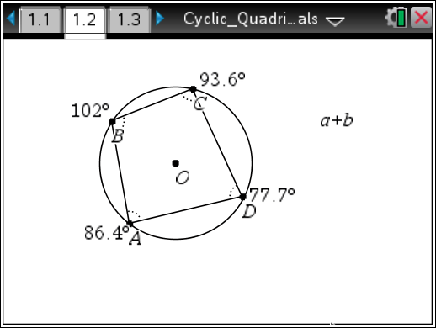
- Press Menu > Actions > Calculate. Move the cursor over the expression a + b. When it begins to blink, press ·. Then a box will appear with the message “Select a? (or press VAR).” Move the cursor to the measure for angle A and press · or x. When the message “Select b? (or press VAR)” appears, move to the measure for angle B and press · or x. A “ghost” sum will appear. Use the Touchpad arrows to move the sum to a location on the screen, and place it there by pressing ·.
Obtain the other angle sums in the same way. Move the cursor over the expression a + b. When it begins to blink, press ·. Then a box will appear with the message “Select a? (or press VAR).” Move the cursor to the measure for angle C and press · or x. When the message “Select b? (or press VAR)” appears, move to the measure for angle D and press · or x. A “ghost” sum will appear. Use the Touchpad arrows to move the sum to a location on the screen, and place it there by pressing ·.
Repeat for other angle sums: A and C, B and D. Press d when finished finding the sums.
Note that the letters a and b could be used for any angle measures, not just those for angles A and B. Make sure to keep track of where the different sums are placed on the screen.
a. m∠A + m∠B =

b. m∠C + m∠D =

c. m∠A + m∠C =

d. m∠B + m∠D =

e. Describe the pattern that you see in any of these sums. Be sure to drag different vertices to check your pattern.

Continue to verify patterns. Use the Redefine tool to redefine one of the vertices to be off the circle to investigate. Press Menu > Actions > Redefine. First click on any of the vertices of the quadrilateral and then click outside or inside the circle. The quadrilateral is no longer a cyclic quadrilateral. Press d.
Drag different vertices again to check the patterns. Then redefine the vertex you are exploring to be back on the circle to re-establish the cyclic quadrilateral.

2. After redefining a vertex off of the circle, what happened to the sum of the opposite angles?
3. How would you describe opposite interior angles in a cyclic quadrilateral?
4. Determine if you can create each of the following quadrilaterals. Explain why or why not.
a. Trapezoid

b. Isosceles trapezoid

c. Kite
d. Rectangle

e. Square

f. Rhombus

Move to page 1.3.
Part 2 – Perpendicular Bisectors
This page contains the cyclic quadrilateral ABCD. Construct the perpendicular bisectors of each side by pressing Menu > Construction > Perpendicular bisector. Move the cursor to a side (make sure it says side) and x. Repeat for all sides. Press d when you are finished.
Drag different vertices of the quadrilateral to look for the relationship between the quadrilateral and the perpendicular bisectors.

5. In a cyclic quadrilateral, the perpendicular bisectors .

Move to page 1.4.
Part 3 – Quadrilaterals
6. Josephine tells Bobby that quadrilateral ABCD is a cyclic quadrilateral. He says it isn’t. Who is correct? How do you know?

Move to page 1.5.
7. Explore more properties of cyclic quadrilateral ABCD as instructed by your teacher.

