Open the TI-Nspire document Radioactive Dating Game.tns.  In this lesson you will use the simulation to identify the percent of remaining isotopes of Carbon-14 and Uranium-238 during their radioactive decay process. You will then develop a mathematical model for the radioactive decay for each element and use this model to determine the age of organic and inorganic materials. |  | 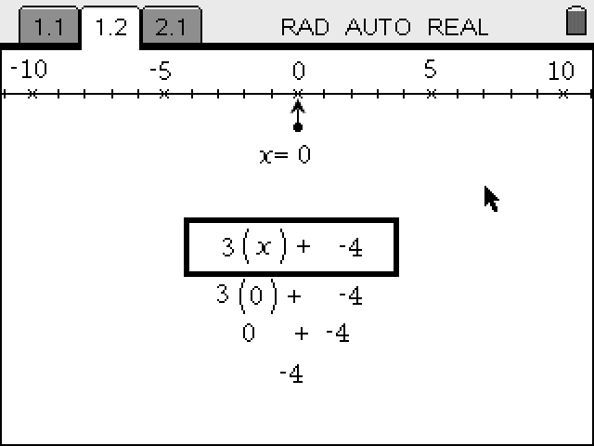
Part 1. Exploring Radioactive Decay
Move to page 1.2.
1. Observe changes in the percent of an isotope in two radioactive decay processes: and . Based on the simulated experiment, you will identify the percent of element remaining after given periods of time.
Once on the screen, you can play , pause , and reset the simulation using the buttons at the bottom of the page. The percent of element remaining will be shown on a graph as a function of time. You can also count the number of remaining isotopes on the top of the page.

Q1. What is a half-life of a radioactive element?

Q2. What is the half-life of Carbon-14?

2. Select the play button at the bottom of the page. Observe the changes in the percent of carbon remaining in the sample. To get a better estimation, select the pause button after each half-life. Then count the number of remaining isotopes shown at the top of the page. Repeat the experiment at least 3 times. Record the percent of carbon remaining in the table below.

 | Percent of Carbon-14 Remaining
Half-lives | Trial 1 | Trial 2 | Trial 3 | Average
1st
2nd
3rd

Q3. What percent of Carbon-14 is remaining after 1 half-life? Two half-lives? Three half-lives?

Q4. What do you think the similarities and differences will be in the decay of Uranium-238?

Q5. What is the half-life of Uranium-238?

3. In order to explore decay of Uranium-238 select  in the bottom left corner of the page to switch the element.

4. Select the play button and observe the changes in the percent of uranium remaining in the sample. You can use the pause button after each half-life to get a better estimation by counting the number of remaining isotopes shown on the top of the page. Repeat the experiment at least 3 times and record the percent of uranium remaining in the table below.

 | Percent of Uranium-238 Remaining
Half-lives | Trial 1 | Trial 2 | Trial 3 | Average
1st
2nd
3rd

Q6. What percent of Uranium-238 is remaining after 1 half-life? Two half-lives? Three half-lives?

Q7. What function type best describes the radioactive decay curve? Why?

Part 2: Mathematical Model of Radioactive Decay  Move to page 1.3.  5. In this part of the activity you will examine the decay curves of Carbon-14 and Uranium-238 and develop a mathematical model for each curve/isotope. Select the Graph tab to switch to the graph showing the decay of Carbon-14. |  |  | 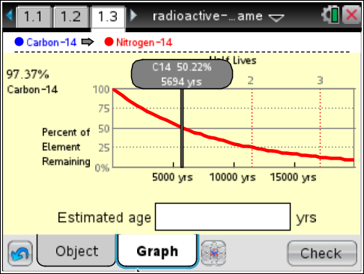
6. Grab and drag the gray examination line to different times to collect detailed information on the time and percent remaining from the chosen isotope. Use these data to develop and/or verify the mathematical model for the curve.

Q8. What is the mathematical model for the exponential decay of Carbon-14? Explain how you developed this model. Verify your model using data collected on page 1.3.

7. Select to change from Carbon-14 to Uranium-238.
Q9. What is the mathematical model for the exponential decay of Uranium-238? Verify your model using data on page 1.3. |  |  | 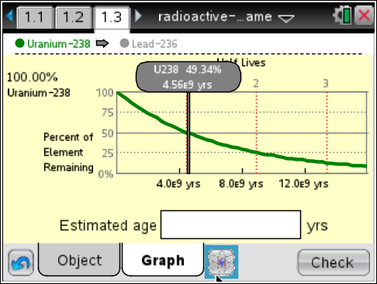
Part 3: Radioactive Dating  Select the Object tab on page 1.3.  8. In this part of the activity you will estimate the age of different objects that can be found on the earth’s surface and in different geological layers using radioactive dating. Select to switch between carbon dating and uranium dating as necessary. |  |  | 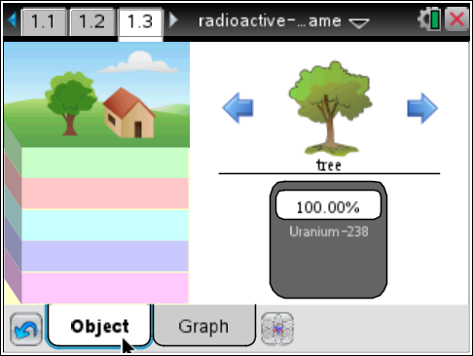
Q10. For what type of objects should you use carbon dating? Why?

Q11. For what type of objects should you use uranium dating? Why?

9. Select the blue arrows, and , on either side of the object to switch the object to date. For each object record the type of dating used (carbon or uranium) and percent of radioactive element remaining. Then use your mathematical model to calculate an estimated age of the object. Show your calculations in the table below. Select the Graph tab. Then key in your calculated age of the object at the bottom of the page and select . If your answer is correct, the smiley green face will appear on the page. If the answer is incorrect, a frown red face will appear.
 | Tech Tip: To enter the estimated age, select the Estimated age box. The keyboard will appear. Select the “.?123” button to the left or right of the space bar to enter a numerical quantity. After you have entered the value, select “return.” Then, select to check your answer.
Object | Type of Dating | % Element Remaining | Calculated Age (show your calculations)
Tree
House
Bone
Wooden cup
Human skull
Fish bones
Rock 1
Dinosaur skull
Rock 2
Trilobite
Rock 3
Rock 4

Q12. Is there a relationship between the age of the object and the geological layer where it is found? If so, what?

