Open the TI-Nspire document DC_Circuits.tns.  In this investigation you will explore a DC Circuit simulation with one battery of varying voltage (Volts – V), up to three resistors of various resistances (Ohms – Ω) and a meter to measure the current (in milliamps – mA). You will observe of the direction and speed of the electron flow as you adjust the variables. |  | 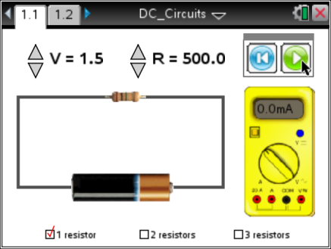
As you explore the circuit you will determine the relationship between voltage (V), resistance (R), and current (I).

A DC circuit is a connected set of items that uses a constant direct current from a battery to supply a constant current. This is different from an AC circuit that uses an alternating current.
Part 1: Exploring the DC Circuit
1. When you first open the Nspire document you will see a Directions window explaining how to use the simulation. Look over the directions and check with your classmates and your teacher if you need more instruction. |  | 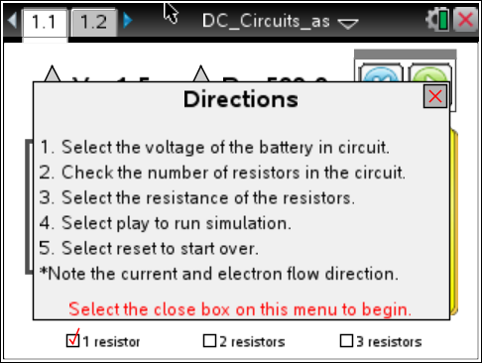
2. Close the pop-up Directions box when you are finished. Select b to view the directions again. |  | 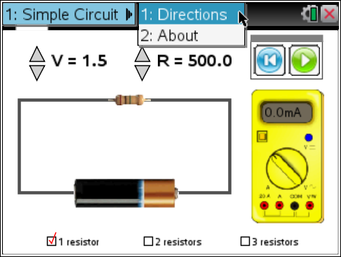
 | Tech Tip: To bring up the directions again, select  > DC Circuits > Directions. You may need to back-out to the main Tools Menu to see the desired menu option.
3. Now select the Play button and observe.

Q1. What do you see? Share this with another student and the class as requested.

To Pause the simulation select . To Reset select .
Q2. Make a list of the variables that can be controlled in the simulation:

Move to page 1.2.  4. Get your assigned variable (to hold constant) from the teacher. Now you will consider what happens to the current as you systematically adjust the other variables. Note the rate of electron flow, the direction, and record the reading on the meter for each scenario. Be careful to try all of the possible combinations of the other variables. Please note that “number_r” on page 1.2 stands for the number of resistors. |  | 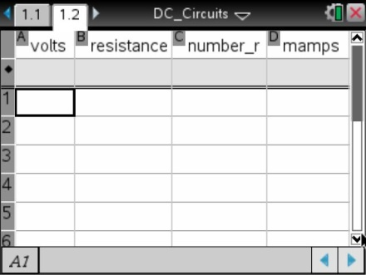
5. Fill in the rows in the spreadsheet as you collect data. One row is one combination of the variables. Try at least 10 different combinations.

 | Tech Tip: To add or modify data in a spreadsheet cell, double-tap the cell. The keyboard will appear. Enter the numerical value and then select enter.
6. Share your data with a student near you and then share with the whole class as instructed.

7. Look for a pattern in your own results and in the class results.

Q3. What is the range of voltages (V) available in the simulation?

Q4. What is the range of resistances (R)?

Q5. What is the range of current (I) as shown by the meter in milliamps?

Q6. What combination of values of the variables will give you the smallest current?

Q7. What combination of values of the variables will give you the largest current?

8. Can you determine a relationship between voltage (V), current (I), and resistance (R)? Look at the numbers for a mathematical pattern. Discuss with another student and/or the class.

Q8. What combination of values of the variables appears to make the electrons flow faster? Slower?

Q9. Describe the direction of the flow of electrons.

Part 2: The Formula V = I • R

9. The relationship between voltage, current, and resistance is given by the formula V = I • R. Use the formula to calculate the missing values in the table below. You may verify your answers by using the simulation, but do your own calculations first.

From row 1 in the table: V = 2.0 Volts R = 200.0 Ω 1 Resistor
To find the value of the current:
- = 0.01 Amps
- 0.01 Amps • 1000 mA/Amps = 10.0 mA
- The current is 10.0 mA.

Q10. Calculate the missing vales in the table.

Volts |  | Resistance  # of Resistors | Current
2.0 V | 200.0 Ω | 1 | = 0.01 and  0.01 • 1000 = 10 mA
1.0 V |  |  | 1.0 mA
 | 300.0 Ω | 1 | 20.0 mA
7.0 V |  |  | 10.0 mA
6.5 V | 400.0 Ω | 1
4.5 | V |  | 7.5 mA
 | 600.0 Ω | 2 | 1.7 mA
 | 500.0 Ω | 3 | 2.3 mA
1.5 V | 800.0 Ω | 3
You Pick One

Q11. What is the relationship between amps (A) and milliamps(mA)?

Q12. Rewrite the formula V = I • R to solve for current (I).

Q13. What happens to the resistance in the circuit when you have more than one resistor?

Q14. Rewrite the formula V = I • R to solve for resistance (R).

Part 3: Predicting and Exploring
10. Now use your knowledge of DC Circuits to get readings for circuits that cannot be made with this simulation.

Q15. What value would you get for current if the voltage was set to 1.65 V and there was 1 resistor of 200Ω? Test your answer by setting the voltage for the one resistor to 1.5 V and then 2.0 V.

Q16. What value would you get for current if the voltage was set to 5.5 V and there were two resistors of 330.0Ω each? Test your results by setting the two resistors to 300Ω and then to 400Ω.

Q17. What voltage would you expect if you set up a circuit with 3 resistors at 450Ω each and it had a current of 5.7 mA? Set up the circuit to test your results.

Q18. In which direction does the current flow? Can you change it?

Q19. Which end of the battery do you think is negative? Why?

