Open the TI-Nspire document Slices.tns.  In this activity, you will explore the two-dimensional figures that result from slicing three-dimensional figures with horizontal and vertical planes. | 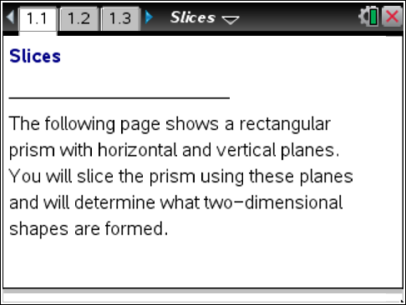

Move to pages 1.2 through 1.7.

Before you move the two-dimensional planes through the three-dimensional figures to slice them, first make a prediction and fill in the table on the next page as described in question 1. If you believe the shape will change as the two-dimensional plane slices the figure, draw multiple sketches that show how the shape changes as the plane slices from one end of the figure to the other.

1. For each of the 3-dimensional figures on Pages 1.2-1.7:
a. Make sketches for your predictions of what two-dimensional shapes will appear if you were to cut the figure horizontally. Make your sketch in the table provided below.
b. When you have made your predictions, check your answers by actually sliding the horizontal plane through the figure on each page. (When you are finished, be sure to return the horizontal plane to the bottom of the figure.)
c. Make sketches for your predictions of what two-dimensional shapes will appear if you were to cut the figure vertically from the back to the front. Make your sketch it the table provided below.
d. When you have made your predictions, check your answers by actually sliding the vertical plane through the figure on each page.
e. After you have drawn the sketches for the actual two-dimensional shapes, note how the two-dimensional shape changes as you move the planes through the figures

 | Rectangular  Prism | Triangular Prism  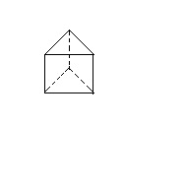 | Square  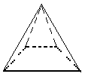Pyramid | Tetra-hedron  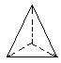 | Cylinder | Cone  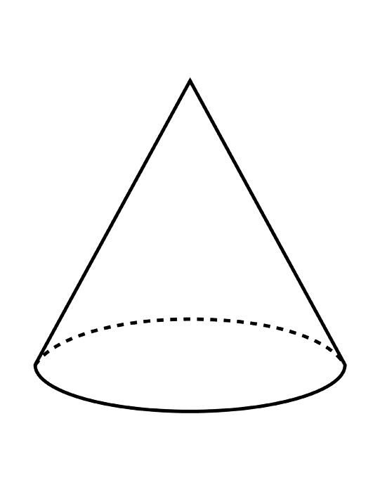
Horizontal Slicing | Sketches of  Horizontal  Slice Predictions
Horizontal Slicing | Sketches  of Actual Horizontal  Shapes
Horizontal Slicing | What changes?
Horizontal Slicing | What stays  the same?
Vertical Slicing | Sketches of  Vertical  Slice Predictions
Vertical Slicing | Sketches of Actual  Vertical  Shapes
Vertical Slicing | What changes?
Vertical Slicing | What stays the same?

2. For which of the six figures did you obtain:
a. Rectangular shapes by slicing? If there is more than one figure, how are these figures related?

b. Triangular shapes by slicing? If there is more than one figure, how are these figures related?

c. Circular shapes by slicing? If there is more than one figure, how are these figures related?

d. Trapezoidal shapes by slicing? If there is more than one figure, how are these figures related?

e. A line by slicing? If there is more than one figure, how are these figures related?

f. A point by slicing? If there is more than one figure, how are these figures related?

3. When sliced vertically back to front and horizontally bottom up, a particular three-dimensional figure first produces a point, then circles that increase in size, then circles that decrease in size, and then finally a point again. What would that three-dimensional figure be? Draw a sketch.

4. When sliced vertically from back to front, a composite three-dimensional figure first produces a square, then hexagons that increase in size, then a pentagon, then hexagons that decrease in size, and then finally a square. When sliced horizontally from the bottom up it produces squares that are first the same size and then eventually squares that decrease in size to a point. What would that three-dimensional figure be composed of? Draw a sketch.

