Open the TI-Nspire document Logarithmic_Transformtions_  of_Data.tns.  The purpose of this activity is to examine the effect of logarithmic transformations on the relationship between two variables. Logarithmic transformations may be used in regression analysis in order to achieve linearity or an approximate linear relationship between the transformed variables. | 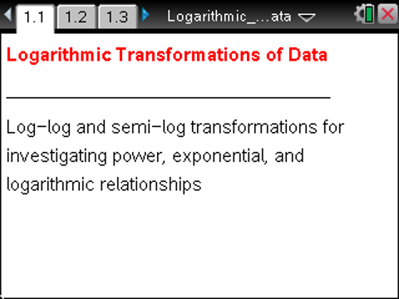

Move to page 1.2. | Press / ¢ and / ¡ to navigate through the lesson.
1. This problem involves the world production of oil as a function of time. Let be the time in years since 1880 and the variable oil represents the world production of oil in millions of barrels.
- Page 1.2 shows a scatter plot of oil versus . Describe the relationship between and oil, and write a possible mathematical equation to describe this relationship.

Move to page 1.3.

b. This graph is a scatter plot of versus . Describe, in words, the relationship between and Describe the effect of this transformation on the relationship between the two variables.

Move to page 1.4.

c. Select MENU > Statistics > Stat Calculations > Linear Regression (a+bx) to find the line of best fit for the ordered pairs Store the regression equation in , and add the graph of to the scatter plot on Page 1.3. Use this equation to predict the world oil production in the year 1980.

d. Use the regression equation in part (c) to write an equation to describe the relationship between the two original variables, and oil. Add the graph of this function, to the scatter plot on Page 1.2. Use this equation to predict the world oil production in the year 1980. Does this prediction agree with your answer in part (c)?

e. On Page 1.4, select MENU > Statistics > Stat Calculations > Exponential Regression to find an equation of best fit for the ordered pairs Store this equation in , and add the graph of to the scatter plot on Page 1.2. How do the graphs of and compare?

Move to page 2.1.

2. This problem involves the height and age of Douglas Fir trees. Let the variable height represent the height of a randomly selected Douglas Fir tree (in feet) and the variable age represent the age of that tree (in years).
a. Page 2.1 shows a scatter plot of height versus age. Describe in words the relationship between age and height, and write a possible mathematical equation to describe this relationship.

Move to page 2.2.

b. This graph is a scatter plot of height versus . Describe in words the relationship between height and Describe the effect of this transformation on the relationship between the two variables.

Move to page 2.3.

c. Select MENU > Statistics > Stat Calculations > Linear Regression (a+bx) to find the line of best fit for the ordered pairs Store the regression equation in , and add the graph of to the scatter plot on Page 2.2. Use this equation to predict the height for a 25-year old tree.

d. Select MENU > Statistics > Stat Calculations > Logarithmic Regression to find an equation of best fit for the ordered pairs Store this equation in , and add the graph of to the scatter plot on Page 2.1. Use to predict the height for a 25-year old tree. How does this prediction compare with your answer in part (c)?

Move to page 3.1.

3. This problem involves Kepler’s Law of Periods, which states that the orbital period of planets revolving about the sun (period) is related to the semi-major axis of its orbit ().
a. Page 3.1 shows a scatter plot of period versus Describe in words the relationship between period and , and write a possible mathematical equation to describe this relationship.
Note: You might have to zoom-in and adjust the window to detect the relationship between the variables.

Move to page 3.2.

b. This graph is a scatter plot of versus Describe in words the relationship between and Describe the effect of this transformation on the relationship between the two variables.

Move to page 3.3.

c. Select MENU > Statistics > Stat Calculations > Linear Regression (a+bx) to find the line of best fit for the ordered pairs Store the regression equation in , and add the graph of to the scatter plot on Page 3.2. Use this equation to predict the period for a planet with

d. Select MENU > Statistics > Stat Calculations > Power Regression to find an equation of best fit for the ordered pairs Store this equation in and add the graph of to the scatter plot on page 3.1. Use to predict the period for a planet with How does this prediction compare with your answer in part (c)?

e. Use the power regression equation found in part (d) to solve for , and use the resulting expression to state Kepler’s Law of Periods.

Larson, Pia Veldt. “ST111: Data.” May 26, 2003. http://statmaster.sdu.dk/courses/st111/data/index.html. The author cites this source: Joglekar, G., Schuenemeyer, J.H., and LaRiccia, V. “Lack-of-fir testing when replicates are not available.” American Statistician, 43, pp. 135-143. 1989.
Data from http://hyperphysics.phy-astr.gsu.edu/hbase/kepler.html. Additional source cited: Resnick, R., Halliday, D., and Walker, J. Fundamentals of Physics, Fourth Edition. John Wiley & Sons. Table 15-3.

