In this activity, you will create a new document and add a Graphs & Geometry application to explore graphing linear equations.

1. Create a new document by selecting c > New Doc > Add Notes.
2. Type Graphing Linear Equations.
Note: To obtain capital letters, press g, then the letter.
3. Select ~ > File > Save As … and type Graphing_ Linear_Equations.
4. Tab to ¾ and press ·.
Note: To obtain the underscore, press / _.
5. To add a new Graphs page, select / ~ > Add Graphs.
6. Select c > Settings & Status > Settings > Graphs & Geometry.  - Press e to move from one field to the next, and press x to uncheck all the boxes.  Tab to OK and press x or ·. | 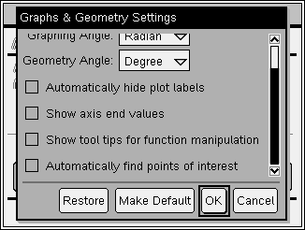
- At the Home Screen, press the number next to the word Current to return to the current file.

Graphing the Line y = x
- The cursor will be flashing in the f1(x) entry line at the bottom of the screen.
8. To graph the line y = x, press X ·.
- Notice that the entry line is now hidden but the equation is displayed on the screen.

Shifting the Graph Up and Down
9. Move the cursor to point to the line, but near the origin. The line will be become bold. In addition, the words graph f1 will appear, and so will the symbol ö.
10. To grab the line, press / x. The symbol { will appear.
11. Use either the Clickpad or Touchpad to move the graph of the line up and down. Notice the changes in the equation as the line shifts.
12. Press d to stop shifting the line.

Rotating the Line About the y-intercept
13. Move the cursor to an end of the line, and the cursor will become two circular arrows, é.
14. To grab the line, press / x. The symbol { will appear.
15. Use either the Clickpad or Touchpad to rotate the graph of the line. Also notice the changes in the equation.
16. Press d to stop rotating the line.

Resetting the Line to the Graph of f1(x) = x
17. Perform the “undo” feature until the graph is f1(x) = x. Do this by pressing /d a few times. If you “undo” too many times, “redo” is / Y.
Saving the Document
18. Press / S to save the document.

This page intentionally left blank.

