Overview

The conic sections—a parabola, an ellipse, and a hyperbola—can be completely described using parametric equations. Provided below are detailed steps for constructing a TI-Nspire™ document to graph and investigate these families of conic sections. Sliders will be used to control the parameters that characterize each conic section. Note: Do not provide the TNS_soln document to students, as they should start from scratch. This document has been provided as classroom instruction reference.

Materials

• TI-Nspire™ CX/CX II handheld or Computer Software

Step 1—Preparing the document  1. Students should start from a blank document. Open a new document on the handheld by pressing c > New Document. Open a new document in the Teacher Software by clicking File > New TI-Nspire Document.  2. Select Add Graphs. | 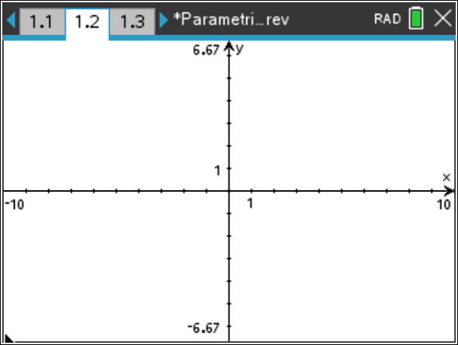
From this point on, directions for the Computer Software and the Handheld will be notated separately where appropriate.  3. Handheld: Select ~ > Page Layout > Select Layout > Layout 2 to split the page in half vertically.  Computer Software: Select Edit > Page Layout > Select Layout and choose the appropriate icon to split the page in half vertically. Or, click the drop-down page layout menu, and select the icon to split the page in half vertically.  4. Add a Graphs page to the right-hand work area also. | 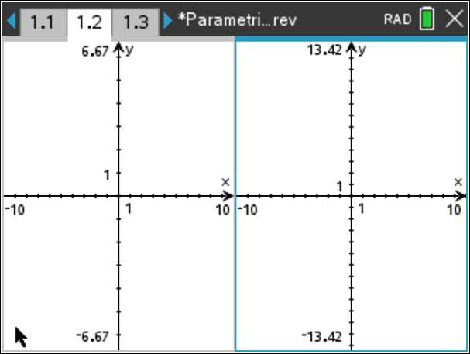
5. Handheld: In the left-hand work area, select MENU > View > Hide Axes.
Computer Software: Click in the left-hand work area, and select Document Tools > View > Hide Axes.
6. Handheld: Select ~ > Page Layout > Custom Split, and use the arrow keys to move the page boundary to the left, leaving room for a slider and increasing the space for the graph. Press · to complete the page boundary change.  Computer Software: Position the cursor along the boundary of the two screens using your mouse. Click and drag the boundary to the left. | 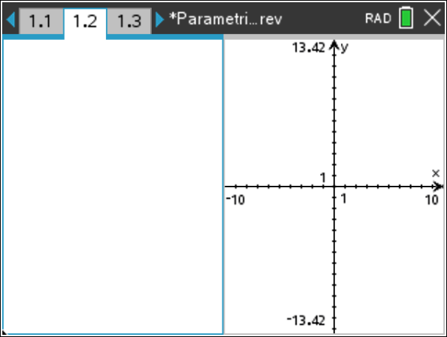
Step 2—Add a Slider  7. In the left work area, select MENU > Actions > Insert Slider. Change the slider settings as indicated in the screenshots below and to the right, and click OK | 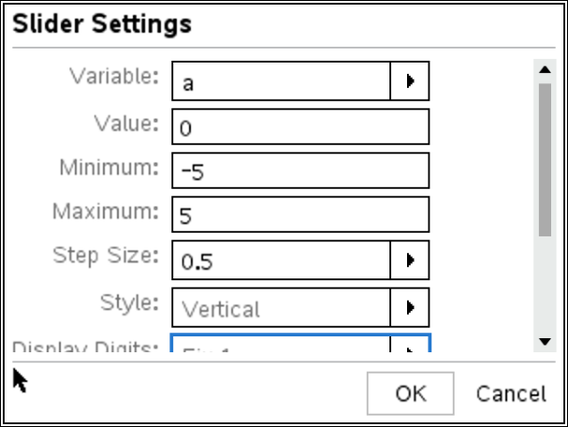
8. Handheld: Select / > MENU > Settings.  Computer Software: Right-click in the slider box, and select Settings. Change the slider settings as indicated in the screenshots below and to the right, and click OK. | 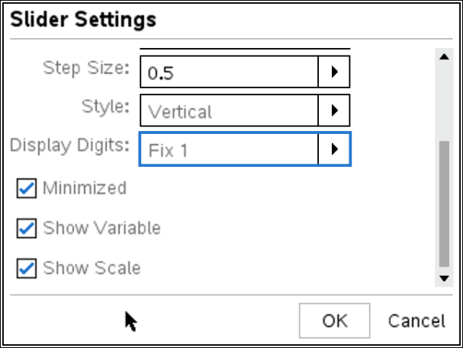
In the figure to the right, the slider is minimized, the variable is shown, and the starting value is 0.You will need to move the slider for optimal placement in the left pane. | 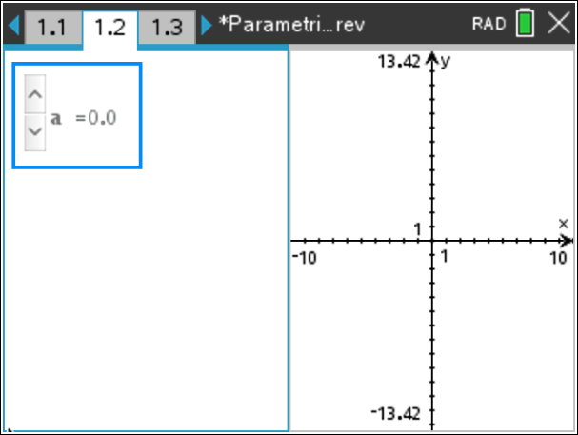

Step 3—Making a Parametric Graph of a Parabola  9. In the right work area, select MENU > Graph Entry/Edit > Parametric, and enter the general parametric equations for a parabola:  - Change the interval to and set  - Press · to display the graph.  - Hide the graph label, and click the slider arrows to change the value of  Note: To obtain a graph of the parabola that is smoother, consider changing the graph attributes to discrete, point connected, and/or adjusting the value of tstep. | 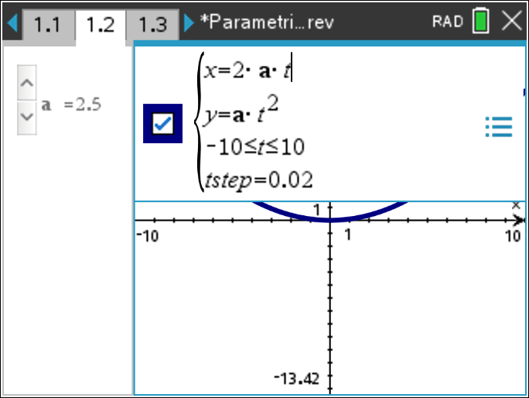  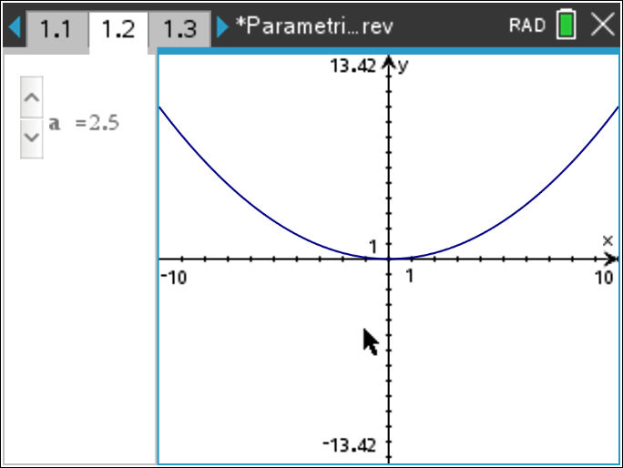
Here are some suggestions for enhancements to this page:  - Add a graph of the directrix.  - Add a point to represent the focus.  - Change the parametric equations so that the parabola opens up along the x-axis.  - Add additional parameters that shift the graph horizontally and/or vertically.  - Add the appropriate points and line segments to demonstrate that for any point on the parabola, the distance from the focus to the point is equal to the distance from the point to the directrix. This page is shown to the right and is included in the .tns file. Drag the point on the parabola to demonstrate this equality. | 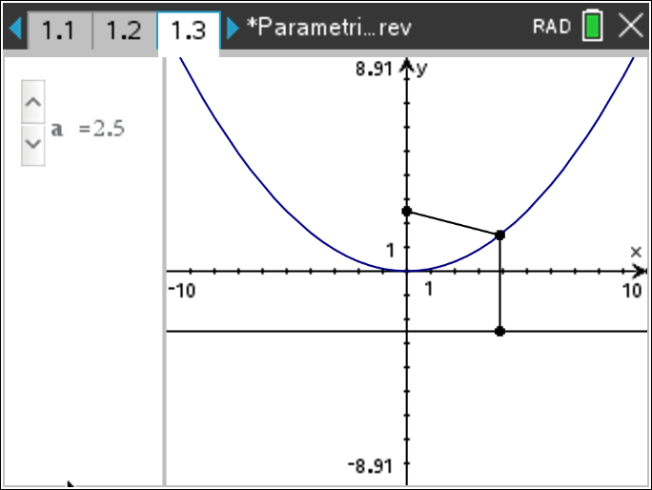
Step 4— Making a Parametric Graph of an Ellipse
10. Handheld: Select ~ > Insert > Problem.
Computer Software: Select Insert > Problem.
11. Insert a new Calculator page at the beginning of this new problem. Leave the Calculator page blank, and continue to the next step. After copying the page below, you can delete this blank Calculator page.

12. Handheld: Press / © to view the document pages. Select the page to be copied (Page 1.1), press / > MENU > Copy, select the position for the new (copied) page, and press / > MENU > Paste.
Computer Software: Select Document Toolbox > Page Sorter, right-click (control-click on the Mac) on the appropriate page, select Copy (or press Ctrl+C), select the position for the new (copied) page, and right-click to select Paste (or press Ctrl+V).
- A copy of Page 1.1 has been pasted as Page 2.2.
13. After you delete the blank calculator page from step 11, Page 2.1 will now be a copy of Page 1.1  14. Add another slider to the left work area. Position the second slider below the first, name the slider variable and change the slider settings for both variables as shown below.  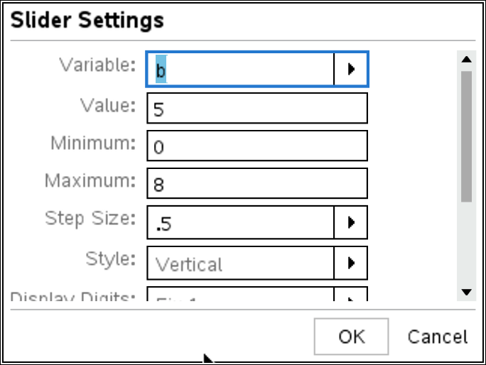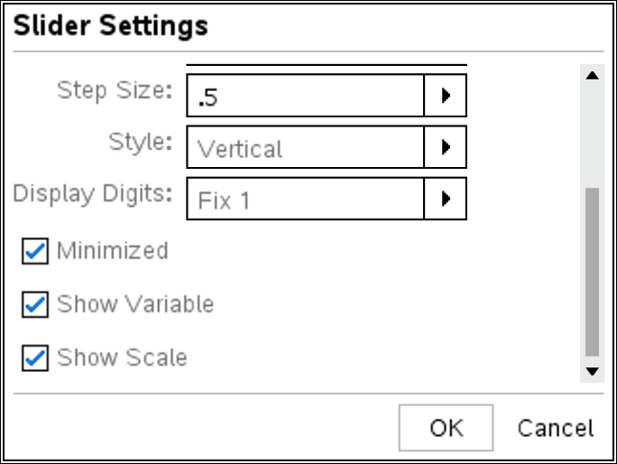 | 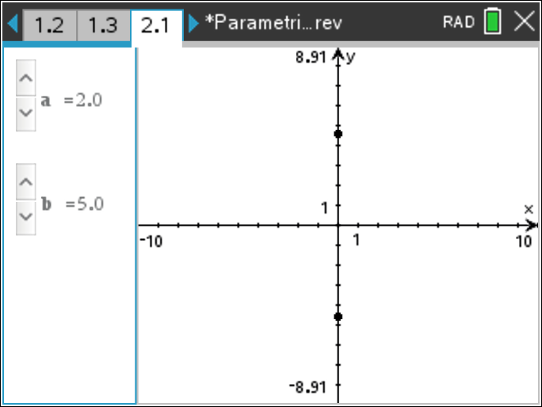
15. Make sure the Graph Type is set to Parametric, and enter the general parametric equations for an ellipse:  ,  16. Change the interval to , and adjust the value of tstep as necessary.  17. Select MENU > Window/Zoom > Zoom – Square, and hide the graph label if desired.  - Click the slider arrows for and to change their values, and observe the effect on the graph of the ellipse. | 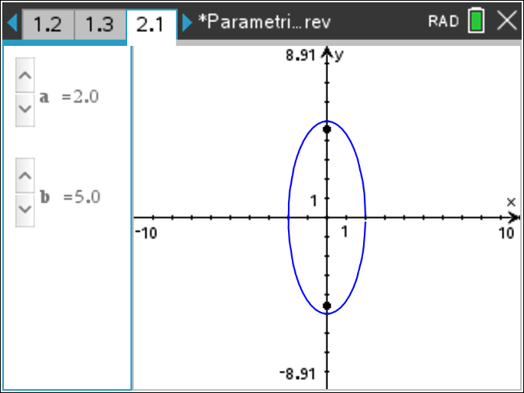
Here are some suggestions for enhancements to this page:  - Add two points to represent the foci of the ellipse. This page is shown to the right and is included in the .tns file.  - Add additional parameters to shift the graph horizontally and/or vertically.  - Add the appropriate points and line segments to show that the sum of the distances from any point on the ellipse to the two foci is constant and equal to the major diameter. | 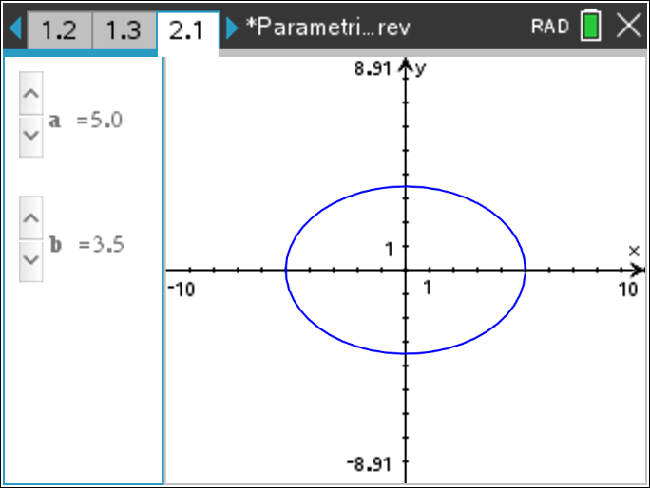
Notes:
- Ask students to verify that the parametric definitions for and satisfy the Cartesian equation of an ellipse:
- Ask students to find values for and such that the graph is a circle. This can help students realize that a circle is a special case of an ellipse.

Step 5—Making a Parametric Graph of a Hyperbola  18. Insert another new problem, and copy Page 2.1 to Page 3.1.  19. In order to generate the complete graph of a hyperbola, enter two sets of parametric equations. Let and  20. Change the interval to , and set  21. Set the graph screen window to Zoom-Square, and click the slider arrows for and to change their values and observe the effect on the graph of the hyperbola.  Note: A hyperbola opening along the x-axis can also be described using the parametric equations , over the intervals and These equations might be more appropriate if students are unfamiliar with the hyperbolic functions. | 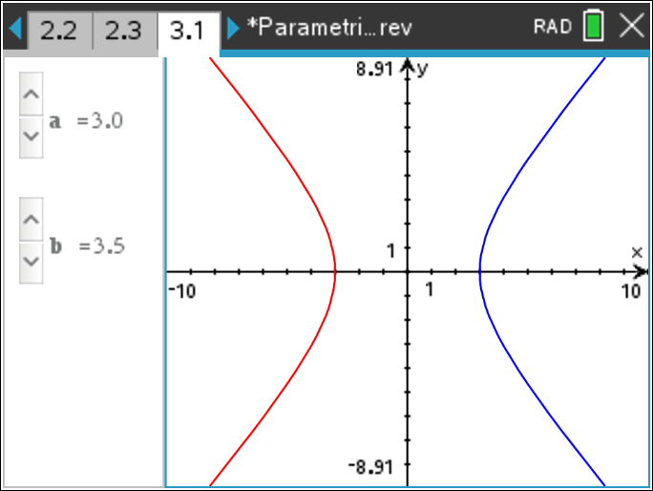
Here are some suggestions for enhancements to this page:
- Add additional parameters to shift the graph horizontally and/or vertically.
- Add two points to represent the foci of the hyperbola.
- Add the directrices.
- Add the graphs of the asymptotes.
- Change the parametric equations such that the graph opens up along the y-axis.

The graph to the right shows the two foci and the asymptotes for a hyperbola opening up along the x-axis (included in the .tns file).  Note: If you change the parametric equations such that the graph opens up along the y-axis, you will also need to redefine the asymptotes () and foci (at ). This construction is shown on Page 4.1 of the .tns file. | 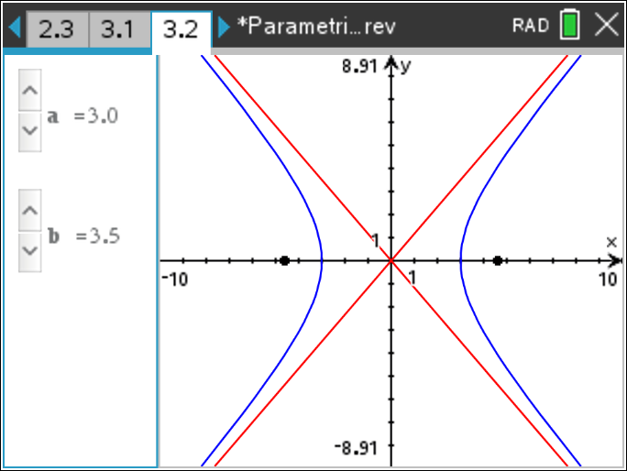
This graph also shows the two directrices and the line segments from a point on the hyperbola to a directrix and to a focus. It is also included in the .tns file. Drag the point on the hyperbola and the line segments will change dynamically. The ratio of the lengths of these line segments is the eccentricity of the hyperbola. | 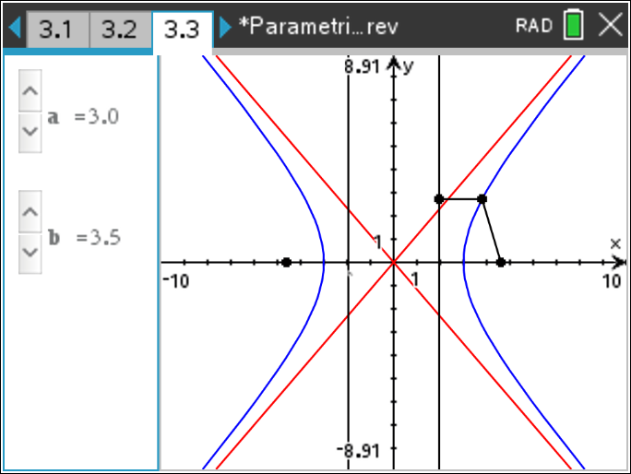
Notes:
- Ask students to find the definitions for and in terms of exponential functions.
- Ask students to verify that the parametric definitions for and satisfy the Cartesian equation of an ellipse:

