Open the TI-Nspire document Day_At_The_Beach.tns.  In this data-gathering activity, you will explore the temperature differences in two sets of sand, one dry and one wet. You’ll gather the data, display it in a spreadsheet, and then graph it. You will then analyze the data and graph and draw conclusions about the temperature differences. | 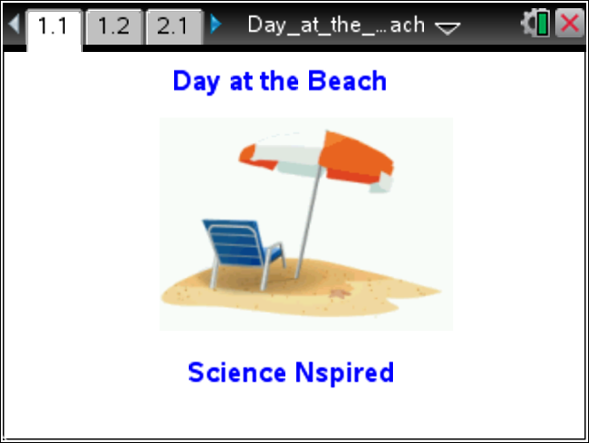
Background:
When you’ve been at the beach, you have likely noticed that in the middle of a hot day, dry sand can be uncomfortably hot on bare feet. On the other hand, wet sand is cooler and easy to walk on with bare feet. Why is there a difference?

In each case—wet sand vs. dry sand—sunlight is absorbed as heat. In the case of the dry sand, the heat is retained in the sand itself. You can feel that heat as you walk on the dry sand.

In the case of the wet sand, the particles of sand are mixed with droplets of water. Each of those substances reacts to heat differently. In the case of the sand particles, they absorb heat. In the case of the water droplets, they, too absorb heat. But if water absorbs enough heat energy, it evaporates.
When water evaporates, it turns into a gas and floats into the air. These gas molecules carry away the heat that was previously absorbed by the sand-water mixture.

Set Up:
- Place 500 ml of dry sand into each of the two aluminum trays.

- Add enough water to one pan to thoroughly dampen the sand. Use room temperature water to keep the initial temperatures of the sand in the two containers the same. It is important that the starting temperatures of the wet and dry sand be as close as possible.

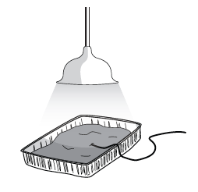
- Heat lamps with clamps designed for labs are optimal; however, student desk lamps with flexible necks and 60-/100-watt bulbs work fine. Keep the distance from the heat source constant for both trials.

- Connect the Temperature Probe to the data-collection interface. Connect the interface to the TI-Nspire handheld or computer. (If you are using an EasyTemp or Go!Temp, you do not need a data-collection interface.)

- Choose Menu > Experiment > New Experiment. Choose Menu > Experiment > Collection Setup. Then choose Interval (seconds/sample) from the drop down menu. Enter 30 as the interval (seconds/sample) and 300 as the experiment duration in seconds (5 minutes) and select OK. | 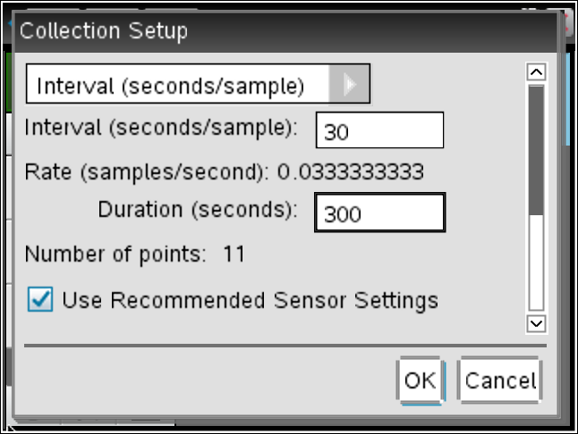
DATA COLLECTION:

- Bury the end of the temperature sensor 0.5 cm below the surface of the dry sand.

- Place the heat lamp 20 cm above the tray of sand.

- When you are ready to begin, start the data collection by pressing . At the end of each 30 second interval, a data point is plotted on the graph.

- Continue to hold the sensor in the dry sand. After 11 data samples are collected from the sensor and plotted, the line graph is displayed.

- Click the data table tab to see each data point and record the values in the table on the next page. Sketch the graph to the right of the table on the next page.  - Repeat steps 6–10 for the tray of wet sand. Sketch both graphs on the same set of axes. | 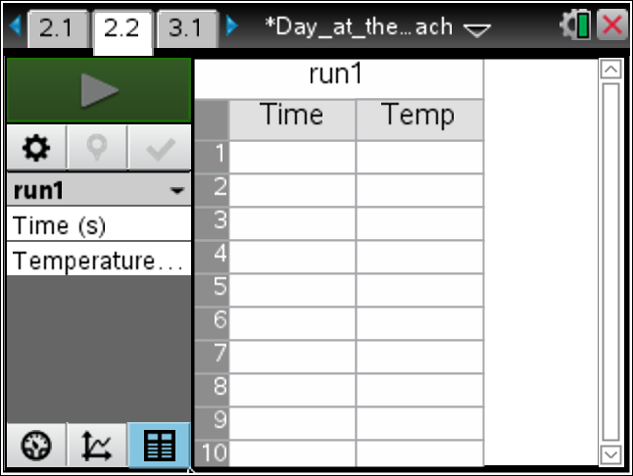

In this adventure, you will compare the heating rates of wet sand and dry sand.
Choose the data table tab on page 2.2. Record the information below.
 |  | 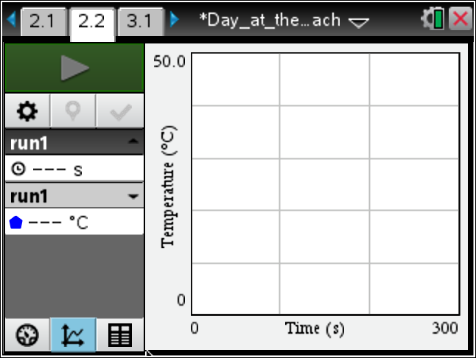
  Time (seconds) | Temperature of  Dry Sand (°C) | Temperature of  Wet Sand (°C)
  0
  30
  60
  90
  120
  150
  180
  210
  240
  270
  300
Move to pages 3.1 – 4.1. Answer questions 1 - 6 here and/or in the .tns file.
Q1. What do the slopes of the lines on the graph represent?

Q2. What do the differences in the two slopes indicate about the heating rates of the wet and dry sand?

Q3. What does the y-intercept represent?

Q4. Compare the temperatures of the wet and dry sand at the same time intervals. How does water affect the heating of the sand?

Q5. Compare the change in temperature for the dry sand and wet sand.

Dry sand: starting temperature (____°C) – ending temperature (____°C) = (____°C)

Wet sand: starting temperature (____°C) – ending temperature (____°C) = (____°C)

Q6. ________ sand heats faster in the sun than ________ sand.

A. Wet; dry | B. Dry; wet

