Open the TI-Nspire document Molecular_Titration.tns.  What happens at the molecular level during a titration of a strong acid with a strong base? In this activity you will be able to answer this question by simulating a titration and observing the molecular view. | 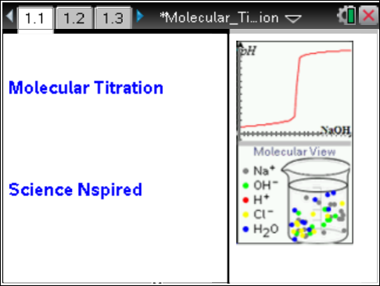

Move to page 1.2.
1. Read the introduction. This activity is a simulation of a titration of a strong acid with a strong base. The strong acid is HCl and the strong base is NaOH.
HCl(aq) + NaOH(aq) → HOH + NaCl(aq)
Move to pages 1.3 and 1.4. Answer the following questions here or in the .tns file.
Q1. Referring to the titration curve on page 1.1, the equivalence point occurs _____.
A. in the middle of the first flat region  B. at the point the pH starts to rise rapidly |  | C. in the middle of the steep region  D. in the middle of the second flat region
Q2. A strong acid (or a strong base) is a chemical species that _____.
A. produces a very low (or very high) pH
B. ionizes completely in water
C. partially ionizes in water
D. is a very active acid (or base)

Move to pages 1.5 and 1.6.  2. Read the directions and study the set-up. The beaker contains 50 mL of .10M HCl acid and the burette contains 50 mL of .20M NaOH. |  |  |  | 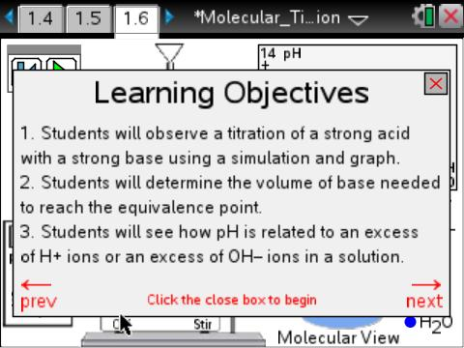
Tech Tip: To access the Directions again, select > Titration > Show Help Screen
Move to pages 1.7 and 1.8. Answer the following questions here or in the .tns file.
Q3. Initially the beaker contains _____.
A. H⁺ and Cl– ions  B. HCl, H⁺, and Cl– ions |  | C. HCl and NaOH  D. Na⁺ and OH– ions
Q4. How many H⁺ ions are present in the simulation initially?

Move to page 1.9.
3. Read the directions.
Move to pages 1.10–1.12. Answer the following questions here or in the .tns file.
Q5. As NaOH is added the pH _____.
A. decreases | B. increases |  | C. is unchanged
Q6. As NaOH is added the number of H⁺ ions _____.
A. decreases | B. increases |  | C. is unchanged
Q7. As NaOH is added the number of Cl– ions _____.
A. decreases | B. increases |  | C. is unchanged
Move to pages 1.13–1.20. Answer the following questions here or in the .tns file.  4. Read the directions on page 1.13 and look at the questions on pages 1.14–1.20. You will return to titration on page 1.6 and use the results to answer the questions. |  |  |  |  | 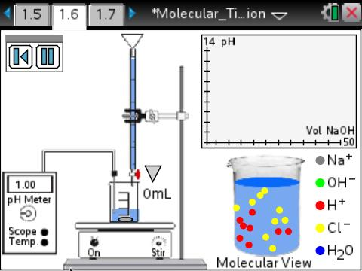
Q8. How many mL of NaOH are needed to reach the equivalence point?

Q9. At the equivalence point how many H⁺ ions remain in the beaker?

Q10. At the equivalence point how many OH– ions are present in the beaker?

Q11. Write a net ionic equation to show what happened to the H⁺ ions.

Q12. At the equivalence point the number of Cl– ions is _____ the number of Na⁺ ions.
A. less than | B. equal to |  | C. greater than
Q13. For a strong acid–strong base titration, what is the pH at the equivalence point?

Q14. As more NaOH is added beyond the equivalence point, the pH increases because of the increase in the number of _____.
A. H⁺ ions  B. OH– ions |  | C. Na⁺ ions  D. Cl– ions

