Open the TI-Nspire document Variables_and_Expressions.tns.  If the numbers that can be substituted for the symbol x can vary, we call x a variable. This activity lets you change the value for x on a number line and see the effect on an algebraic expression involving x. | 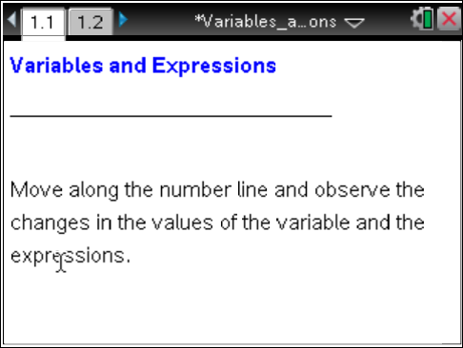

Move to page 1.2. | Press /¢ and /¡ to navigate through the lesson.
1. As you grab the point and move the arrow beneath the number line, what changes? What stays the same?

2. Wade says that when x is negative, the value of 3(x) + −4 is always negative. Explain why he is right or wrong.

3. a. Find a value of the variable x that causes the expression 3(x) + −4 to equal 17.

b. Estimate a value of the variable x that causes the expression 3(x) + −4 to equal 15. Explain your reasoning.

4. Find a value for x that will make the value of the expression 3(x) + −4 equal to −4.

5. a. If the value of x is increased by 1, how does the value of the expression change?

b. How is this change related to the expression?

6. a. Write an expression you think will increase by 5 when the value of x is increased by 1.

b. Give some examples to support your reasoning.

7. Write an expression that will not vary (change in value) when the value of x is increased by 1. Explain your reasoning.

