Open the TI-Nspire document Area_FOILed_Again.tns.  In this activity, you will practice finding rectangular areas with algebraic expressions for the lengths of the sides. | 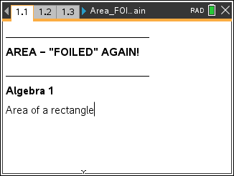

Problem 1 – Introduction to area of a rectangle.  Move to page 1.2 – Meet Mr. FOIL | 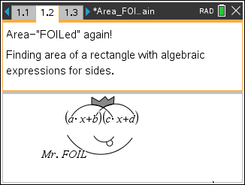
Move to page 1.3 | 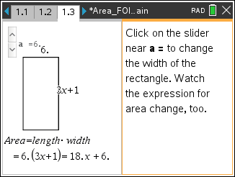

1 What are the lengths of the sides of the rectangle?

2. What is the area of the rectangle when a = 6?

Change the length of the side by clicking on the slider.

3. What is the area of the rectangle when a = 4? When a = 11?

4. How is the expression for the area simplified?

Move to 1.5

5. Choose the expression for the area of a rectangle with sides of length 5 units and x + 8 units.

Problem 2 – Areas of small rectangles  Move to page 2.1  On page 2.1, you see a rectangle of dimensions  (x + 7) and (x + 2). Each piece of the rectangle is a different color so that you can focus on its area. | 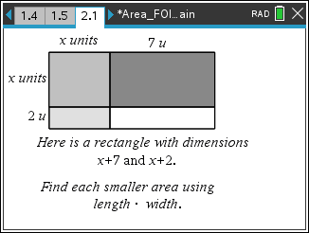
6. What is the area of each small rectangle?

Move to page 2.2 and check your answers.

7. What is the total area of the rectangle?

Move to page 2.3 and mark your answer.

Problem 3 – FOIL method  Move to pages 3.1 and 3.2  The rectangle on pages 3.1 and 3.2 has the same dimensions as the rectangle from Problem 2. The FOIL method is shown on page 3.2. | 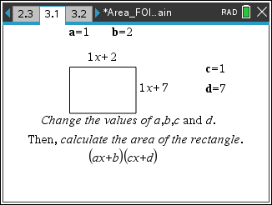

8. How do the areas of the small rectangles in Problem 2 relate to the expression shown on page 3.2?

You can change the dimensions of the rectangle on page 3.1 by double-clicking on a, b, c, or d. Practice finding the area of the rectangle and then check your answers on page 3.2.

9. What is the area of a rectangle with dimensions (3x + 5) and (6x + 2)?

10. What is the area of a rectangle with dimensions (4x + 1) and (3x + 9)?

11. What is the area of a rectangle with dimensions (x + 8) and (7x + 3)?

12. What is the area of a rectangle with dimensions (2x + (-3)) and (5x + 8)?

Homework/Extensions
Pages 4.1 – 4.3
On page 4.2, there is another opportunity for you to practice finding area. Record your answer to the first problem here. Show each step of your work. Advance to page 4.3 to check your answer.
1. a. (4x + 2)(x + 7) =

b. (3x – 7)(2x + 4) =

c. (2x + 5)(6x + 1) =

d. (5x + 3)(9x – 2) =

Pages 5.1 – 5.2
On pages 5.1 and 5.2, you will be multiplying a trinomial (3 terms) times a binomial (2 terms) to find the area of a rectangle.
2. What method can you use to find the simplified expression for the area?

3. Use the letters a, b, c, d, and e to determine the formula used to find the 6 terms of area shown on page 5.2.

4. What is the area of the rectangle with dimensions (1x² + 3x + 4) and (5x + 6)?

5. Find the areas of each rectangle. Show each step of your work
a. (2x² + 1x + 7)(3x + (–6)) =

b. (4x² + 3x + 8)(x + 3) =

c. (2x² + 6x + 4)(–3x + 9) =

