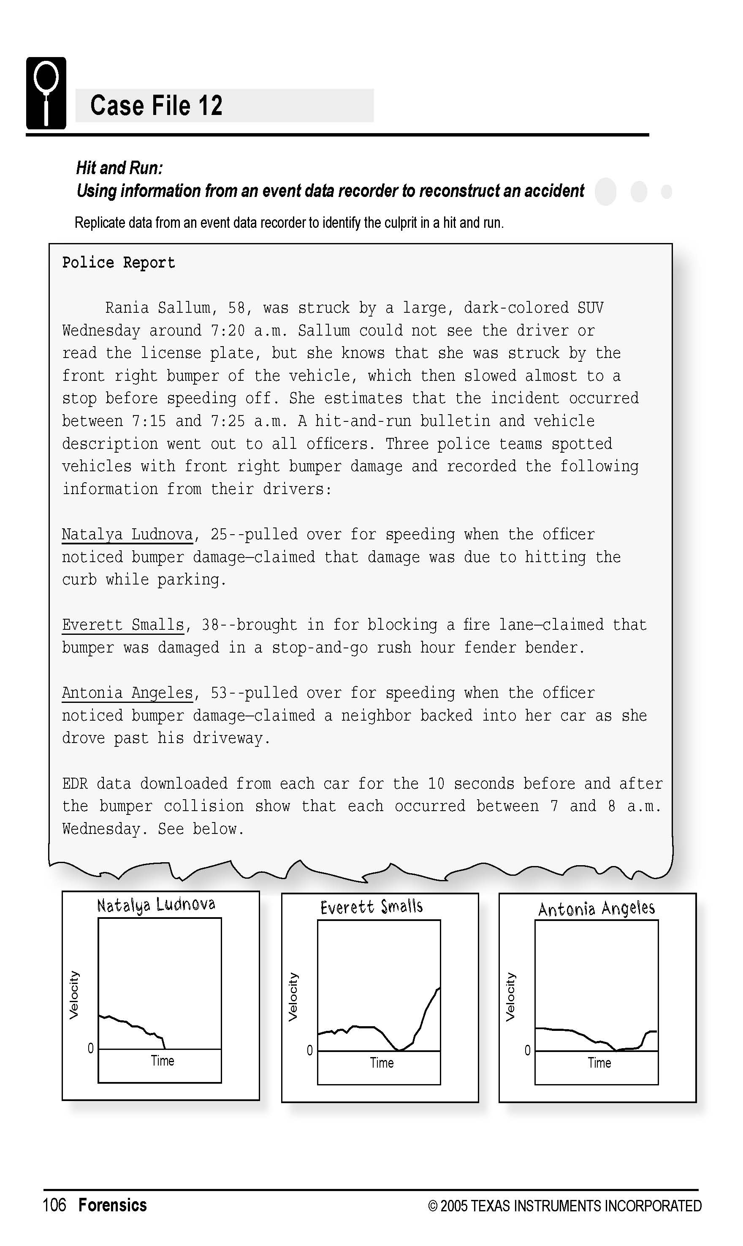

Science Objectives
- Simulate the use of an event data recorder (EDR) in order to show how the evidence gathered by this device can be used for legal purposes
- Show how accident scenes can be recreated through an analysis of the data that are gathered by an EDR
- Learn how distance traveled, velocity, and acceleration are related to one another
- Learn how the appearance of an acceleration, velocity, or distance vs. time graph can be used to predict the appearance of the other graphs

Activity Materials
- TI-Nspire™ technology  - Case 12 Hit and Run.tns file  - Vernier Motion Detector and TI-Nspire Lab Cradle or CBR 2™ | - metric tape measure or meter stick  - toy car, at least 5 cm tall
Procedure
Open the TI-Nspire document Case 12 Hit and Run.tns.  In this data-gathering activity, you will replicate data from an event data recorder to identify the culprit in a hit and run. |  |  | 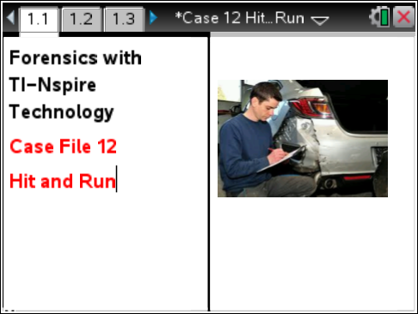
Part 1 – Collecting Data
Move to pages 1.2–1.4.
1. Prepare the Motion Detector for data collection.  a. Open the pivoting head. If the Motion Detector has a sensitivity switch, set it to Track.  b. On page 1.4, if using CBR 2™ connect it directly to the TI-Nspire, if using a Motion Detector, connect to DIG 1 of Lab Cradle. |  |  |  | 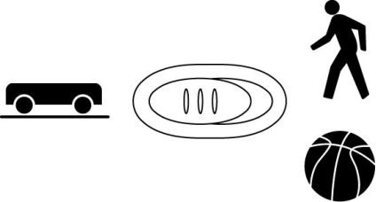
2. Place the Motion Detector and car on a lab table or the floor. The Motion Detector should be facing the car, and should be about 30 cm apart. Remove any surrounding objects so that the data you acquire will be relatively “noise” free.
3. Perform a test run with your car. Have one team member push the car and release it. Push the car from the top instead of from the back, so that the motion detector does not pick up the motion of your hand. Have another team member check the readings on the screen. You do not need to record the motion at this point. Just be sure that the Motion Detector is measuring the increasing distance as the car moves away. Also be sure that the car is pushed gently enough that it stops before the end of the table.
4. Position the team members so that one can start data collection and the other can push the car away from the Motion Detector.
5. Start data collection by press the green collect button and push the car away after data collection begins. Be sure to push the car away in the same manner that you did in your test run. |  | 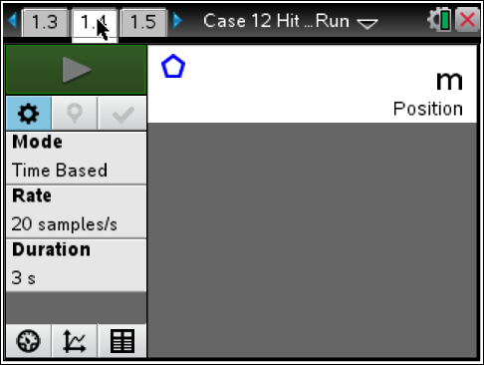
Part 2 – Analyzing the Data
Move to pages 1.4–1.5.  6. Select the “graph view” tab , and examine the distance and velocity graphs. These graphs should be relatively smooth, indicating that you picked up the motion of the car and not other objects. If the graphs of the distance and velocity are not relatively smooth (an absolutely smooth graph is rarely observed), repeat data collection.  7. Sketch these graphs in the Evidence Record below. Then, complete the Case Analysis. |  | 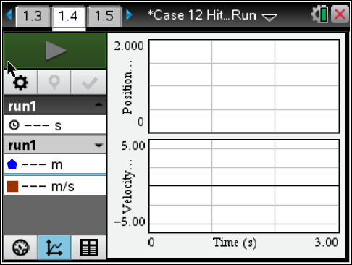
Evidence Record
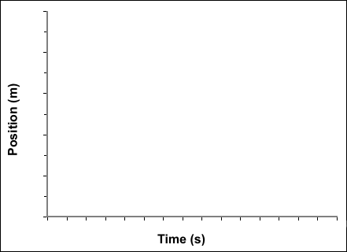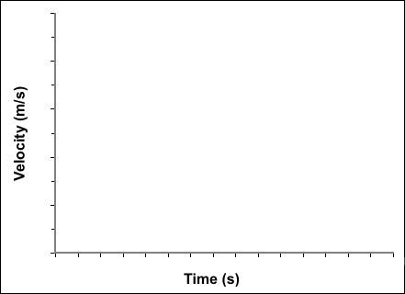
Position vs. Time Velocity vs. Time

Case Analysis
Move to pages 2.1–2.9.
Answer the following questions here, in the .tns file, or both.
Q1. Look at the velocity vs. time graph. At what time did the car begin to move?

Q2. What was the maximum velocity of the car?

Q3. At what time did the car reach its maximum velocity?

Q4. Look at the distance vs. time graph. Does the time at which the car’s distance from the Motion Detector increased match the time in Question 1?

Q5. How far did the car move before it reached its maximum velocity?

Q6. EDRs in vehicles record information on velocity and acceleration for moving vehicles. The data recorded by EDRs help reconstruct the events of an accident. For example, data from the EDR can show when a car’s brakes were applied, if at all.
Suppose a vehicle was traveling at a constant speed, using cruise control, when suddenly the brakes were applied until the vehicle stopped. Sketch a velocity vs. time graph for this situation. Label the point at which the brakes were applied and the point at which the vehicle came to a complete stop.

Q7. Do the EDR data taken from the suspects support their stories? Do the EDR graphs suggest that any of these suspects is the culprit in the hit and run? Explain your answers.

