Open the TI-Nspire document Linear_Transformations.tns.  In this activity, you will visualize linear transformations from to to characterize some special cases. You will also observe the effect of a linear transformation in two dimensions, use your own words to describe the relationship between the input and output vectors, and use specific numerical results to support your conclusions. | 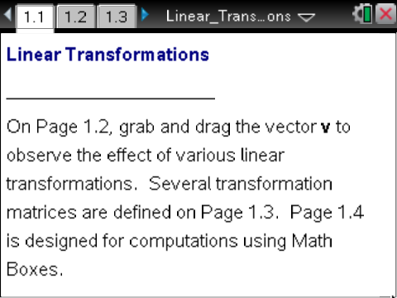

A linear transformation from to can be represented by a matrix.
If is a linear transformation that maps to and v is a column vector, then the linear transformation can be written as for some matrix
The matrix is called the transformation matrix.

Move to page 1.2. | Press / ¢ and / ¡ to navigate through the lesson.
The left work area is a Notes page with two interactive Math Boxes.
- In the first Math Box, define the matrix to be a transformation matrix. Note: to define edit the Math Box following the assignment characters, := .
- When you open the .tns file, initially.
In the right work area, grab and drag the vector (at the tip of the arrow).
- The product, in the left work area, and the vector in the right work area, are automatically updated.
On Page 1.3, there are several defined transformation matrices and constants.
There are also several Math Boxes on Page 1.4 to compute for various input vectors
Note: The calculator function norm of a vector returns the length of the vector. Consider how each of the following transformations affects the magnitude and direction of the input vector.

1. Let .
a. Describe this transformation in words.

b. Complete the following table.

c. Do the calculations in the table above support your description from part a? Why or why not?

2. For , let
Note: To change the transformation matrix, click the Math Box in which is defined (on Page 1.2). Delete the current transformation matrix (for example, ), and type the variable representing any one of the transformation matrices defined on Page 1.3 just after the assignment characters := (for example, ).
a. Describe this transformation in words.

b. Complete the following table.

c. Do the calculations in the table above support your description from part a? Why or why not?

d. Describe this transformation for any value of

3. Let
a. Describe this transformation in words.

b. Complete the following table.

c. Do the calculations in the table above support your description from part a? Why or why not?

4. Let .
a. Describe this transformation in words.

b. Complete the following table.

c. Do the calculations in the table above support your description from part a? Why or why not?

5. For let .
a. Describe this transformation in words.

b. Complete the following table.
Note: is the magnitude, or length, of the vector The magnitude of the vector can be found on Page 1.4: .

c. Do the calculations in the table above support your description from part a? Why or why not?

d. Describe this transformation for any value of

6. Let
a. Describe this transformation in words.

b. Complete the following table.

c. Do the calculations in part (b) support your answer in part (a)? Why or why not?

