Open the TI-Nspire document Solving_Stoichiometry_Problems.tns  In this lesson you will use simulations of three combustion reactions to develop skills necessary to solve stoichiometric problems. | 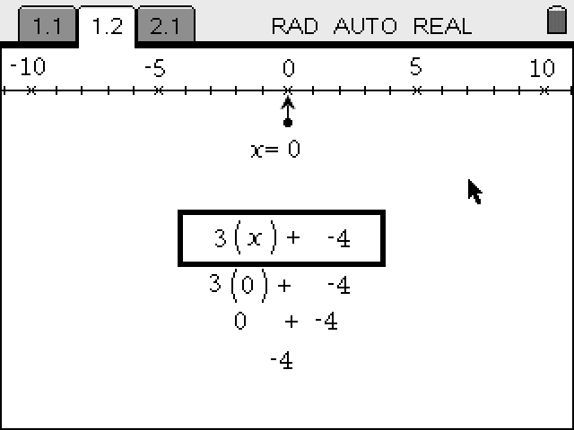

Move to page 1.2.  In this part of the activity you will analyze mole ratios. Use two significant figures for your calculations in this part of the activity.  1. Read the directions on how to use the simulation. When finished, select to close the directions. Select b if you need to view the directions again. |  | 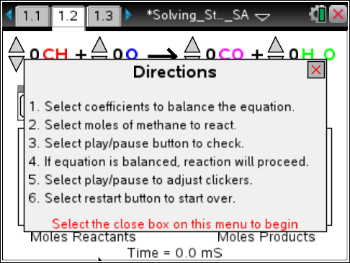
 | Tech Tip: To view the directions again, select  > Stoichiometric Problems > Directions. You may need to back-out to the main Tools Menu to see the desired menu option.
2. Balance the equation. Use the up and down arrows to adjust the coefficients that appear in front of each reactant and product.

Answer questions 1-11 here before moving to page 1.3.
Q1. Record the balanced equation: _____________________________________

3. Select the up arrow to change the number of moles of methane to be used in the reaction. Then select the play button 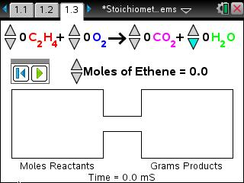.

Q2. Select four different amounts of methane. For each amount, record the moles of reactants and products in the table below.

Moles of Methane | Moles of Oxygen | Moles of Carbon Dioxide | Moles of  Water

Q3. How many moles of water are produced for 0.30 mole of methane? What is the mole ratio?

Q4. How many moles of water are produced for every mole of methane? What is the mole ratio?

Q5. How many moles of water are produced for 2.0 moles of methane? For any given number of moles of methane?

Q6. How many moles of oxygen are consumed to produce 1.5 moles of carbon dioxide?

Q7. How many moles of oxygen are consumed for every mole of carbon dioxide?

Q8. How many moles of oxygen are consumed to produce 3.2 mole of carbon dioxide? How many are consumed to produce any given number of moles of carbon dioxide?

Q9. What do mole ratios tell us?

Q10. How do you calculate the mole ratios?

Q11. Write all mole ratios for a given reaction.

Move to page 1.3.
In this part of the activity you will use the simulation to determine that mole to mass conversion is necessary to calculate the mass of products for a given amount of reactants in moles. Use three significant figures for your calculations in this part of the activity.

4. Balance the equation. Use the up and down arrows to adjust the coefficients that appear in front of each reactant and product.
Answer questions 12-19 here before moving to page 1.4.

Q12. Record the balanced equation: _____________________________________

5. Set the number of moles of ethene equal to 1.00. Then select the play button .
Q13. How many moles of carbon dioxide will be produced in this reaction? Support your answer using the appropriate mole ratio.
Q14. How many grams of carbon dioxide will be produced in this reaction? Support your answer using the appropriate molar mass.

Q15. How many moles of water will be produced in this reaction? Support your answer using the appropriate mole ratio.

Q16. How many grams of water will be produced in this reaction? Support your answer using the appropriate molar mass.

6. Enter your calculated answers in the appropriate text boxes. If necessary, revise your calculations.

 | Tech Tip: Be sure to enter three significant digits into the text boxes. Otherwise, the program will not recognize your responses.
Tech Tip: Students will need to tap in the grams box to bring up the keyboard to input answers. Press and hold down the key that hides the keyboard – and choose split -- to see behind the keyboard. You can then use the same key to slide the split keyboard up and down.
7. Reset the simulation. Select the up or down arrows to change the number of moles of ethene to be used in the reaction.

Q17. Select three different amounts of ethene and calculate the mass of the products. Show your calculations and results in the table below. Verify your calculations using simulation.

Moles of C₂H₄ | Calculations | Grams of CO₂ | Grams of H₂O

Q18. How many grams of water and carbon dioxide are produced if 0.700 moles of ethene is burned?

Q19. How many grams of water and carbon dioxide are produced if 4.00 moles of oxygen is consumed?

Move to page 1.4.
In this part of the activity you will use the simulation to calculate the mass of products given the mass of reactants in the combustion of propane. Use three significant figures for your calculations in this part of the activity. Based on your work, you will determine the key steps to solving stoichiometry problems.

8. Balance the equation. Use the up and down arrows to adjust the coefficients that appear in front of each reactant and product.

Q20. Record the balanced equation: _____________________________________

9. Set the mass of propane equal to 10.0 g. Then select the play button .

Q21. How many moles of propane are used in this reaction? Show your calculations.

Q22. How many moles of carbon dioxide will be produced in this reaction? Show your calculations.

Q23. How many grams of carbon dioxide will be produced in this reaction? Show your calculations.

Q24. How many moles of water will be produced in this reaction? Show your calculations.

Q25. How many grams of water will be produced in this reaction? Show your calculations.

10. Enter your calculated answers in the appropriate text boxes. If necessary, revise your calculations.

11. Reset the simulation. Select the up or down arrow to change the mass of propane to be used in the reaction.

Q26. Select two different values and calculate the moles and mass of the products. Show your calculations and results in the table below. Verify your calculations using simulation.

Grams of C₃H₈ | Calculations | Grams of CO₂ | Grams of H₂O

Q27. How many grams of water and carbon dioxide are produced if 25.0 grams of propane is burned?

Q28. How many grams of propane and oxygen were used if it resulted in 50.0 grams of water?

Q29. Describe the ordered sequence of key steps necessary to calculate the number of moles and the mass of a reactant or product when given the number of moles or the mass of another reactant or product.

