Open the TI-Nspire document Heart_and_Lungs_Make_Them_Work.tns.  The cardiovascular system and the respiratory system are linked by the pulmonary circulation circuit. This systemic circuit supplies oxygenated blood to the body and returns deoxygenated blood to the heart. With increased exercise, changes occur in vital signs in both systems, such as oxygen and carbon dioxide levels.  What effect will exercise have on heart rate, respiratory rate, and air flow in and out of the lung? Do you think there will be a correlation between physical fitness and the changes that occur? | 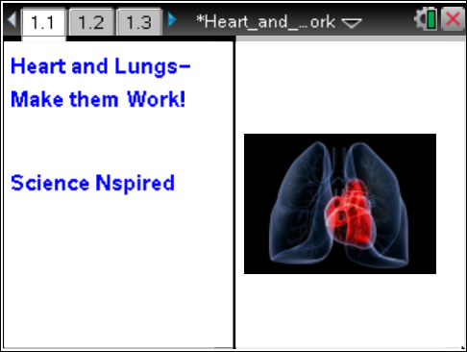

Move to page 1.2. |  |  |  | Press / ¢ and / ¡ to navigate through the lesson.
1. The graph on page 1.2 represents respiratory response data from a student during three continuous “Situations”. Click the ¢ icon in the top left of the screen and notice any changes that occur.
Move to pages 1.3–1.5. Answer the following questions here or in the .tns file.
Q1. What is the height of the wave (amplitude) measuring?
A. amount of air moving in and out of the lungs | B. respiratory rate |  | C. time
Q2. What is the distance between wave peaks (frequency) measuring?
A. amount of air moving in and out of the lungs | B. respiratory rate |  | C. time
Q3. What is the best explanation for what the student was doing during Situation 1 of the data collection?
A. hyperventilating  B. holding breath |  | C. increasing physical activity  D. breathing normally
Return to page 1.2. Answer the remaining questions on this worksheet only.
2. Click the ¢ icon in the top left of the screen to advance to Situation 2.
Q4. What is the best explanation for what the student was doing during Situation 2 of the data collection?
A. hyperventilating  B. holding breath |  | C. increasing physical activity  D. breathing normally
Q5. Using the terms frequency and amplitude, justify your answer choice for Question 4.

3. Click the ¢ icon in the top left of the screen to advance to Situation 3.
Q6. What is the best explanation for what the student was doing during Situation 3 of the data collection?
A. hyperventilating  B. holding breath |  | C. decreasing physical activity  D. breathing normally
Q7. Using the terms frequency and amplitude, justify your answer choice for Question 6.

Q8. Describe the overall pattern of the total graph on page 1.2 in terms of CO₂ levels and their effect on changes that occurred in the respiratory response.

Move to pages 2.1 and 2.2.
The graph on page 2.2 represents the heart rate data for a well-conditioned athlete performing a 200-second stress test of the following:
a. Standing still for 40 sec.
b. Running in place for the next 60 sec.
c. Standing still for the remaining 100 sec.
Q9. On the graph below, sketch a graph for a non-athlete, performing the same activity.

Q10. Explain your rationale for how you sketched the non-athlete’s graph in Question 9.

4. Now check your answers to Questions 9 and 10 by doing the following steps on your handheld.
a. Press Menu > Plot Properties > Add Y Variable.
b. Select hr2_bpm and the graph for the non-athlete will appear.
Q11. Describe how your prediction graph compared to the correct graph. Note: Ignore the auto-window which adjusts the y-axis.

