Open the TI-Nspire document Rotational_Motion_and_Torque.tns.  How do you balance on a see-saw so that you and your friend can keep the board balanced even if your weights are different? How is balancing a see-saw similar to a wrench? | 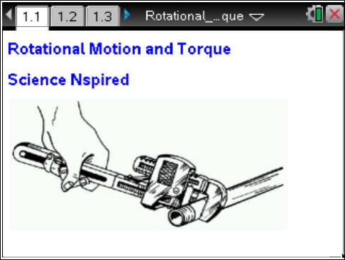

Move to pages 1.3 and 1.4. |  |  | Press / ¢ and / ¡ to navigate through the lesson.
In this activity you are going to explore how to keep eccentric (off center) forces in balance around a fulcrum point. Then you will expand this concept into an understanding of levers and torque.
1. Find four different situations where the beam (lever arm) is in balance by changing the mass1, the length1 and, the mass2. Enter the force and length values you used to balance the beam on page 1.4. Determine the force of mass1 and mass2 with the assumption that the value of gravity is 9.81 m/s². |  |  | 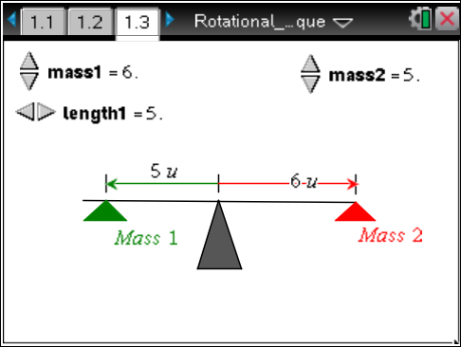
Move to pages 1.5–1.8. Answer the following questions here or in the .tns file.
Q1. If the applied forces are not equal, what else has to be considered to balance them?

Q2. When are Force 1 (F₁) and Force 2 (F₂) in balance?
A. F₁ = F₂  B. L₁ = L₂ | C. F₁ * L₁ = F₂ * L₂  D. F₁/L₁ = F₂/L₂ | E. none of the above
Q3. If a force of 50.0 N is placed at a distance of 3.00 m from the fulcrum, what would the length of the lever arm need to be for a force of 30.0 N to balance this beam?

Move to pages 2.1–2.3.
Balancing of Multiple Forces  2. On the following page the idea is to balance the forces on both sides of the beam by adjusting the forces (F₁ and F₂) and the distances (L₁ and L₂) from the fulcrum. Find multiple situations where the beam is balanced.  3. Enter the values on page 2.3 under F1 (force 1), L1 (length1), F2 (force 2), L2 (length2), F3 (force 3) and L3 (length 3). | 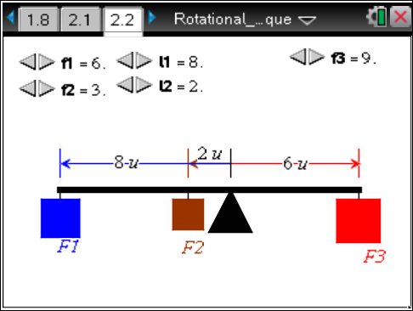
Move to pages 2.4–2.6. Answer the following questions here or in the .tns file.
Q4. What must be true of the conditions required for the beam to balance? Explain how this relates to the other situations where the beam was balanced.

Q5. What is the product of Force 3 and the lever arm of F₃?

Q6. How does the product of Force 3 and F₃’s lever arm compare to the other two forces and lever arms?

Move to pages 3.1 and 3.2.
4. Torque is defined as the product of the perpendicular force (F⊥) and the length of the lever arm (r). The perpendicular force is the force that is applied at 90 degrees to the lever arm. On page 3.2, determine the equilibrium torque (τ₀). Equilibrium torque is the maximum torque before rotation occurs.  F_perp represents the force perpendicular and r is the length of the lever arm. | 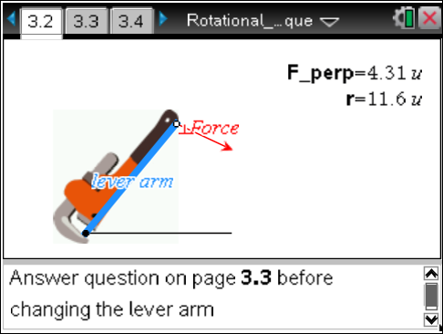

Move to pages 3.3–3.5. Answer the following questions here or in the .tns file.
Q7. Torque is defined as the product of the lever arm (r) and the perpendicular force (F⊥). What is the equilibrium torque needed on page 3.1?

Q8. If the end point of the lever arm is moved does the product of r and F⊥ change? Explain.

Q9. How long does the lever arm need to be for a perpendicular force of 5.00 N to create a torque of 35.0 N·m?

Move to pages 4.1 and 4.2.
5. Torque without perpendicular forces. When a person is pulling or pushing on a wrench to loosen a nut they sometimes are not applying a force perpendicular to the wrench or lever arm. Explore the result of changing the force vector to a non-perpendicular position to the lever arm. | 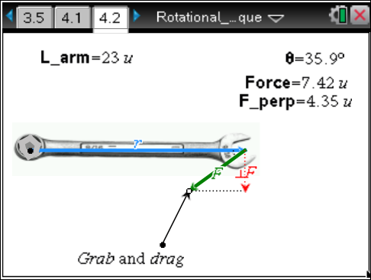
Move to pages 4.3–4.6. Answer the following questions here or in the .tns file.
Q10. What angle between r and F requires the least amount of force?

Q11. What is the torque for this diagram?

Q12. Since the total torque of this system does not change, how can the force at any angle be calculated based on that angle?

Q13. A force of 20.0 N is applied at a 70° angle to a lever arm that is 0.500 m long, what is the torque?

