Open the TI-Nspire document Air_Movement_in Pressure_Systems.tns  How often do you check the weather forecast when you make plans for an outdoor activity? While no forecast can ever be 100% certain, meteorologists are generally very good at predicting the weather. How do they do it? Cloud cover, wind direction, pressure, temperature and humidity are all important factors used in predicting the weather.  Meteorologists also observe patterns that occur in the atmosphere, such as the movement of high and low pressure systems. Low-pressure systems generally bring clouds and precipitation. High-pressure systems normally bring dry weather and mostly clear skies.  In this activity, you will observe how pressure systems and the rotation of the earth affect the movement of air in the atmosphere. |  | 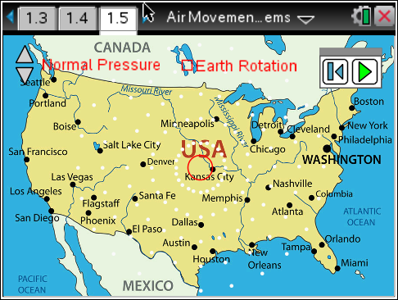
Move to page 1.2 and read the information given.
Wind is moving air. It is produced by the uneven heating of the earth’s surface by the Sun. When the Sun heats a region near the earth's surface, the air in that region heats up and begins to rise upwards into the atmosphere. This creates an area of low pressure near the surface. Because the Sun heats different regions unevenly, there are various regions of high pressure and low pressure acorss Earth's surface. Air moves from areas of high pressure to areas of low pressure, producing wind. Part of weather forecasting involves knowing the locations as well as the directions of motion of pressure systems.

Move to pages 1.3 - 1.4 and answer questions 1 and 2 below and/or on your device.
Q1. A high pressure system moves

A. towards other high pressure systems.
B. towards low pressure systems.
C. away from low pressure systems.

Q2. There is a low pressure system at point A. There is a high pressure system at point B, which is 10 miles north of point A. In which direction will the wind blow?

A. north
B. south
C. east
D. west

Move to page 1.5.
Read the directions for the simulation.
1. Begin by selecting High Pressure. Leave the Earth Rotation box unchecked. Select the Play button and observe the motion of the air molecules in the system. (The air molecules are represented by white dots).  2. Select the Reset button and change the pressure to Low Pressure. Then select Play and observe the motion of the air molecules in this type of system.  3. Repeat this process with Normal Pressure. | 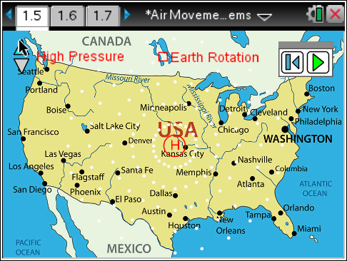
Tech Tip: To access the Directions again, select b or Document Tools () > Air Movement in Pressure Systems > Directions.
Tech Tip: To access the Directions again, select > Air Movement in Pressure Systems > Directions.
Move to pages 1.6 - 1.8. Answer the questions on your handheld and/or below.
Q3. If the earth did not rotate, in what direction would the air move in a high pressure system?

A. move inward in a straight line
B. curve inward
C. move outward in a straight line
D. curve outward

Q4. If the earth did not rotate, in what direction would the air move in a low pressure system?

A. move inward in a straight line
B. curve inward
C. move outward in a straight line
D. curve outward

Q5. Describe the air circulation in the normal pressure system. Propose a reason for your observation.

Return to page 1.5.
5. Check the Earth Rotation box and repeat the simulation for all three pressure systems. Observe the motion of the air molecules.

Move to pages 1.9 - 1.15 and answer the questions on your handheld and/or below.
Q6. How does the rotation of the earth affect the movement of the air in the northern hemisphere?

Q7. In what direction does the air move in a high pressure system in the northern hemisphere?

A. moves inward in a straight line
B. curves inward
C. moves outward in a straight line
D. curves outward

Q8. In what direction does the air move in a low pressure system in the northern hemisphere?

A. moves inward in a straight line
B. curves inward
C. moves outward in a straight line
D. curves outward

Q9. Looking at the high pressure system, what is the wind direction in Denver?

A. northeast
B. northwest
C. southeast
D. southwest

Q10. Looking at the high pressure system, what is the wind direction in Nashville?

A. northeast
B. northwest
C. southeast
D. southwest

Q11. Looking at the low pressure system, what is the wind direction in Minneapolis?

A. northeast
B. northwest
C. southeast
D. southwest

Q12. Looking at the low pressure system, what is the wind direction in Salt Lake City?

A. northeast
B. northwest
C. southeast
D. southwest

Move to page 1.16. Observe the graphic shown. Then, move to pages 1.17 and 1.18 and answer the questions on your handheld and/or below.
Q13. In what direction would the air move in a low pressure system in the southern hemisphere?

A. curves clockwise inward
B. curves clockwise outward
C. curves counterclockwise inward
D. curves counterclockwise outward

Q14. Predict the approximate locations of the center of the system as it moves across the USA.

A. Denver, Salt Lake City, Boise
B. Santa Fe, Flagstaff, San Diego
C. Memphis, Atlanta, Orlando
D. Chicago, Cleveland, Boston

