Open the TI-Nspire document sigfigs_en.tns.

As scientists collect data for scientific experimentation, they rely upon measurements and calculations to make sense of their data. Imagine you are a biologist whose job is to calculate the correct amount of food for each animal in captivity per day based upon the animal's weight. First, you would have to be sure you have the most accurate weight of each animal. A measurement is only as accurate and precise as the tool that produces it. Scientists have to express the accuracy of a number, not just the numerical value itself. To do this, scientists determine accuracy by the number of significant figures a measurement contains.

You will be using a significant figures tool to perform calculations using addition (+), subtraction (-), multiplication (×), and division (÷). This program allows you to display the significant figures of entered values. It also allows you to perform mathematical operations using either decimal or scientific notation, and to display the result with the correct number of significant digits.

There are some important rules to consider when calculating with significant figures:
- When multiplying and dividing, round your answer to the least number of significant figures in any of the factors.
- When adding or subtracting, round your answer to the least number of decimal places shown in any of the numbers that make up your answer.
On page 1.1, you will see a list of directions explaining how to use the significant figure tool. Look over these and check with your classmates and teacher to discuss any items you do not understand.

Move to page 1.2. |  | Press / ¢ and / ¡ to navigate through the lesson.
Example 1:
In this first example, you will learn how to navigate a significant figure problem using the handheld.
- Enter 126.45 into the Calculate box and press ·.
- The Answer box displays the number in terms of the number of Significant figures. (5)
- Delete the last two numbers (45) and the decimal point so that the number reads 126 in the Calculate box and press ·
(or e to and press ·).
- The Answer box displays the number in terms of the number of Significant figures. (3)
Example 2:  A baby ostrich weighs 58.4 lbs and gains 12.64 lbs in two months.  Q1. Type the problem into the Calculate box as shown in the screenshot at the right.  A. What is the baby ostrich’s new weight (lbs)?  B. How many significant figures are there in the answer? Why? | 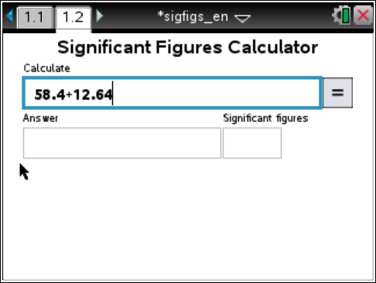
NOTE: Remember the rules of rounding:
- When the number to the right of the last significant figure is less than five, keep the number the same and change the rest of the numbers to the right to zeros.
- When the number to the right of the last significant figure is greater than five, increase the last significant figure by one and change the rest of the numbers to the right to zeros.

Part 1: Significant Figures of Numbers
How many significant figures are there in a number?
NOTE: When entering scientific notation numbers into the handheld, you must do the following:
- Enter the number with the decimal point with no spaces after the number.
- Press i at the bottom left of the keypad. It will appear in the Calculate box as e.
- If the exponent is a negative number, press v before entering the exponent.
- Example: If you entered À^ÂÇivÁ, it would appear as 1.38e–2 in the Calculate box.
- Click and the answer should read 0.0138 with 3 significant figures.

Q2. For each number in the table, determine the number of significant figures. Type the number into the Calculate Box and click . Record the number of significant figures in the table below.

Number | # of Significant Figures | Number | # of Significant Figures
387.04 |  | 2.530
0.00193 |  | 0.00713
12.00075 |  | 10,634.005
2.15 × 10³ |  | 6.02 × 10²³
405.0089 |  | 0.022
0.0130507 |  | 9.1 × 10⁻³
6506 |  | 400,000

In this tool, you must enter a decimal point at the end of a number. The handheld does not automatically assume that there is a decimal point at the end of a number unless you enter the decimal point.

Q3. Enter the following numbers into the Calculate box and click .
A. How many significant figures are there in the number 1,200?

B. How many significant figures are there in the number 1,200.? (Enter a period after 1,200.)

Q4. Determine the location of the last significant digit of each number by underlining the digit.

A. 6,070. B. 0.00213 C. 90,312.
D. 8,900. E. 0.1020 F. 0.00410

Now, check your answers by entering the numbers into the significant figures calculator.

Part 2: Significant Figures of Problems

You can use this significant figures tool to determine the number of significant figures for a mathematical problem. After the problem is entered and is clicked, the numeric answer and number of significant figures will be displayed. The steps to determine the answer of the problems are displayed under the Answer box. If there are more than two operations in the problem, left and right arrow buttons ( and ) will appear on the right side of the page. Click these buttons to see all the steps.

Q5. Calculate the problems in the table using your handheld. Record the numeric answer and the number of significant figures in the answer.

Problem | Answer | # Significant Figures
1.35 × 2.467
1045 ÷ 35.23
0.15 + 2.86 + 32.046
0.0087 + 1.345 + 100.1
1.278 × 0.6548 × 0.012
893.13 – 674.005
505 ÷ 6.5
55.46 – 27.3
3003.45 ÷ 13.2 × 55.003
19.45 × 7.29 ÷ 2.114

Student Inquiry
Using your knowledge of significant figures, answer the following questions.

Q6. Reduce the number 4897.84 to four significant figures:

Q7. Explain in a sentence how you determined the four significant figures for the number in question 6.

Q8. Give an example of a situation or experiment in which a chemist studying exothermic (heat is released) reactions might use this significant figures calculator tool.

