Open the TI-Nspire document Balancing_Torques_and_Forces.tns  In this activity, you will explore the relationships between the effort force and the lever arm in three types of levers, and the conditions necessary to produce static equilibrium.  Pre-lab Information  You will study the conditions necessary to produce static equilibrium in first-, second-, and third-class levers. Static equilibrium occurs when the net force and net torque on the system are both zero. | 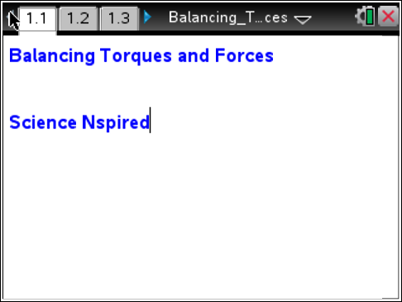
You will measure the effort force required to balance the meterstick a) when the fulcrum is between the effort force and the resistance force (first-class lever), b) when the resistance force is between the fulcrum and the effort force (second-class lever), and c) when the effort force is between the fulcrum and the resistance force (third-class lever). You will apply your knowledge of torque to analyze the relationship between the lever arm and the effort force in each case.
Problem 1: First-Class Levers  Move to page 1.2 and answer the pre-lab questions here.  1. Place a fulcrum close to the edge of the table and balance a meterstick on the fulcrum. Place the level on top of the meterstick and use it to check the balance.  Q1. If you place a mass at the 90-cm mark on the meterstick, where do you think you would need to apply a larger force to balance the meterstick—at the 10-cm mark or at the 40-cm mark? Assume that the fulcrum is at the 50-cm mark.  Q2. What forces act on the system in static equilibrium? Draw a force diagram. | 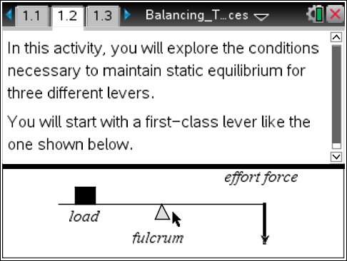
Problem 1: Lab Set-Up and Procedures  Move to page 1.3.  2. You will use a Vernier Dual-Range Force sensor to collect force data. Make sure the switch is on the force sensor is in the ±10N position. Connect the EasyLink interface to your handheld (or the Go! Link interface to your computer).  3. Select Menu > Experiment > View > Graph. The data you collect will be displayed in the graph view.  4. Wait for the data collection display to stabilize, and then zero the force sensor (Menu > Experiment > Set up Sensors > Zero). Then, make a string loop and use it to hang the mass from the hook on the force sensor. Once the reading stabilizes, record the reading as the resistance force. (Note: Throughout this activity, record forces to the nearest tenth of a newton.)  5. Remove the mass from the force sensor. Re-zero the force sensor (once the reading has stabilized).  6. Set up the data collection for Events with Entry Mode (Menu > Experiment > Collection Mode > Events with Entry).  7. Place the mass on the meterstick, centered on the 90-cm mark. Loop the string over the meterstick at the 10-cm mark. | 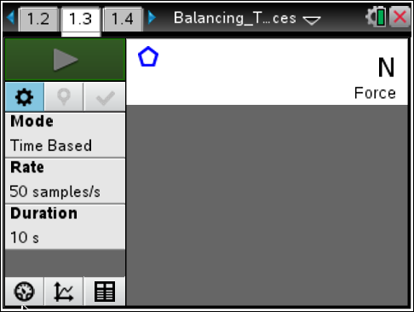  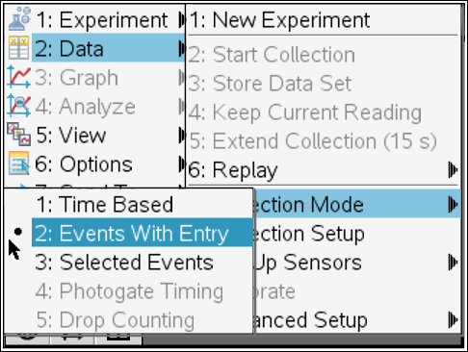

8. Start the data collection by clicking on Start and then pull downward on the force sensor until the meterstick is balanced (use the level to check that the meterstick is horizontal). Once the reading is stable, click on Keep to save the data point. In the event box, enter the distance (in meters) between the fulcrum and the string. (For example, if the fulcrum is at 50 cm and the string is at 10 cm, enter 0.4 in the event box.)
9. Repeat Step 8 at least four times, moving the string 5 cm closer to the fulcrum for each trial. Once the data have been collected, stop the data collection, and disconnect the EasyLink from the handheld (or Go! Link from the computer).
Answer the following questions here.
Q3. What was the length of the resistance arm (the lever arm of the resistance force) in each trial?

Q4. What was the length of the effort arm (the lever arm of the effort force) in each trial?

Q5. What happened to the effort force as you decreased the length of the effort arm?

Move to page 1.4  10. You will calculate the torque produced by the effort force. Move to the formula bar of column A and select the variable run1.event. Then, set column B to display the variable run1.force, the data set containing the effort force data you collected. Label column A “e_arm” and column B “e_force.”  11. Label column C “torque.” Then, enter the expression =a[ ] • b [ ] in the formula bar for column C and press ·. Column C should now display the effort torque for each trial. | 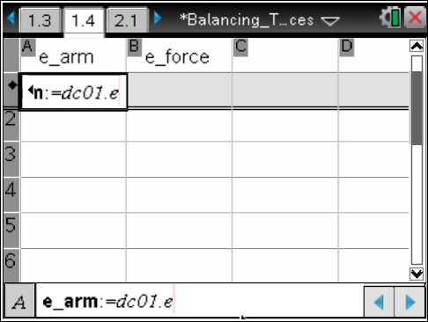

Answer the following questions here.
Q6. The effort force produces a torque on the lever. What happens to the magnitude of that torque as you change the position where the effort force is applied? Explain your answer.

Q7. What type of mathematical equation represents the relationship between the length of the effort arm and the magnitude of the effort force?

Q8. How could this relationship between effort force and lever arm be used to reduce the effort required to lift a heavy load with a first-class lever?

Problem 2: Second-Class Levers  Move to page 2.1 and answer the pre-lab questions here.  12. Place the fulcrum in the middle of the table, and place the meterstick on top of it so that fulcrum is aligned with the 90-cm mark on the meterstick.  Q9. How is the second-class lever different from the first-class lever?  Q10. What forces act on this system in static equilibrium? Draw a force diagram.  Q11. At what position do you think the effort force is minimal? Explain your answer. | 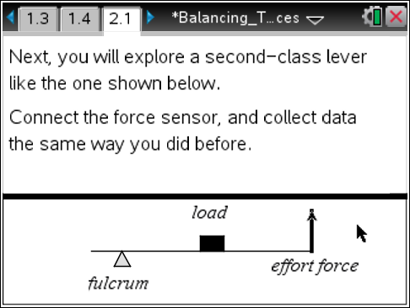
Problem 2: Lab Set-Up and Procedures  Move to page 2.2.  13. Connect the EasyLink interface to your handheld (or the Go! Link interface to your computer).  14. Select Menu > Experiment > View > Graph. The data you collect will be displayed in the graph view.  15. Wait for the data collection display to stabilize, and then re-zero the force sensor (Menu > Experiment > Set up Sensors > Zero).  16. Set up the data collection for Events with Entry Mode (Menu > Experiment > Collection Mode > Events with Entry).  17. Place the 200-g mass on the meterstick, centered on the 50-cm mark. Slide the string loop to the 10-cm mark on the meterstick.  18. Start the data collection by clicking Start , and then pull upward on the force sensor until the meterstick is horizontal. Click on Keep to save the data point. In the event box, enter the distance (in meters) between the fulcrum and the string.  19. Repeat Step 18 at least four times, moving the string 5 cm closer to the fulcrum at each trial. Once the data have been collected, stop data collection and disconnect the sensor. | 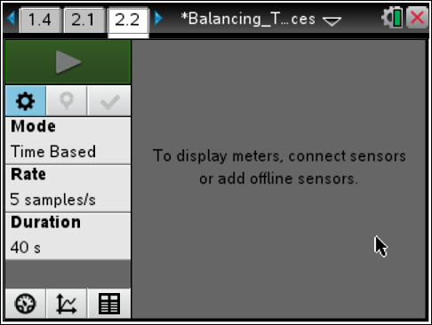
Answer the following questions here.
Q12. What were the initial lengths of the effort and resistance arms?

Q13. What happened to the effort force as you decreased the length of the effort arm?

Move to page 2.3

20. As you did in Problem 1, use the spreadsheet to calculate torque. Set column A to display run1.event and column B to display run1.force. Label column A “e_arm” and column B “e_force.”  21. Label column C “torque.” Enter the expression =a[ ] • b [ ] in the formula bar for column C and press ·. | 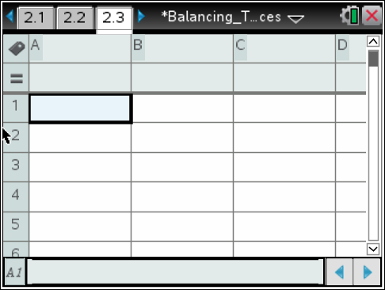

Answer the following questions here.
Q14 What happens to the effort torque as you change the position where force is applied? Explain your answer.

Q15. Give a real-world example of a second-class lever.

Q16. In a second-class lever, where should the load be placed to minimize the effort force?

Problem 3: Third-Class Levers  Move to page 3.1 and answer the pre-lab questions here.  22. In this part of the activity, leave the meterstick and fulcrum in the same positions as they were in for Problem 2  (the fulcrum at the 90-cm mark on the meterstick). Remove the mass from the meterstick.  Q17. Is it possible to balance a third-class lever with an effort force that is smaller than the resistance force? Explain your answer.  Q18. What forces act on the system in static equilibrium? Draw a force diagram. | 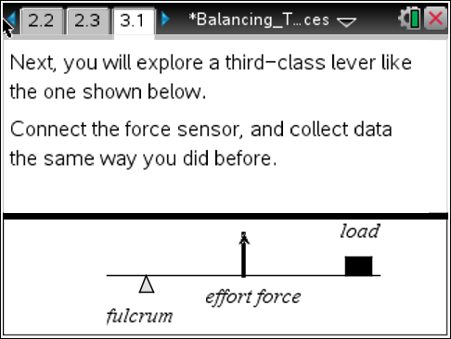
Q19. What is a common third-class lever you use every day?

Problem 3: Lab Set-Up and Procedures
Move to page 3.2.
23. Connect the EasyLink interface to your handheld (or the Go! Link interface to your computer).
24. Select Menu > Experiment > View > Graph. The data you collect will be displayed in the graph view.
25. Wait for the data collection display to stabilize, and then re-zero the force sensor
(Menu > Experiment > Set up Sensors > Zero).
26. Set up the data collection for Events with Entry Mode (Menu > Experiment > Collection Mode > Events with Entry).
27. Place the string loop at the 80-cm mark on the meterstick. Place the 200-g mass at the 10-cm mark on the meterstick.
28. Start the data collection by clicking Start , and then pull upward on the force sensor until the meterstick is horizontal. Click on Keep to save the data point. In the event box, enter the distance (in meters) between the fulcrum and the string.
29. Repeat Step 28 at least four times, moving the string 5 cm closer to the fulcrum at each trial. Once the data have been collected, stop data collection and disconnect the sensor.
Answer the following questions here.
Q20. What were the initial lengths of the effort arm and the resistance arm?

Q21. What happened to the effort force as you increased the length of the effort arm?

Move to page 3.3  30. As you did in Problems 1 and 2, use the spreadsheet to calculate torque. Set column A to display run1.event and column B to display run1.force. Label column A “e_arm” and column B “e_force.”  31. Label column C “torque.” Enter the expression =a[ ] • b [ ] in the formula bar for column C. | 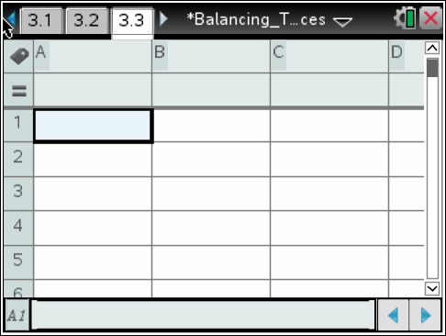

Answer the following questions here.
Q22. What happens to the effort torque as you change the position where force is applied? Explain your answer.

Q23. Why would you use third-class levers if they do not reduce the required effort force?

