Open the TI-Nspire™ document Analyzing_Country_Data.tns.  This investigation will compare and contrast the population distributions of the United States, Kenya, and Japan. Issues related to commerce, health, transportation, and education are related to the information in this investigation. | 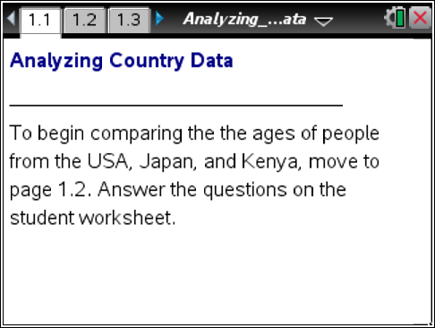
According to the 2010 US Census, nearly 15% of the population is 45 to 54 years old. A summary of the USA population from birth to over 100 years old indicates that more people are 45 to 54 years old than any other 10-year age group. What challenges does this pose for the United States? Does this affect teenagers or people who are younger? In what way could the data explain some of our challenges in education, health care, transportation?

Other countries have challenges and opportunities based on different distributions of their populations. How might other countries benefit by studying Japan or Kenya’s special demographics? (See Bluezones.com)

Move to page 1.2.
1. The spreadsheet shows a sample of the ages of 200 people from each of the United States, Kenya, and Japan. The numbers have been rounded to the nearest integer not larger than the number, so a "2" in a cell indicates someone who is two years old but not yet three.
a. Identify the age of the youngest person and the age of the oldest person in each of the three samples.

Country | Youngest | Oldest
USA
Kenya
Japan

b. Based on the list of ages from each sample, how do you think a summary of the population of the USA differs from a summary of the population of Kenya? In a similar way, how would a summary of the USA population differ from a summary of the population of Japan? Explain your answers.

Move to page 1.3.

The histogram in the upper region of the screen displays the sample population data for the USA and the histogram in the lower region of the screen displays the sample population data for Kenya. Note that the vertical scale for each histogram is percent.
2. Describe at least two differences between the histogram of the USA sample and the histogram of the Kenya sample.

3. Move the cursor over the bins in the histogram.
a. Stop the cursor at the first bin for the USA. What ages are represented by this bin? How many people from the sample does this bin represent?

b. What percent of the Kenya sample represents 0, 1, 2, 3, and 4-year olds? How many people does that percentage represent?

c. What percent of the sample population in each of the two countries is under 30 years old? Explain how you found your answer.

d. What percent of the sample population in each of the two countries is 65 and older?

e. Based on the differences in the percents derived from the samples, would you change your previous descriptions of the population distributions of these two countries? Why or why not?

f. How is using histograms to compare the population samples from the two countries different from using a spreadsheet?

4. a. What ages are summarized by [10,15)?

b. What percent of each sample is in that age interval?

c. Without using the spreadsheet of the actual data, estimate the percent of people in this interval who are 13 or 14 years old. Explain how you derived your estimate.

d. Based on your estimate in c, what percent of the USA sample are teenagers (13 to 19 years old)?

e. In a similar way, estimate the percent of the Kenya sample who are teenagers.

Move to page 1.4.

5. a. What percent of the Japanese sample population is in the age bracket [0,5) years old?

b. What percent of the Japanese sample population is under 30 years old?

c. What percent of the Japanese sample population is 65 and older?

d. Using the numbers in the USA and Japan who are in the [0,5) age range and those 65 and over, compare the ages of people in the USA and in Japan. Explain your thinking.

6. Estimate the percent of teenagers in Japan in a way similar to the one you used to estimate the percent of teenagers for the USA and Kenya.

Move to page 1.5.

7. Which country do you think is represented by the box plot for country_x? Which country do you think is represented by the box plot for country_y? Explain your reasoning.

8. Move the cursor over the box plots on Page 1.5, and fill out the tables for each country.
a. USA sample:
Minimum age | Q1 | Median Age | Q3 | Maximum age

b. country_x:
Minimum age | Q1 | Median Age | Q3 | Maximum age

c. country_y:
Minimum age | Q1 | Median Age | Q3 | Maximum age

9. What additional information do the box plots provide that were not provided in the histograms?

10. According to the US Census Bureau in the year 2000, the population of the United States was approximately 285 million people.
a. If the USA sample provided in this investigation were representative of the United States, what is an estimate of the number of people 0 to 9 years old?

b. If another sample of 200 people were obtained from the USA population, do you think you would get the same percent of people 0 to 9 years old? Why or why not?

c. Statistical techniques suggest that the variation in estimates from sample to sample for a sample size of 200 is about + or -7%. For the percent of the 0 to 9-year olds from the sample, what interval of percents might be seen in multiple samples of size 200?

d. Given that there are about 285 million people in the USA, use your answer in part c to determine a reasonable range of estimates for the number of people in the USA who are 0 to 9 years old.

11. The estimated population of Kenya in 2000 was 31 million people, and the estimated population of Japan in 2000 was 127 million people. Use the information about the samples of 200 people in each country in the TI-Nspire activity and the +/- 7% rule to estimate the number of people within the age categories specified in the table.

 | United States | Kenya | Japan

Ages 0-9
Sample percentage
Interval
Estimated number of people

Older than 65
Sample percentage
Interval
Estimated number of people
Teenagers (13-19)
Sample percentage
Interval
Estimated number of people

Extension:
Create your own country that has the following characteristics:
- The total population of your country is approximately 140 million people who are 0 to 100 years old.
- 15% of the people are 0 to 9 years old.
- 25% of the people are 65 to 100 years old.
- The median age is approximately 37 years old.

1. Draw a prediction of your estimation for what the histogram and boxplot would look like.

2. Create a sample of 200 people for your country in the spreadsheet. Be sure to label the country at the top of the column.
3. Insert new pages (/ ~), and graph a histogram and boxplot of your sample.
4. Compare your country’s histogram and box plot to that of the United States. (Don’t forget to name your country.) Refer to the Statistics Math Nspired Activities Multiple Boxplots and How to Make Histograms if you need help making these plots.

