Open the TI-Nspire document Basic_Limits.tns.  How can you find one-sided and two-sided limits graphically? You will examine each graph presented in the TI-Nspire document and answer the questions on the following pages. Grab and move the open circle on the x-axis to help answer the questions. Once you have determined your answer, you may record your results on the worksheet or the TI-Nspire document depending upon your teacher’s instructions. | 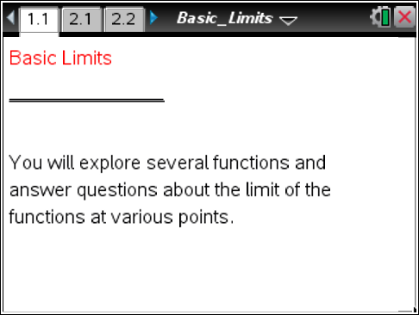

Move to page 2.1. | Press / ¢ and / ¡ to navigate through the lesson.
1. What is the limit of f(x) as x→1⁺?

2. What is the limit of f(x) as x→1–?

Move to page 3.1.

3. What is the limit of f(x) as x→–2⁺?

4. What is the limit of f(x) as x→–2–?

Move to page 4.1.

5. What is the limit of f(x) as x→3⁺?

6. What is the limit of f(x) as x→3–?
Move to page 5.1.

7. What is the limit of f(x) as x→1⁺?

8. What is the limit of f(x) as x→1–?

Move to page 6.1.

9. What is the limit of f(x) as x→0–?

10. What is the limit of g(x) as x→0⁺?

Move to page 6.3.

Let h(x) = g(x) + 1.
11. What is the limit of h(x) as x→0⁺?

Move to page 6.4.

12. Define a function j(x) in terms of f(x) that makes the graph continuous.

Move to page 7.1.

13. Define a function j(x) in terms of g(x) that makes the graph continuous.

Let h(x) = f(x) – c.
14. What value of c makes the limit of h(x) as x→1– = 2?

