Activity Overview
In this activity, you will create three parallel boxplots and compare them.

Materials
- Technology needed (TI-Nspire™ handheld, computer software)

Step 1—Preparing the Document  1. Open a new document by selecting c > New Document > Add Notes.  2. Type “Multiple Boxplots” as the activity title on the first page.  Note: To obtain capital letters, press the g key and then the letter. | 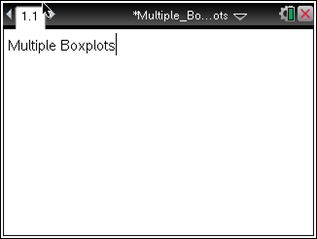
3. Select ~ > File > Save As, and type Multiple_Boxplots as the file name. Press e to move the cursor to ¾ , and press ·.

Note: To obtain the underscore, press / _.

4. To add a new page, select / ~ > Add Lists & Spreadsheet.

 | Test Scores
Harris | 80 | 90 | 93 | 77 | 75 | 70 | 68 | 85 | 78
Smith | 50 | 68 | 95 | 75 | 83 | 90 | 98 | 55 | 65
Brown | 85 | 88 | 76 | 90 | 84 | 74 | 78 | 84 | 80

5. The data above represents the test scores of three students in a Statistics class. Enter the data into the Lists & Spreadsheet page as shown. | 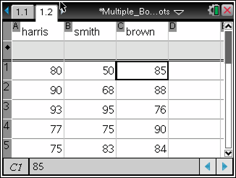
Step 2—Creating a Boxplot  Note: Statistics graphing is done through the Data & Statistics application.  6. To add a new page, select / ~ > Add Data & Statistics. | 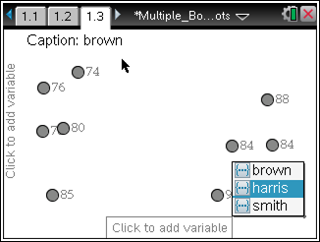
7. Move the cursor to the bottom of the page where it says “click to add variable,” and press x. Select one of the students. The screen will display a dot plot of the data.

Note: To create a vertical plot instead of a horizontal one, move the cursor to the left of the page where it says “click to add variable,” and press x.

8. To change to the dot plot to a boxplot, select MENU > Plot Type > Boxplot. | 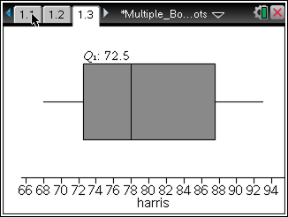
Step 3—Creating a Parallel Boxplot  9. Select MENU > Plot Properties > Add X Variable.  10. Select another student’s data. | 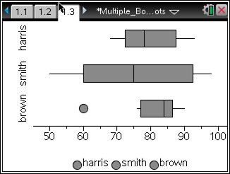
11. Repeat Steps 1 and 2 so that the data for all three students are represented on the same screen.

Note: Outliers are displayed by default. To extend the whiskers, select MENU > Plot Properties > Extend Box Plot Whiskers.

Step 4—Data Analysis  12. Move the cursor over the plot to show the key values such as the Median, the Q₁, and the value of the maximum. | 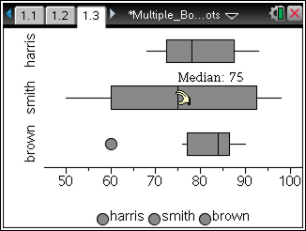
Note: To change the color of a boxplot, move your cursor over one of the boxplots, and press x. Then, select ~ > Edit > Color > Fill Color and the color you would like for your data set using the arrow keys. Press · to select a color. To change the color of another boxplot, move your cursor to the white part of the screen, press x, and then repeat the directions above.

