Open the TI-Nspire document Rock_Formations.tns  Many processes are at work on the earth’s surface. Weathering, erosion, and deposition all shape the landscape we see around us. The movement of water is an example of all three processes occurring at the same time. Rock particles in the water can wear down larger rocks around the water. This is an example of weathering. Water can erode rocks as it dissolves and carry away minerals in the rock. Also, water can deposit small rock pieces in a new location. In this simulation, you will observe the effects of wave action on a rock cliff. |  | 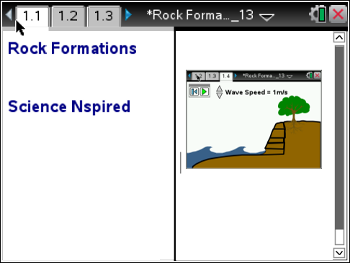
Move to page 1.2 and read the background information below or in your .tns file.

Weathering is the process that breaks down rocks into smaller pieces. Erosion is the process of moving weathered rock and soil by wind, water, and, ice. Deposition is the dropping of materials moved by erosion. These processes work together to create the rock formations we see on Earth. Some processes work slowly over long periods of time. Others can occur rapidly. Geoscience processes include weathering and erosion by the movements of water, ice, wind, and the force of gravity.

Move to pages 1.3 - 1.4 and answer questions 1 and 2 below and/or on your device.
Q1. Water waves pound on the face of a rock cliff. Which of the following processes can occur over time?

A. weathering
B. erosion
C. deposition
D. all three can occur

Q2. Geoscience processes can change the earth’s surface:

A. very quickly
B. over the course of hundreds of thousands of years
C. all of the above

Move to page 1.5.
Read the instructions for the simulation.
1. Select the Play button to start the simulation. Observe what is happening to the rocks at the base of the cliff.  2. Select the up and down arrows to change the speed of the waves.  3. Run the simulation until the bottom layer of the cliff has eroded completely. | 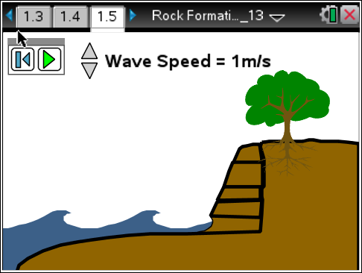
Tech Tip: To access the Directions again, select b or Document Tools () > Rock Formations > Directions.
Tech Tip: To access the Directions again, select > Rock Formations > Directions.
Move to pages 1.6 - 1.12. Answer questions 3 - 9 below and/or in your .tns file.
Q3. What happens to the size of the bottom layer of rock during the simulation?

A. It increases.
B. It decreases.
C. It stays the same.

Q4. The waves smash into the rock, knocking off small particles from the rock cliff. Which process or processes does this demonstrate?

A. weathering
B. erosion
C. deposition

Q5. After the small particles of the rock cliff are knocked off, the waves carry them away. Which of the following process or processes does this demonstrate?

A. weathering
B. erosion
C. deposition

Q6. What force caused the upper rock layers to fall into the ocean?

- waves
- gravity
- water

Q7. Which of the following process or processes best categorizes the action of the upper rock layers on the cliff falling into the ocean and settling onto the ocean floor?

A. weathering
B. erosion
C. deposition

Q8. Which action best demonstrates erosion and weathering over a long period of time?

A. wave action dissolving and abrading the lowest rock layer
B. gravity causing the unstable upper rock layers to fall

Q9. What would eventually happen to the upper rock layers that fell into the ocean?

