Open the TI-Nspire document What_Is_A_P-value.tns.  Suppose you draw a sample from a population you assume has a given mean and calculate a sample mean from your sample. How likely are you to draw a sample that will have a mean at least as extreme as your observed sample mean? This activity will help you think about this question. | 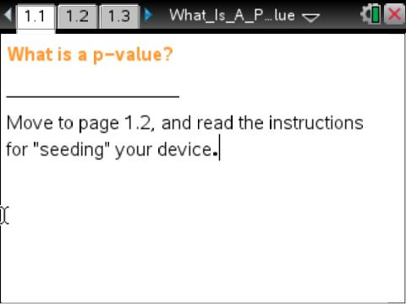

Move to page 1.2.

This activity involves generating a number of random samples from a population. In order to avoid results that are identical to those of another student in the room, it is necessary to “seed” the random number generator. Read the instructions on Page 1.2 for seeding your random number generator.

Move to page 2.1.

Consider the following hypothesis test scenario:  H₀: μ = 10 and H_{a}: μ > 10  Page 2.1 represents a population whose mean is 10, as assumed in the null hypothesis. | 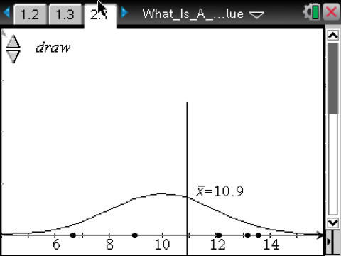
1. Use the arrow labeled “draw” to select a random sample of size 5 (n = 5) from this population.
a. What do the points in the graph represent?

b. What does the vertical line in the graph represent?

c. Estimate the values of the elements in the sample and give the sample mean.

d. Considering the alternative hypothesis stated above, does it seem likely that your sample came from the hypothesized population or from a population whose mean is noticeably larger than 10? Explain your reasoning.

2. Predict the sampling distribution of the sample means from this population.

Use the random sample you have for Question 1 to answer the next set of questions.

Move to page 2.2.

The graph in the top work area is from Page 2.1 with the vertical axis rescaled; the one in the lower work area is the sampling distribution of sample means of size 5 from that population.

The term p-value describes the probability that the mean of a new sample will be at least as extreme in the direction of the alternative hypothesis as the one from the random sample you drew if the null hypothesis is correct. The shaded area in the lower screen indicates the p-value.

3. a. Interpret the p-value you have on your screen.

b. Explain why this area represents a probability.

c. Based on your observed p-value, does it seem likely that your sample came from a population with mean = 10? Why or why not?

Move to page 2.3, without changing the p-value you found above.

The distribution curve on Page 2.3 is a rescaled plot of the curve in the lower work area of Page 2.2. However, the values generated by the draw arrow here are not the sample values as on Page 2.1. Instead, the means of samples are plotted, with five sample means displayed for each click.

4. Use the draw arrow to select 100 sample means.
a. How does the simulated sampling distribution of the sample means compare to your predictions in Question 2? Explain any differences.

b. From your simulation of sample means, estimate the likelihood of getting a sample from the given population so that the new sample mean is at least as extreme as the original observed sample mean.

Move to page 3.1.

5. Assume H₀: μ = 10 and H_{a}: μ > 10.
a. Draw samples from the population for n = 5 until you find a p-value less than 0.1. What are your sample mean and the corresponding p-value?

b. Change the sample size to n = 10, and draw samples until you get a sample mean close to the sample mean you found in part a. What is the corresponding p-value? Repeat the process for sample size n = 15.

c. Jordan found an observed sample mean for a sample of size n = 5 and claimed that a sample of size n = 20 with the same sample mean would have the same p-value. Explain whether you agree with Jordan and why.

6. All of the work in this activity has assumed that H₀: μ = 10 and H_{a}: μ > 10. How would your thinking change if H_{a}: μ < 10?

7. In earlier work, you studied alpha levels. Describe similarities and differences between alpha levels and p-values.

