Open the TI-Nspire document Newton and THE Law.tns.  Newton’s three laws of motion are among the most fundamental laws of physics. They help us describe the motion of objects that we see in our everyday lives, such as a football moving through the air or a car skidding to a stop. In this activity, you will explore how two of Newton’s laws apply to collisions between cars. | 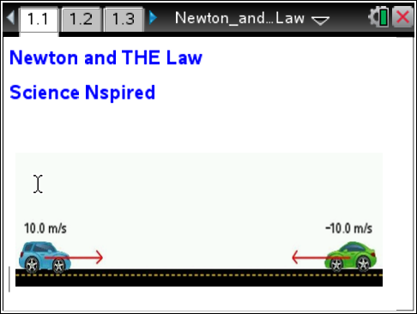
Move to pages 1.2 –1.3 and read the background information for this activity.
The average acceleration of an object is equal to the change in velocity of the object over a period of time. A force is a push or pull on an object. Forces cause objects to accelerate. According to Newton's second law, the acceleration, a, of an object is proportional to the net external force, F, that acts on the object. The acceleration of the object is also inversely proportional to the mass, m, of the object. Another way of stating Newton's second law is: F = ma.
Newton's third law of motion states that for every action, there is an equal and opposite reaction. Consider a girl standing on ice with a heavy bag in her hand. If she throws the bag, she exerts a force F on the bag. According to Newton's third law of motion, the bag will exert an equal force back on the girl! So, the girl exerts a force F on the bag, and the bag exerts a force -F on the girl.
Move to page 1.4.  Read the directions for the simulation.  - To begin, you will observe the final velocities of each car when the cars have the same initial mass and speed. Use the up and down arrows (¤ and £) to set the mass of the blue and green cars. Set the masses of each car equal to 1.00 kg. Observe the initial velocities of each car.  - Then, select the play button to run the simulation. Observe the final velocities of each car after the collision.  - Repeat this process for different values of mass. In each trial, keep the mass of the cars equal to one another. Select the  button to reset the simulation after each trial.  - Next, you will observe the final velocities of each car when the cars have the same initial mass but different initial velocities. Set the mass of each car equal to 1.00 kg again.  - Select and drag the arrow of the blue car to the left or right to change its velocity. Select the arrow again to lock it in place. Repeat this process to change the velocity of the green car. The two speeds should not be equal to one another, but be sure to set the arrows so that they always point towards each other. (This will ensure that the cars will collide.)  - Select the play button to run the simulation. Observe the final velocities of each car after the collision. | 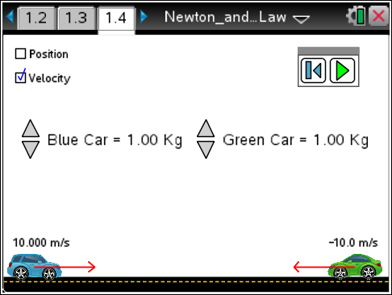

Tech Tip: To access the Directions again, select > Newton and THE Law > Directions.
Tech Tip: To access the Directions again, select b or Document Tools () > Newton and THE Law > Directions.
Move to pages 1.5 - 1.8.
Answer questions 1 – 4 below and/or in the .tns file.

Q1. When the blue and green car have the same initial mass and speed, what happens to the velocity of each car after the collision?

Q2. When the blue and green car have the same initial mass but different initial speed, what happens to the velocity of each car after the collision?

Q3. The blue car exerts a force F on the green car during the collision. Based on Newton's third law, what can you conclude?

A. The blue car experiences a force F.
B. The green car experiences a force –F.
C. The green car exerts a force -F on the blue car.
D. The green car exerts a force F on the blue car.

Q4. What does a negative velocity value mean?

Move back to page 1.4.
- Now, you will observe the final velocities of the cars when they have different initial masses and the same initial velocities. For the first trial, set the initial speed of each car to 10.0 m/s. Set the mass of each car to any value. (Be sure that the masses are different.) Then, record the masses and initial velocities in the table below.
- Run the simulation. Observe and the record the final velocities of each car in the table below.
- Reset the simulation. Repeat these steps for three total trials. Be sure to keep the initial speed of each car at 10.0 m/s, but change the mass of the cars each trial. (Do not worry about the three final columns yet.)
Trial | Car | Mass (kg) | Initial Velocity (m/s) | Final Velocity (m/s) | Change in Velocity (m/s) | Acceleration (m/s²) | Force (N)
1 | Blue
1 | Green
2 | Blue
2 | Green
3 | Blue
3 | Green

- Next, you will calculate the quantities for the three final columns. To do this, use the following information:

a. Change in Velocity = Final Velocity - Initial Velocity

b. Acceleration = Change in Velocity
Change in Time

This is the acceleration of the car during the collision. Assume that the cars are in contact for 0.5 s, so the change in time = 0.5 s.

c. Force = mass x acceleration

This is Newton’s second law. This equation determines the force that a car experiences during the collision.

d. Important: Be sure to include the correct negative signs in all of your calculations!

Tech Tip: To insert a calculator select /I > Add Calculator.

Move to pages 2.1 - 2.2.
Answer questions 5 and 6 below and/or in the .tns file.

Q5. Do your calculations of force in the table support Newton’s third law of motion? Why or why not?

Q6. Two cars have the same initial speeds. According to Newton's third law, they experience equal and opposite forces during a collision. Why is it that they may move away from one another at very different final velocities after the collision?

