Open the TI-Nspire document Swimming_with_Acids_and_Bases.tns.  What happens when acids and bases are added to water? In this activity you will able to answer this question by zooming in on molecules of acids and bases. This view will bring you closer to the molecular level, as if you were swimming with these molecules. | 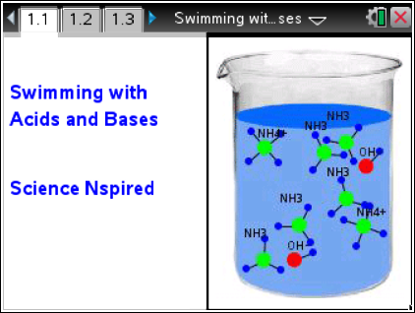

Move to pages 1.2 and 1.3.
1. Read the instructions on page 1.2 for controlling the simulation on page 1.3. The up and down arrows in the top left controls the addition (and removal) of water. The check-box at the top will show the particle names if the box is checked and will hide the names if the box is unchecked.
Move to page 1.4. Answer question 1 here and/or in the .tns file.
Q1. When added to water, gaseous HCl _______.
A. partially dissociates into H and Cl atoms  B. completely dissociates into H and Cl atoms |  | C. partially ionizes into H⁺ and Cl⁻ ions  D. completely ionizes into H⁺ and Cl⁻ ions
Move to pages 2.1 and 2.2.
2. Run the second simulation with gaseous HF.
Move to page 2.3. Answer question 2 here and/or in the .tns file.
Q2. When added to water, gaseous HF _______.
A. partially dissociates into H and F atoms  B. completely dissociates into H and F atoms |  | C. partially ionizes into H⁺ and F⁻ ions  D. completely ionizes into H⁺ and F⁻ ions
Move to pages 3.1 and 3.2.
3. Run the third simulation with solid NaOH.
Move to page 3.3. Answer question 3 here and/or in the .tns file.
Q3. When added to water, solid NaOH _______.
A. partially dissociates into Na atoms and OH molecules  B. completely dissociates into Na atoms and OH molecules |  | C. partially ionizes into Na⁺ and OH⁻ ions  D. completely ionizes into Na⁺ and OH⁻ ions
Move to pages 4.1 and 4.2.
4. Do the fourth simulation with gaseous NH₃.
Move to page 4.3. Answer question 4 here or in the .tns file.
Q4. When added to water, gaseous NH₃ _______.
A. partially dissociates into N and H atoms  B. completely dissociates into N and H atoms | C. partially ionizes into NH₄⁺ and OH⁻ ions  D. completely ionizes into NH₄⁺ and OH⁻ ions
Move to pages 5.1 – 5.4. Answer questions 5 - 8 here or in the .tns file.
Q5. HCl and HF are acids because they _______ in water.
A. produce H⁺ ions  B. produce OH⁻ ions | C. partially ionize  D. completely ionize
Q6. NaOH and NH₃ are bases because they _______ in water.
A. produce H⁺ ions  B. produce OH⁻ ions | C. partially ionize  D. completely ionize
Q7. HCl and NaOH are “strong” because they _______ in water.
A. produce positive ions  B. produce negative ions | C. partially ionize  D. completely ionize
Q8. HF and NH₃ are “weak” because they _______ in water.
A. produce positive ions  B. produce negative ions | C. partially ionize  D. completely ionize

