Open the TI-Nspire document Friction_Your_Friend_or_Your_Enemy.tns.  Do you know how to construct and interpret a free-body diagram? Can you measure or calculate the frictional force and the coefficient of friction between two surfaces? In this activity, you will explore static and kinetic friction by dragging different shoes across a flat surface. | 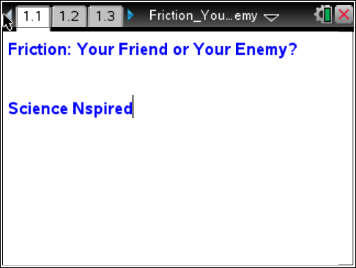

Problem 1: Kinetic and Static Friction for a Hiking Boot
The goals of this activity are a) to observe and compare the forces needed to start the motion of shoes with different soles, b) to observe and compare the forces needed to drag different shoes across a table at a constant speed, and c) to determine what factors affect the friction between two surfaces.

Move to pages 1.1 and 1.2.
1. You will be using a Vernier Dual-Range Force sensor to collect force data. Make sure the switch on the force sensor is in the ±10 N position.
2. If you are using the TI-Nspire .tns file for data collection, connect the force sensor to the EasyLink interface. If you are using TI-Nspire computer software to collect data, connect the Dual-Range Force sensor to the Go! Link interface. Do not connect the EasyLink or Go! Link interface to the .tns file or computer yet.
3. Connect the string to the hiking boot. If the boot has a hanging loop on the back of the heel, tie a loop of string through that loop. Otherwise, tie the loop of string around the lower laces of the boot. The loop of string should be placed so that the boot can be dragged across the table or floor with its sole completely touching the table or floor.

Answer the following questions.
Q1. Do you think you will need a larger force to start moving the shoe or to steadily drag the shoe across the table?

Q2. What forces act on the shoe when you pull the string? Draw a free-body diagram for the shoe.

Move to pages 1.1–1.3.  4. Open the file Friction_Your_Friend_or_Your_Enemy.tns, and read the first two pages, and while on page 1.3 connect the EasyLink or Go! Link interface to your handheld or computer. The DataQuest application should be ready for capturing force data.  5. Select the graph tab. | 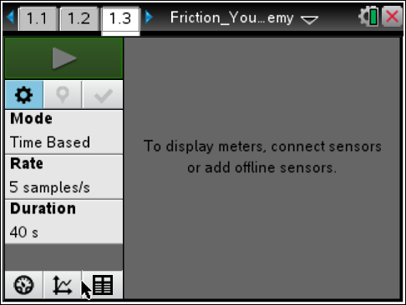
6. Wait for the force reading to stabilize, and then zero the sensor (Menu > Experiment > Set Up Sensors > Zero). Use the string loop to hang the hiking boot from the hook on the force sensor, and wait for the reading to stabilize. This stable reading is the weight of the hiking boot. Record the reading as the weight of the hiking boot.
7. Remove the boot from the force sensor, wait for the reading to stabilize, and then re-zero the sensor. Clear any data stored in the device (Menu > Experiment > New Experiment). Place the boot at one end of the table or floor.
8. Set up the data collection for a time graph (Menu > Experiment > Collection Mode > Time Based). Set the time between samples to 0.02 sec and the experiment length to 5 sec.
9. Before you start the data collection, connect the string to the force sensor and practice several times dragging the boot across the table at a constant speed. You should be able to maintain the constant speed for at least 4 sec. | 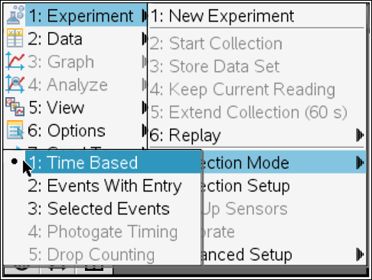
10. Once you can drag the boot steadily, collect a data set. When you are ready, start the data collection by selecting Start Data Collection and then carefully pull the string until the boot starts moving. Continue dragging the boot across the table at a constant speed for at least 4 sec. When the data collection has ended, a scatter plot should be displayed on the DataQuest application.  11. Once you have collected a clean data set, disconnect the EasyLink or Go! Link interface. | 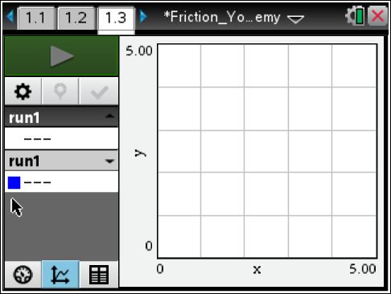
Answer the following questions.
Q3. Determine the force of static friction on the hiking boot from the graph of your data.
Q4. Determine the force of kinetic friction on the hiking boot from the graph of your data.

Q5. Derive an equation for the coefficient of friction in terms of the pulling force and the weight of the boot. Use this equation to calculate the coefficients of kinetic and static friction for the hiking boot.

Q6. Compare the coefficients of kinetic and static friction for the hiking boot.

Problem 2: Kinetic and Static Friction for a Sneaker
Move to pages 2.1 and 2.2.  12. Read the text on page 2.1. Then, repeat Steps 4 and 5 from Problem 1.  13. Use the blank DataQuest application on page 2.2. Wait for the reading to stabilize, and then zero the force sensor. Then, find the weight of the sneaker as you did with the hiking boot in Step 6 of Problem 1. Remove the sneaker from the force sensor and place it on the floor or table.  14. Repeat Steps 8–11 from Problem 1. | 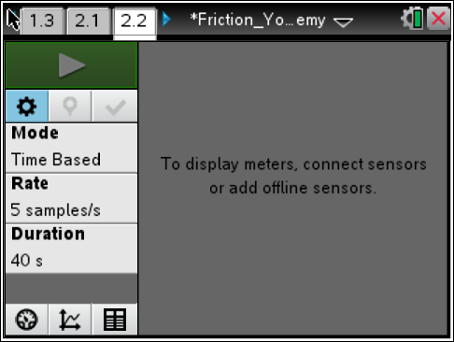
Answer the following questions.
Q7. Determine the force of static friction on the sneaker from the graph of your data.

Q8. Determine the force of kinetic friction on the sneaker from the graph of your data.

Q9. Use the equation you derived in Question 5 to calculate the coefficients of kinetic and static friction for the sneaker.

Q10. Compare the coefficients of kinetic and static friction for the sneaker.

Problem 3: Kinetic and Static Friction for a Dress Shoe
Move to pages 3.1 and 3.2.  15. Read the text on page 3.1. Then, repeat Steps 4 and 5 from Problem 1.  16. Use the blank DataQuest application on page 3.2. Wait for the reading to stabilize, and then zero the force sensor. Then, find the weight of the dress shoe as you did with the hiking boot in Step 6 of Problem 1. Remove the dress shoe from the force sensor and place it on the floor or table.  17. Repeat Steps 8–11 from Problem 1. | 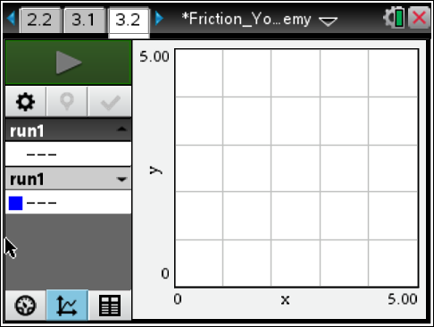
Answer the following questions.
Q11. Determine the force of static friction on the dress shoe from the graph of your data.

Q12. Determine the force of kinetic friction on the dress shoe from the graph of your data.

Q13. Use the equation you derived in Question 5 to calculate the coefficients of kinetic and static friction for the dress shoe.

Q14. Compare the coefficients of kinetic and static friction for the dress shoe.

Q15. Which shoe has the largest coefficient of static friction? Which has the smallest? Which has the largest coefficient of kinetic friction? Which has the smallest?

Q16. What is the most likely explanation for the differences in coefficients of friction between the three shoes?

Problem 4: Applications and Problem Solving
Move to pages 4.1 and 4.2.  18. Read the text on page 4.1.  19. Study the diagram. You can use the Calculator application on page 4.2 to help you solve the problems below. | 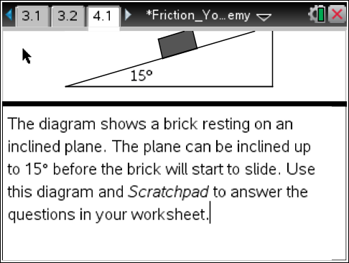
Answer the following questions.
Q17. What keeps the brick from sliding down the ramp? Draw a force diagram for the brick.

Q18. Write equations for the components of the brick's weight that act parallel and perpendicular to the ramp.

Q19. Find the coefficient of static friction between the surface of the ramp and the brick.

Q20. If the ramp is inclined a little more, the brick starts sliding down the ramp. Is it sufficient to decrease the angle of the ramp back to 15° to stop the brick from sliding? Explain your answer.

