Open the TI-Nspire document One_Giant_Leaf_For_Mankind.tns.  You are a horticultural engineer on the International Space Station (ISS) and have been researching food production for extended space exploration missions. | 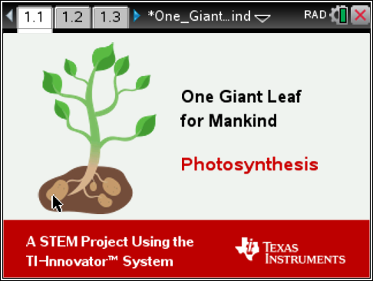
You have been tasked with designing and building a space-based greenhouse model, conducting a simple experiment using the scientific method. You will also learn about photosynthesis and plant cell structure. Then use your model to investigate how the plant surface area and light brightness affect how fast energy is stored (in the form of yams). The goal is to grow at least 800 calories of yams in three months (from a single plant).
Move to pages 1.2 - 1.5 in TI-Nspire Document.
- Background: Read the background information on Pages 1.2 through 1.5.
- Identify: You have an engineering goal and a science research question.
- The engineering goal is to design and build a space-based greenhouse with a light sensor embedded to evaluate and to continue research on growing food in space.
- Your science research question is to find the relationships among the two manipulated variables: light brightness and plant surface area, and investigate how they impact plant growth/ yam productivity (energy storage).
Write two hypothesis statements that predict the relationships between the independent variables (light brightness and place surface area) and the dependent variable (yam growth) :
- Predict the relationship between light brightness (lux) and energy stored (yams).

- Predict the relationship between plant surface area and energy stored (yams).

Move to pages 2.1 – 2.8 in TI-Nspire Document.
- Research: Use appropriate internet resources and the plant cell simulation in Problem 2 to learn about plant cells and photosynthesis in preparation for solving your engineering problem.

- Sketch the plant cell and the major organelles below. Write a brief description of the organelle(s) that are important to the process of photosynthesis.
Q1. Based on your observations, which of these organelles can ONLY be found in plant cells? Select all that apply.
- Mitochondria
- Chloroplasts
- Cell wall
- Rough ER
Q2. Plants have both chloroplasts and mitochondria organelles. Why does the cell have both organelles? Explain.
Q3. Photosynthesis...
- uses light energy
- uses carbon dioxide
- Produces oxygen
- All of the above
Move to page 3.1 -3.2 in TI-Nspire Document.
- Task 1: Establish a Control.  Plug the Light Sensor into port IN 1 of the TI-Innovator™ Hub and connect the TI-Innovator Hub to the TI-Nspire™ CX handheld. Insert the “B” end of the unit-to-unit cable into the DATA port on the TI-Innovator™ Hub.  Note: You should note a green line appears at the top of screen to show you are connected.  You will need to select the ‘play’ button. The brightness of light will then be detected and will display that value in units of Lux.  To take your control reading, a light source (flashlight) should be held one meter away from the light sensor sitting on the desk/table. Now, you are ready to record a baseline Lux reading (control).  Note: Your teacher may ask you to modify the set-up slightly depending on the lighting in your classroom. | 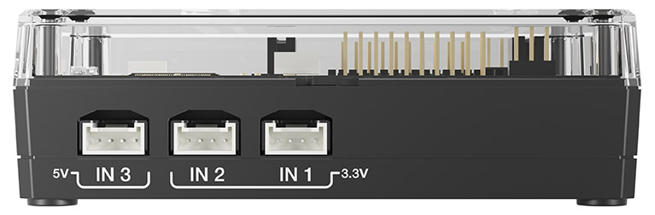  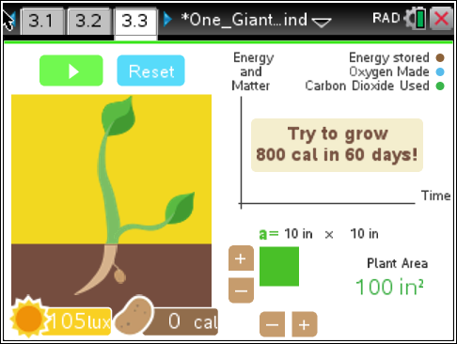  Plug light sensor into IN 1
By establishing a baseline (control), you will be able to better gauge the effectiveness of your greenhouse design. The surface area should be left at the default setting (100 in²).
- What is your Lux reading- (control)?
Move to pages 3.3-3.4 in TI-Nspire Document.
- Design/Prototype: When designing your space-based greenhouse, you should consider the nature of the Sun’s light in outer space. The sunlight differs from the sunlight on earth in several ways:
- In space, there is no atmosphere to scatter the light. This causes the light to be very directional and beam-like. Similar to a flashlight.
- In space, the sun might be much further away than it is on Earth. For example on Mars, the sun is 1.5 times further away than it is from Earth. This results in the sun light being less than half as bright on Mars as it is on Earth.
Since the Sun’s rays of light are beam-like as it is with a flashlight, your design should attempt to capture the sunlight and focus it onto the growing plants (Light Sensor). Your greenhouse model should be directional and “point-able”. Your light sensor must be inside your greenhouse design, as it represents “the plant”.
A) Sketch your design below using the materials provided to you in the classroom. Be sure to show where you plan to place the light sensor in your model.
- Build: You will have one class period to build, unless your teacher has instructed differently. Using your design sketch and the materials and tools provided, build your model space-based greenhouse. Remember to mount the Light Sensor in a position that represents a plant inside your model greenhouse. Safety: Wear safety glasses and be careful with tools.
Move to page 3.4 in TI-Nspire Document.
- Task 2: Testing Your Greenhouse Design
Now, you are ready to test your greenhouse design. Remember that:
- The sensor should be “inside” your greenhouse.
- The greenhouse/sensor should be same distance from light source that you used for your control.
- Your greenhouse should be pointed directly at the distant lamp (flashlight) to simulate the light of the distant sun.
You will record the brightness of the light (Lux), as recorded by the light sensor.
- What is your Lux reading?

- Was the reading greater or less than your Lux reading (control) in Task 1?

- Your Lux reading WITH the greenhouse should be at least as much as the “control” reading. If it is not, what changes could you make to your design? Tweak your design, retest, and record any additional Lux readings below:

- Task 3: Investigate relationships using your model.
Keeping your greenhouse/sensor model in place from the above tasks, you will next continue to investigate the independent variable of light intensity and also surface area, observing the impact on energy stored (yams).
Remember that you should investigate one independent variable at a time. For example, you should keep the surface area constant while the brightness is varied by moving the light source progressively further away/closer to the greenhouse. A flashlight can be used to increase the light intensity falling on the greenhouse (if you were using just the overhead lights in the classroom)
On Page 3.4, you will see a graph of the results of each “test” you run. Add a moveable line (menu> Analyze> Moveable Line), and adjust and align it with the data to measure the slope (rate of production). The steeper the slope, the faster food energy is produced. Record the value of the slope for each of your experiments. These slopes will help you make conclusions about how to maximize food growth.
- As you move the light source closer to/further away, go to Page 3.4 and add the moveable line as directed. Record the lux setting and energy slopes below. Do at least 2-3 different trials of varying distances from the light source. Remember to keep the surface area the same for all three trials
Surface Area: ___________
- Trial 1: lux______ ; Slope _______
- Trial 2: lux______ ; Slope _______
- Trial 3: lux______ ; Slope _______
B) Next, you should keep the distance to the light held constant and vary the surface area of the plant. After each adjustment to the surface area, go to Page 3.4 and add the moveable line as directed. Record the surface area and energy slopes below. Do at least 2-3 different trials of varying surface areas (SA), recording the values below after each change. Remember to keep the distance from the light source the same for all three trials.
Distance in centimeters: ____________
- Trial 1: SA______ ; Slope _______
- Trial 2: SA______ ; Slope _______
- Trial 3: SA______ ; Slope _______
C) What combination of conditions (variables) enable the greatest yield of yams, in the shortest amount of time?
Q5. What dimension of a rectangle can be changed to increase its surface area?
- The length.
- The height.
- The area cannot be changed.
- Both dimensions affect area.
Q6. Increasing the surface area of the yam plant will...
- have no effect on the growth rate.
- increase the growth rate.
- decrease the growth rate.
- none of the above.
Q7. The brightness (lux) of light...
- is the amount of energy falling on the plant.
- affects the growth rate of the plant.
- affects how much carbon is used by the plant.
- all of the above.
Q8. The slope of the energy vs. time graph represents the...
- the height of the plant.
- the number of leaves on the plant.
- The growth rate of the plant.
- The number of yams produced.
Q9. Photosynthesis produces food and...
- uses oxygen and makes CO₂.
- uses CO₂ and makes oxygen.
- uses both CO₂ and Oxygen.
- Has no effect on either gas.
9. Conclusions:
A) Write a conclusion stating the relationships between the variables of plant surface area, brightness, and energy production.
- A trip to Mars from Earth would take around 200 days. If an average person needs 2400 calories a day, and a single plant produces 800 calories of yams, then 3 plants are need per day to feed an average person. You will need to have 600 plants to feed an average person for 200 days. Calculate how big (area) the greenhouse needs to be to hold 600 plants. Show work from the calculator below, and record your answer here.

