Open the TI-Nspire document Balancing_Act.tns.
In this simulation, you will balance different masses on a teeter-totter. You will solve different types of equations to balance the teeter-totter:

- Where two different masses should be placed;
- Given two masses and the location of one mass, where to place the other; and
- Given two masses at given locations on one side, where a mass of a given amount should be placed.
Background
When you place two different masses on either side of a teeter-totter, they will balance only under the right conditions.

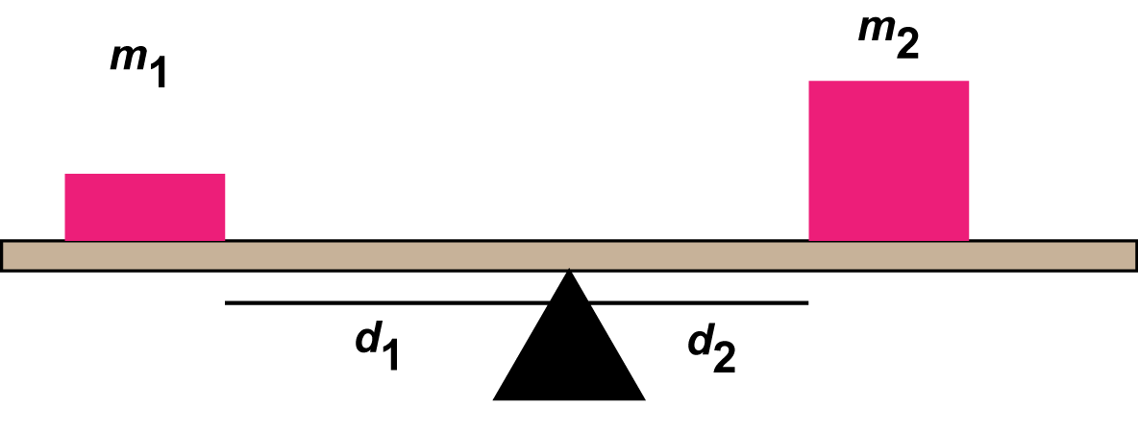

The product of an object’s mass and its distance from the center of the teeter-totter (also called the fulcrum) is a measure of the object’s torque. So, to get a balanced teeter-totter have an equal amount of torque on each side. Let’s look at an example.

Launch the simulation.
When you start the simulation, the teeter-totter has blocks under either end to keep it from moving up and down. You then place people on either side of the teeter-totter at distances from the fulcrum. By default there is a 20-kg person in the space to the right. Selecting the blue arrows above the person will bring up other people and object of different masses.
Move to page 1.2.

Part 1: Balancing Two Different Masses
1. Place a 20-kg person on the left, 3rd mark from the center and a 30-kg person on the right, 2nd mark from the center.

Q1. Select the Play button . Describe what happened.

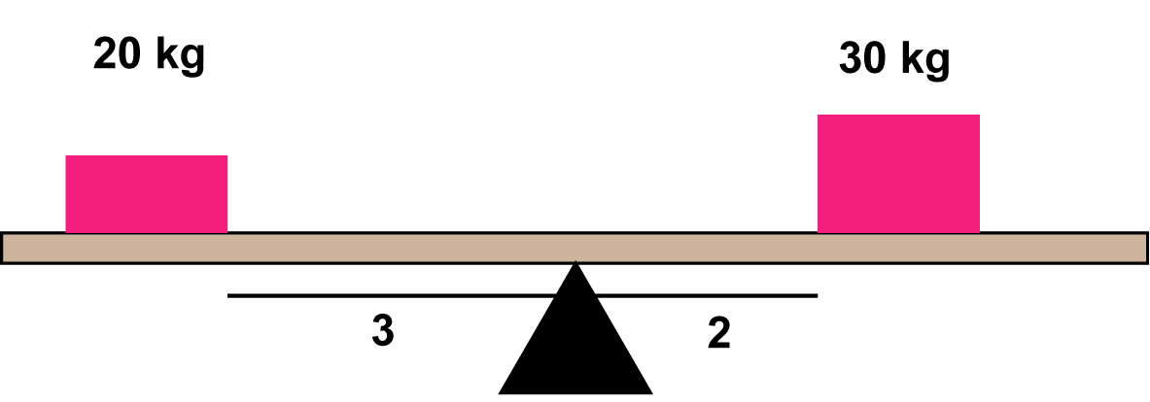

Mathematically, placing the 20-kg mass at position 3 and the 30-kg mass at position 2 achieves balance.

Q2. Complete the table shown below. For each set of masses and distances determine if this arrangement will result in a balanced teeter-totter or not. Calculate the torques, determine if balance will be achieved, then test your prediction using the simulation.

m₁ | d₁ | Torque₁ | m₂ | d₂ | Torque₂ | Predicted  Result | Actual  Result
20 | 6 |  | 30 | 4
20 | 5 |  | 30 | 3
60 | 3 |  | 80 | 2
60 | 4 |  | 80 | 3
30 | 1 |  | 5 | 6
30 | 2 |  | 5 | 9

Part 2: Solving Equations
When you have two different masses and you’ve determined the position of one of the masses, you can calculate the position of the other one. Here is an example:
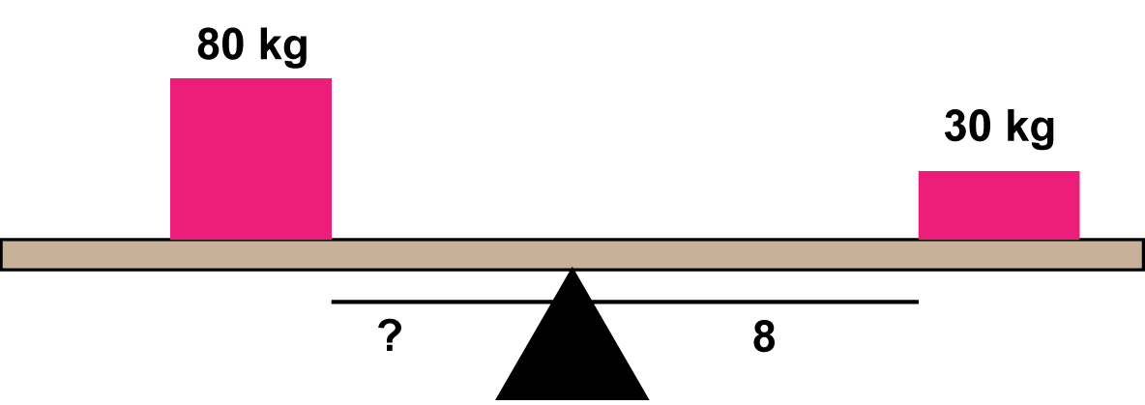

When the distance is the unknown, then you solve the equation to find the value for d₁ or d₂.

Q3. Confirm the results of this equation using the simulation. Describe your results.

Q4. Complete the table below. Calculate the value for d₁ using the equation shown earlier.

m₁ | d₁ | m₂ | d₂
80 |  | 20 | 4
60 |  | 30 | 2
30 |  | 5 | 6
80 |  | 10 | 8
80 |  | 60 | 2
60 |  | 30 | 3

Q5. Use the simulation to verify your results from the table in Q4. Describe any limitations to the simulation.
Part 3: Solving Equations When There are Three Masses
Suppose there are two different masses on one side and one on the other side. If you know the positions of the masses on the same side, you can solve an equation to find the position for the mass on the other side. Here is an example:

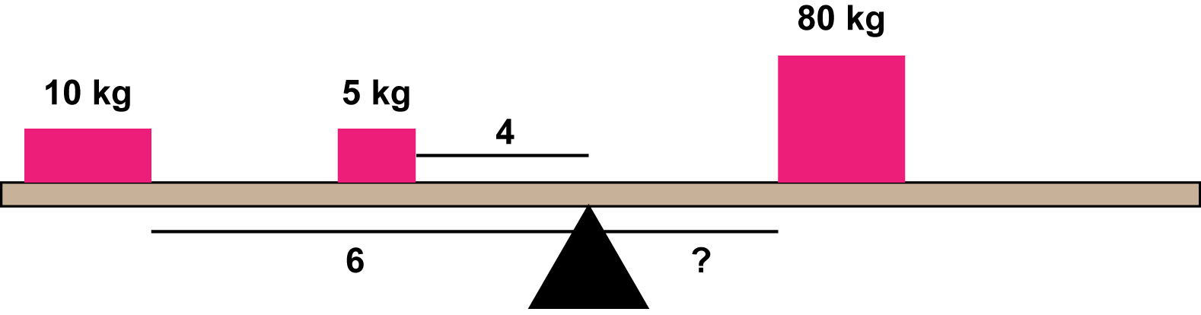

Even though there are three terms, there is still one variable to solve for, d₃.

Q6. Confirm the results of this equation using the simulation. Describe your results.

Q7. Complete the table below. Calculate the value for d₃ using the equation shown earlier.

m₁ | d₁ | m₂ | d₂ | m₃ | d₃
10 | 6 | 60 | 1 | 60
5 | 6 | 30 | 3 | 60
30 | 2 | 10 | 2 | 80
30 | 9 | 10 | 5 | 80
80 | 1 | 10 | 4 | 60

Q8. Use the simulation to verify your results from the table in Q7. Describe any limitations to the simulation.

