Reflection and Absorption
of Light
Would you feel cooler wearing a light or dark-colored shirt on a hot, sunny day? The color and texture of an object influences how much radiant energy from the sun it will absorb or reflect. Every color reflects a certain amount of light while absorbing the rest as heat energy. The amount of reflected light is called the color’s light reflectance value. Dark colors with low light reflectance values tend to reflect little light while absorbing lots of heat energy, whereas light colors with high reflectance values reflect a lot of light and absorb little energy. People in warm, sunny climates are more likely to purchase light-colored cars since they don’t heat up as quickly as dark-colored ones. Many house paints come with a predetermined light reflectance value to guide consumers when making color choices for their homes. Since the Earth’s surface is made of many colors and textures, it is heated unevenly. Snow, ice, and clouds reflect a lot of energy back into space while green forests and vegetated lands absorb energy.
In this experiment, you will investigate the relationship between the percent reflectivity of various colors and the temperature change due to energy absorption. You will measure the amount of light reflected from paper of various colors using a Light Sensor and calculate percent reflectivity. You will also measure the temperature change of the air under the paper due to energy absorption by the paper using a Temperature Probe.

OBJECTIVES
In this experiment, you will
- Use a Light Sensor to measure the amount of reflected light.
- Calculate percent reflectivity of various colored paper.
- Use a Temperature Probe to measure the energy absorbed from light.

MATERIALS
TI-Nspire handheld or | white paper
computer and TI-Nspire software | black paper
data-collection interface | 2 other pieces of colored paper
Light Sensor | ring stand
Temperature Probe | 2 utility clamps
4 cm piece of drinking straw | tape
lamp and 150 W clear bulb | ruler
aluminum foil


Figure 1
PROCEDURE
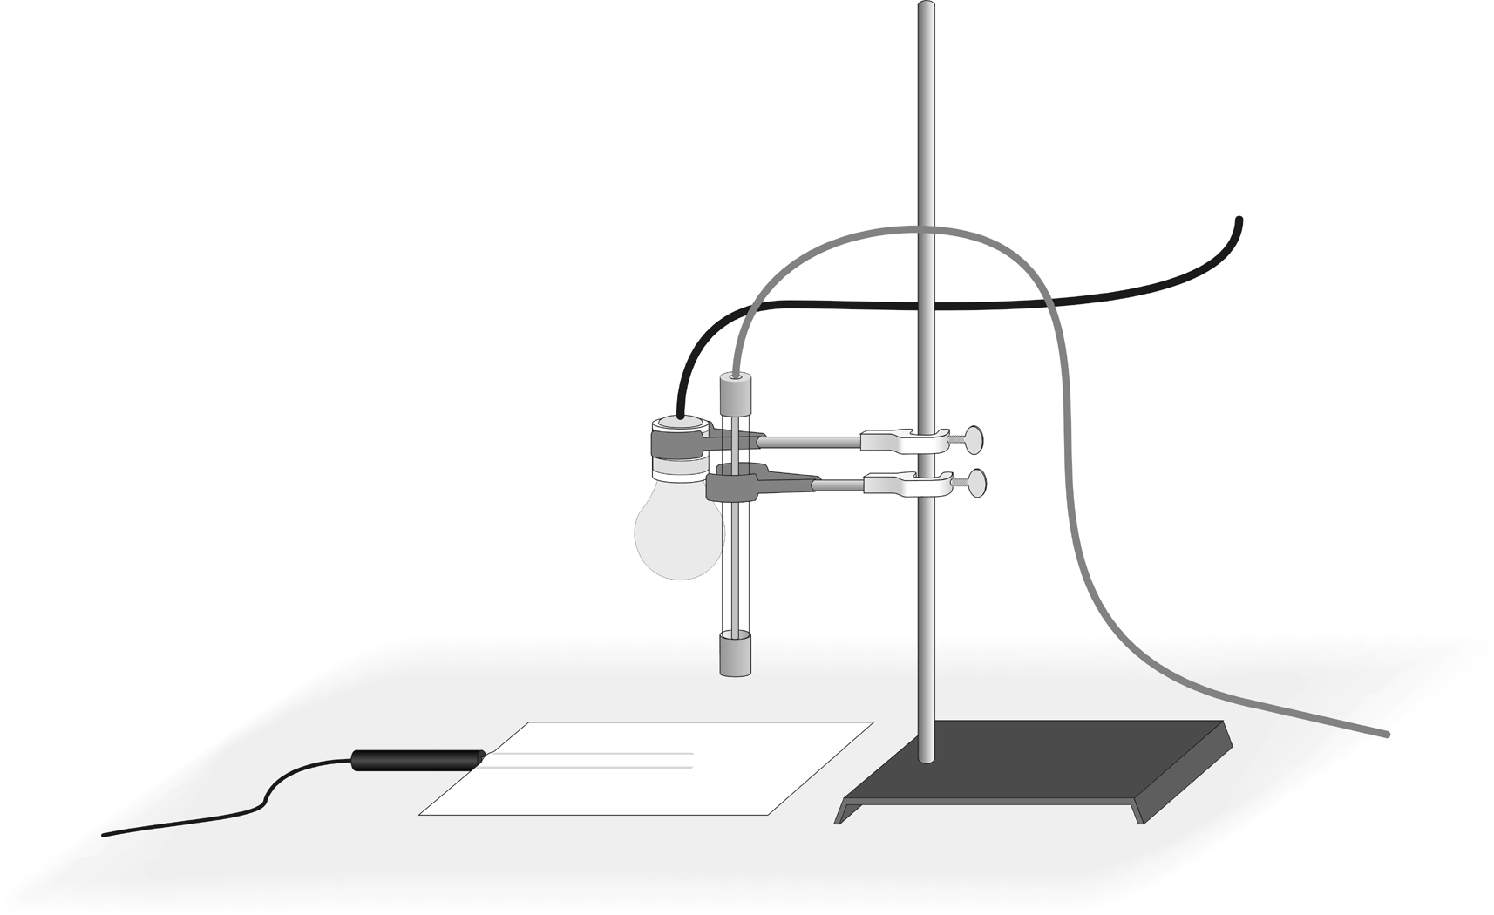
1. Prepare the sensors for data collection.
Figure 2
- Tape the straw to the table surface as shown in Figure 1.
- Insert a Temperature Probe into the straw as far as it will go. Check to make sure the end of the Temperature Probe is not touching the tabletop.
- Place the piece of white paper over the Temperature Probe.
- Use a utility clamp and ring stand to fasten a Light Sensor 5 cm above the paper as shown in Figure 2. Set the Light Sensor switch to the 0–6000 lux position.
- Use the other utility clamp to fasten the lamp and bulb to the ring stand 10 cm above the paper.
- The classroom lights should be on.

2. Connect the Light Sensor and Temperature Probe to the data-collection interface. Connect the interface to the TI-Nspire handheld or computer.
3. Choose New Experiment from the Experiment menu. Choose Collection Setup from the Experiment menu. Enter 0.1 as the rate (samples/second) and 600 as the experiment duration (seconds). The number of points collected should be 61. Select OK.
4. Switch on the light bulb and immediately start data collection (). When data collection is complete, turn off the light bulb.
5. Determine and record the mean light reflection value and the minimum and maximum temperature readings.
- Choose Statistics ► Illumination from the Analyze menu. Record the mean light reflection value in your data table (to the nearest whole lux). The lux is the SI unit for light illumination.
- Choose Statistics ► Temperature from the Analyze menu. Record the minimum and maximum temperature readings (round to the nearest 0.1°C).

6. Click the Store Latest Data Set button () to save the first run data. Replace the white paper with the black paper. Repeat Steps 4–5 for black paper.
7. Click the Store Latest Data Set button () to save the second run data. Replace the black paper with aluminum foil. Repeat Steps 4–5 for aluminum foil.
8. If time allows, collect data for two additional colors of paper. Be sure to store the latest data set () before collecting new data.

DATA
Color | White | Black | Aluminum | __________ | __________
Starting temperature (°C)
Final temperature (°C)
Change in temperature (°C)
Reflection value (lux)
Percent reflectivity | % | % | 100% | % | %

PROCESSING THE DATA
1. Subtract to find the change in temperature for each color paper. Record your values in the data table.
2. Calculate the percent reflectivity of each color paper using the relationship:
% Reflectivity = × 100
Record your values in the data table.

qUESTIONS
1. Which color paper had the largest temperature increase?
2. Which color paper had the smallest temperature increase?
3. Solar collectors can be used to absorb the sun's radiation and change it to heat. What color would work best for solar collectors? Explain.
4. Which color paper has the highest reflectivity?
5. Which color paper has the lowest reflectivity?
6. What relationship do you see between percent reflectivity and temperature change?
7. What types of surfaces might give a planet a high reflectivity? Explain.
8. Does the planet Earth have high reflectivity? Why or why not?

EXTENSIONs
1. Design an experiment to test the reflectivity of sand, soil, water, and other materials. Perform the experiment you designed.
2. Design an experiment to test the effect of texture on reflectivity. Perform the experiment you designed.

