Open the TI-Nspire document Like_Moths_Around_a_Flame.tns.  Imagine that you have a piece of red construction paper on your desk in front of you. If you wrote your name on the construction paper with a red marker and then wrote your name on the same paper with a black marker, which would be easier to read? If you showed the paper to one of your friends across the room, which do you think they would see? A similar scenario happens all the time in nature. Blending into the environment (camouflage) can help an animal avoid being seen, which may help it avoid being eaten by a predator. | 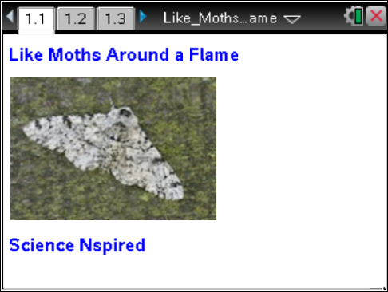

In England, there is a species of insect called the peppered moth that provides us with a great example of camouflage, and this helps us understand the process of natural selection. Some of these moths are dark-colored, and some are light-colored. The color of each moth is determined by its genes for color, so a moth that is born dark stays dark, and a moth that is born light stays light.
The peppered moth is most active during the nighttime hours (nocturnal) and it spends its days resting on things like tree trunks. From the mid-1800s until the mid-1900s, people observed that the number of moths of each color changed. Why did these changes occur? In this activity you will examine data about moths, graph the data, and draw some conclusions.
Move to page 1.2.  1. Examine the data in the spreadsheet, which shows the number of moths of each color by decade. In 1860, for example, if a sample of 100 moths were counted, 90 of them would have been light (lmcount) and 10 of them would have been dark (dmcount). In this activity, you can assume that the counts for the sample accurately reflect the proportions in the entire population. |  |  |  | 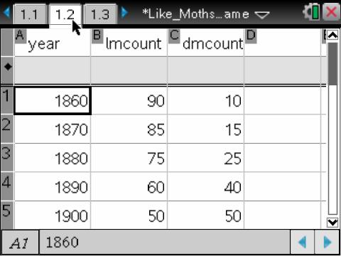
Move to pages 1.3 and 1.4. Answer the following questions here or in the .tns file.
Q1. Which of the following is an independent variable in this activity?
(More than one response may be correct.)
A. the number of dark-colored moths |  | B. the number of light-colored moths | C. the year
Q2. Which of the following is a dependent variable in this activity?
(More than one response may be correct.)
A. the number of dark-colored moths |  | B. the number of light-colored moths | C. the year
Move to page 1.5.  2. Select the x-axis to choose an independent variable(s) for the x-axis. Choose a dependent variable(s) for the y-axis. To add a second variable to the y-axis, select Menu > Plot Properties > Add Y Variable. Examine the graph and look for trends in the data. |  |  |  | 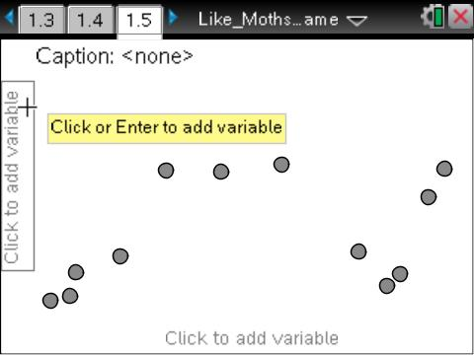
 | Tech Tip: To add a second variable to the y-axis, select  > Plot Properties > Add Y Variable. You may need to back-out to the main Tools Menu to see the desired menu option.
Move to page 1.6. Answer question 3 here or in the .tns file. Answer questions 4–11 here.
Q3. Describe the trend(s) you see in the numbers of light-colored moths as the decades passed. Also, describe the trend(s) you see in the numbers of dark-colored moths.

Q4. From 1950 to 1970, what was the change in the number of light-colored moths? During this time, what was the change in the number of light-colored moths per year? per decade?

Q5. From 1950 to 1970, what was the change in the number of dark-colored moths? During this time, what was the change in the number of dark-colored moths per year? per decade?

Q6. Using your answers for questions 4 and 5, predict when (after 1970) you would expect the number of each type of moth to be the same. Explain your prediction.

Q7. During the middle 1800s, England began what was called the Industrial Revolution. Industry increased rapidly, and with that increase came a much greater need for energy. Since nuclear power plants were still decades away, what was the source of energy that England used to power their huge increase in industry? What was the environmental impact of using this type of fuel? How do you think this impact influenced the numbers of light- and dark-colored moths?

Q8. During the middle 1900s, environmentalists really started voicing their concerns about the harmful effects that industry was having on the environment. England and other countries started paying closer attention to cleaning up the environment by reducing emissions from industrial factories. These concerns helped to promote policies like the Clean Air Act in many countries. As these policies became implemented, new forms of energy started being used, and industry was required to reduce emissions from their existing factories. What was the environmental impact of the Clean Air Act? How do you think this impact influenced the numbers of light- and dark-colored moths?

Q9. Explain how your answers to questions 7 and 8 could be used to explain the effects of natural selection on the population of peppered moths in England.

Q10. What do you think would happen to the environment and to the moth population if factories went back to using older energy sources for their power, and the Clean Air Acts were eliminated? Explain your response.

Q11. Brainstorm and then describe another example of natural selection in animals, and one in plants.

