Open the TI-Nspire document Maximum_Minimum_Zeroes.tns.  Objective: To determine a relationship between the maximums, minimums, and zeroes of functions and their derivatives. | 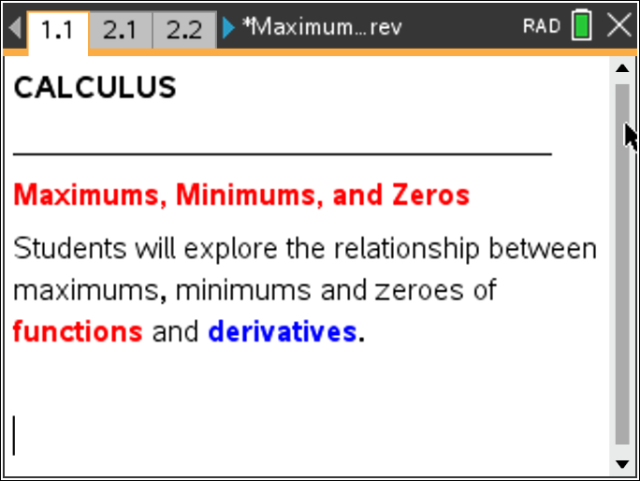

Part I
Directions: Grab and move the open circle on the graph to the points indicated on the worksheet. You may also move with the slider, however the words asked for below will NOT show when using a slider. Next, make a conjecture about the relationships seen.
The function that is graphed with a thicker line is the antiderivative function. The other function is the graph of the derivative.
The dotted vertical line is a perpendicular line that will help you record coordinates from both functions.

Move to page 2.1.

1. Move the empty circle point along the function until you see “maximum” appear on the screen. Record the coordinates of the point where the perpendicular line and the derivative intersect. | 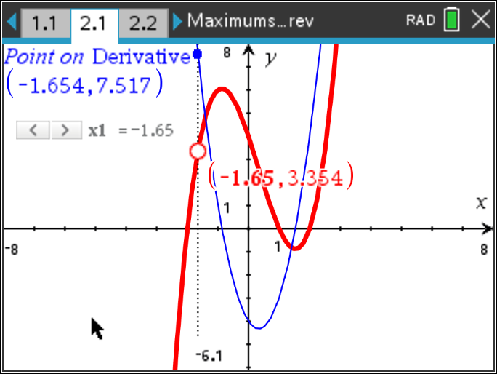
2. Move the empty circle point along the function until you see “zero” appear on the screen. Record the coordinates of the point where the perpendicular line and the derivative intersect. Repeat for each ‘zero’ point.

3. Move the empty circle point along the function until you see “minimum” appear on the screen. Record the coordinates of the point where the perpendicular line and the derivative intersect.

Move to page 2.2.

4. Move the point along the derivative until you see “zero” appear on the screen. Record the coordinates of the point where the perpendicular line and the function intersect. Repeat for each ‘zero’ point. | 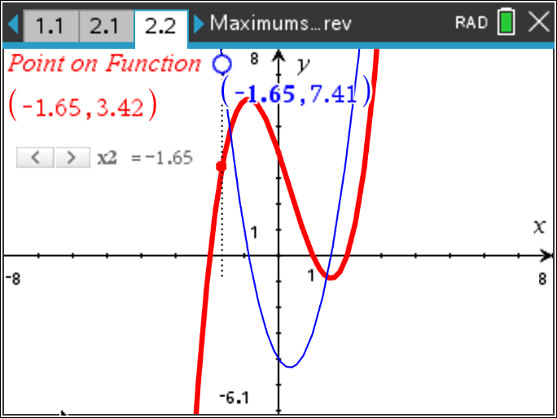
5. Move the empty circle point along the derivative until you see “minimum” appear on the screen. Record the coordinates of the point where the perpendicular line and the function intersect.

6. Making a Conjecture: Examine the points you recorded for problems 2.1 and 2.2. Next, write down any relationships you see between the points.

Testing Your Conjecture:

Move to page 3.1.

Test your conjecture by moving the slider or the empty circle to all of the maximums, minimums, and zeroes on the function as in problem 2.1. Record the coordinates in the table on the following page. Do the same for problem 3.2 by moving the empty circle as you did in problem 2.2.

Problem 3.1
 |  | Problem 3.2
Type of Point | Coordinates |  | Type of Point | Coordinates

7. Does your conjecture still hold? Why or why not?

Exploring Further
Refer to pages 4.1 to 5.2.
Repeat the process for problem 4 and problem 5. Record your results below and the following page. After you record all possible maximum, minimum and zero points, go back to the graph and examine the sign of the derivative to the left and right of each maximum and minimum point.

Problem 4.1
Type of Point | Coordinates | Sign of Derivative (Left) | Sign of Derivative (Right)

Problem 4.2
Type of Point | Coordinates | Sign of Derivative (Left) | Sign of Derivative (Right)

Problem 5.1
Type of Point | Coordinates | Sign of Derivative (Left) | Sign of Derivative (Right)
Problem 5.2
Type of Point | Coordinates | Sign of Derivative (Left) | Sign of Derivative (Right)

8. Explain the relationship between the maximum, minimums and zeroes based on the problems you explored.

