Open the TI-Nspire document Horizontal and Vertical Lines.tns.  This activity investigates slope and its relationship to two very special kinds of lines: horizontal and vertical. | 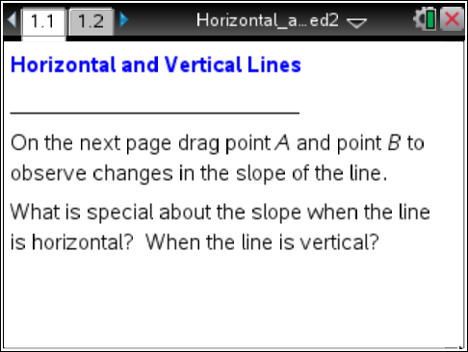

Move to page 1.2. | Press / ¢ and / ¡ to navigate through the lesson.
1. a. Following the arrows from point A to point B, what is the value of the vertical change?

b. Horizontal change?

Slope is the number that describes the ratio of vertical change to horizontal change for two distinct points on a line.
c. What number represents the slope of the line through points A and B on page 1.2?

2. Move one or both points until the value for the vertical change is zero, and the value for the horizontal change is not zero.
a. Describe the line passing through points A and B.

b. What is the slope of the line through the points A and B?

3. Move the points until the value for the horizontal change is zero, and the value for the vertical change is not zero.
a. Describe the line passing through points A and B.

b. What is the slope of the line passing through points A and B?

4. a. Why is the slope undefined when the horizontal change is zero?

b. How is this different from a zero slope?

5. Set point A to (-4, 2). Where must you move point B for the vertical change to be zero and the horizontal change not be zero?

6. Set point A to (-4, 2). Where must you locate point B for the horizontal change to be zero and the vertical change not be zero?

7. Suppose you have two points with the same x-coordinates. What do you know about the line through those points and about the slope ratio? Explain your reasoning.

8. Suppose you have the same y-coordinates instead of the same x-coordinates. Would your answer from question 7 change? Why or why not?

9. a. Suppose you have a horizontal line through (5,-3). What can you say about the coordinates of the points on this line?

b. Suppose you have a vertical line through the same point (5, -3). What can you say about the coordinates of the points on this line?

10. What relationship exists between the coordinates of points A and B when the slope of the line passing through them is zero? Undefined?

11. What does it mean when someone says that a line has no slope?

